UNIVERSITY OF BUEA
HIGHER TECHNICAL TEACHERS TRAINING COLLEGE (HTTTC) KUMBA
DEPARTMENT OF COMPUTER SCIENCE
INFORMATION TECHNOLOGY

DESIGN AND IMPLEMENTATION OF A SMART COURSE COVERAGE MANAGEMENT SYSTEM: CASE STUDY HTTTC KUMBA
A PROJECT REPORT SUBMITTED TO THE HIGHER TECHNICAL TEACHERS TRAINING COLLEGE (HTTTC) KUMBA IN PARTIAL FULFILMENT OF THE REQUIREMENTS FOR THE AWARD OF DIPET I IN INFORMATION TECHNOLOGY (IT)
PRESENTED BY
OJONG YANICK ARREY
REGISTRATION NUMBER: HP24A068
SUPERVISOR
Prof. KINFACK JUETSA AUBIN
27/05/2027

DECLARATION
I, OJONG YANICK ARREY, with Registration Number HP24A068, hereby declare that this project report entitled “DESIGN AND IMPLEMENTATION OF A SMART COURSE COVERAGE MANAGEMENT SYSTEM: CASE STUDY HTTTC KUMBA” is my original work and has been carried out under the supervision of PROF. KINFACK JUETSA AUBIN.
I further declare that this work has not been submitted, either wholly or in part, to any other institution for the award of a degree, diploma, or any other academic qualification. All sources of information used in this work have been duly acknowledged and referenced.
Student’s Name: OJONG YANICK ARREY
Registration Number: HP24A068
Signature: __________________________
Date: ______________________________

CERTIFICATION
This project report entitled “DESIGN AND IMPLEMENTATION OF A SMART COURSE COVERAGE MANAGEMENT SYSTEM: CASE STUDY HTTTC KUMBA”, presented by OJONG YANICK ARREY, Registration Number HP24A068, has been carried out under my supervision and is hereby submitted for examination with my approval.
Supervisor:
Prof. KINFACK JUETSA AUBIN
Signature: __________________________
Date: ______________________________

APPROVAL
This project report has been examined and approved as meeting the requirements for the award of DIPET I in INFORMATION TECHNOLOGY at the Higher Technical Teachers Training College (HTTTC) Kumba.
Head of Department:
Prof. KINFACK JUETSA AUBIN
Signature: __________________________
Date: ______________________________

DEDICATION
This project is dedicated to my Lord and Savior, Jesus Christ, and to all my loved ones for their love, encouragement, prayers, and support throughout my academic journey.

ACKNOWLEDGEMENT
I would like to express my sincere gratitude to God Almighty for granting me the strength, wisdom, good health, and perseverance required to successfully undertake and complete this project.
I am deeply grateful to my supervisor, Prof. KINFACK JEUTSA AUBIN, for his meticulous supervision, guidance, constructive advice, and continuous support throughout the development of this project. His contributions greatly assisted me in completing this work.
My sincere appreciation also goes to the Director of the Higher Technical Teachers Training College (HTTTC) Kumba, Prof. AKUME DANIEL AKUME, for providing an enabling academic environment for my studies.
I equally extend my gratitude to the entire teaching staff of the Computer Science Department of HTTTC Kumba for their knowledge, guidance, and support throughout my academic training.
I am also grateful to my family and friends for their encouragement, prayers, financial, moral, and spiritual support throughout my studies. Their support and motivation contributed greatly to the completion of this project.
Finally, I appreciate everyone who contributed directly or indirectly to the success of this work. May God Almighty bless you all.

ABSTRACT
The effective monitoring of course delivery is an important aspect of academic management in higher education and professional training institutions. In a teaching environment where several lecturers are responsible for different courses, programmes, levels, and academic sessions, maintaining accurate information on the progress of course delivery can be challenging when course coverage is not centrally managed. Difficulties in monitoring assigned courses, topics taught, hours covered, and the progress of course delivery can affect the ability of academic administrators and Heads of Departments to obtain timely information for monitoring and decision-making. This project therefore focuses on the design and implementation of a Smart Course Coverage Management System: Case Study HTTTC Kumba, with the aim of providing a centralized computerized platform for managing and monitoring course coverage.
The proposed system is designed around three categories of users: Admin, Head of Department (HOD), and Lecturer. The Admin role provides administrative management functions, while the HOD is concerned with monitoring course assignments, course coverage, and academic progress. The Lecturer interacts with the system in relation to assigned courses, course coverage, and coverage history. The system incorporates role-based access so that users are directed to interfaces corresponding to their respective roles after authentication.
The implemented system uses a relational database to organize information required for course coverage management. The database includes structures for academic sessions, attendance, courses, course assignments, course coverage, course topics, departments, lecturers, notifications, programmes, roles, and users. Course assignments associate courses with lecturers, programmes, academic sessions, semesters, and levels, while course coverage records provide information such as the topic taught, date taught, hours taught, coverage status, remarks, and the user responsible for updating the record. This structure provides a foundation for maintaining course delivery information in a centralized database.
The system also provides mechanisms for monitoring course coverage by relating the hours taught to the expected hours associated with course topics. The supplied system documentation defines coverage monitoring using the total hours taught compared with the expected hours for the relevant course topics. It also provides coverage-status categories based on the calculated percentage and identifies courses with relatively low coverage for monitoring purposes. Recent coverage submissions can likewise be used to provide an overview of recently recorded course-delivery activities.
Security and controlled access are incorporated into the system through user authentication and role-based redirection. The login mechanism verifies user credentials and account status before directing authenticated users to the appropriate dashboard. Password management is also provided, including verification of the existing password, confirmation of a new password, password-length validation, password hashing, and protection against unauthorized password-change requests.
The system is developed using web-based technologies and is intended to operate within an environment supporting PHP, MySQL/MariaDB, and a local web server such as XAMPP, WAMP, or Laragon. The resulting platform provides a centralized approach to recording, organizing, and monitoring course coverage information and establishes a basis for improving the accessibility and organization of academic course-delivery records at HTTTC Kumba. The system can further support academic monitoring by making course assignment and coverage information available according to the responsibilities of the Admin, HOD, and Lecturer roles.
Keywords: Smart Course Coverage Management System, Course Coverage, Higher Technical Teachers Training College, HTTTC Kumba, Course Management, Academic Monitoring, PHP, MySQL, Database Management System.

TABLE OF CONTENTS
TITLE PAGE
DECLARATION
CERTIFICATION/APPROVAL
DEDICATION
ACKNOWLEDGEMENT
ABSTRACT
TABLE OF CONTENTS
LIST OF FIGURES
LIST OF TABLES
LIST OF ABBREVIATIONS AND ACRONYMS

CHAPTER ONE: GENERAL INTRODUCTION

1.1 Background of the Study

1.2 Problem Statement

1.3 Objectives of the Study

1.3.1 General Objective

1.3.2 Specific Objectives

1.4 Scope of the Study

1.5 Significance of the Study

CHAPTER TWO: LITERATURE REVIEW

2.1 Introduction

2.2 Conceptual Review

2.3 Course Coverage Management

2.4 Smart/Computerized Course Coverage Management

2.5 Review of Existing Systems/Approaches

2.6 Limitations of Existing Systems

2.7 Research Gap

2.8 Summary of Literature Review

CHAPTER THREE: REQUIREMENTS ANALYSIS AND SYSTEM DESIGN

3.1 Introduction

3.2 Analysis of the Existing System

3.2.1 Existing Course Coverage Process

3.2.2 Use of Logbooks for Course Coverage

3.2.3 Existing Users and Responsibilities

3.2.4 Existing Information Flow

3.2.5 Existing Course Coverage Monitoring

3.2.6 Limitations of Existing Logbook Approach

3.2.7 Need for an Improved System

3.2.8 Summary of Existing System Analysis

3.3 Problems of the Existing System

3.4 Proposed System

3.5 Development Methodology

3.5.1 Requirements Analysis

3.5.2 System Design

3.5.3 Database Development

3.5.4 Incremental System Implementation

3.5.5 Testing and Debugging

3.5.6 System Refinement and Improvement

3.5.7 Iterative Development Process

3.5.8 Current Development Stage

3.5.9 Justification for Selected Methodology

3.5.10 Summary

3.6 System Requirements

3.6.1 Hardware Requirements

3.6.2 Software Requirements

3.6.3 Database Requirements

3.6.4 User Requirements

3.6.5 Operational Requirements

3.7 Functional Requirements

3.7.1 Admin Functional Requirements

3.7.2 HOD Functional Requirements

3.7.3 Lecturer Functional Requirements

3.7.4 Course Coverage Management Requirements

3.7.5 Authentication and Access Requirements

3.7.6 Reporting and Monitoring Requirements

3.8 Non-Functional Requirements

3.8.1 Security

3.8.2 Usability

3.8.3 Performance

3.8.4 Reliability

3.8.5 Data Integrity

3.8.6 Maintainability

3.8.7 Compatibility

3.8.8 Scalability

3.8.9 Availability

3.9 System Design

3.9.1 System Architecture

3.9.2 Role-Based System Design

3.9.3 Course Coverage Processing

3.9.4 Data Flow Design

3.9.5 Activity Design

3.9.6 Sequence Design

3.9.7 Database Design

3.9.8 System Navigation Design

3.9.9 Security Design

3.9.10 System Design Summary

3.10 Use Case Diagram

3.11 Data Flow Diagram

3.12 Activity Diagram

3.13 Sequence Diagram

3.14 Database Design

3.15 Entity Relationship Diagram

3.16 Project Schedule

3.17 Cost Evaluation

3.18 Development Tools

CHAPTER FOUR: SYSTEM IMPLEMENTATION, RESULTS AND TESTING

4.1 Introduction

4.2 System Implementation

4.3 System Interfaces

4.4 Admin Interface

4.5 HOD Interface

4.6 Lecturer Interface

4.7 Course Management

4.8 Course Assignment

4.9 Course Coverage Recording

4.10 Coverage History

4.11 Reports/Progress Monitoring

4.12 System Testing

4.13 Test Results

4.14 Discussion of Results

CHAPTER FIVE: CONCLUSION AND RECOMMENDATIONS

5.1 Introduction

5.2 Conclusion

5.3 Recommendations

5.4 Suggestions for Future Improvements

REFERENCES

APPENDICES

APPENDIX A: SYSTEM SCREENSHOTS

A.1 Login Interface

A.2 Admin Dashboard

A.3 HOD Dashboard

A.4 Lecturer Dashboard

A.5 User Management

A.6 Department Management

A.7 Programme Management

A.8 Course Management

A.9 Course Assignment

A.10 Course Coverage Recording

A.11 Coverage History

A.12 Reports/Progress Monitoring

A.13 Change Password

APPENDIX B: DATABASE STRUCTURE

APPENDIX C: SYSTEM DIAGRAMS

C.1 Use Case Diagram

C.2 Data Flow Diagram

C.3 Activity Diagram

C.4 Sequence Diagram

C.5 Entity Relationship Diagram

C.6 Database Design Diagram

C.7 Gantt Chart

APPENDIX D: SYSTEM TESTING MATERIAL

APPENDIX E: SAMPLE SYSTEM DATA

APPENDIX F: SOURCE CODE EXTRACTS

LIST OF FIGURES
Figure 3.1: System Architecture
Figure 3.2: Role-Based Use Case Diagram
Figure 3.3: Course Coverage Processing Flow
Figure 3.4: Data Flow Diagram (Level 0)
Figure 3.5: Activity Diagram for Course Coverage Management
Figure 3.6: Sequence Diagram for the Smart Course Coverage Management System
Figure 3.7: Entity Relationship Diagram (ERD)
Figure 3.8: System Navigation Structure
Figure 3.9: Gantt Chart for the Smart Course Coverage Management System Project Schedule
Figure 4.1: Login Interface
Figure 4.2: Admin Dashboard
Figure 4.3: HOD Dashboard
Figure 4.4: Lecturer Dashboard
Figure 4.5: User Management Interface
Figure 4.6: Department Management Interface
Figure 4.7: Programme Management Interface
Figure 4.8: Course Management Interface
Figure 4.9: Course Assignment Interface
Figure 4.10: Course Coverage Recording Interface
Figure 4.11: Coverage History Interface
Figure 4.12: Reports/Progress Monitoring Interface
Figure 4.13: Change Password Interface
Figure B.1: Database Structure
Figure C.1: Use Case Diagram
Figure C.2: Data Flow Diagram
Figure C.3: Activity Diagram
Figure C.4: Sequence Diagram
Figure C.5: Entity Relationship Diagram
Figure C.6: Database Design Diagram
Figure C.7: Gantt Chart

LIST OF TABLES
Table 2.1: Comparison of Existing Systems/Approaches
Table 3.1: Hardware Requirements
Table 3.2: User Roles and System Functions
Table 3.3: Development Tools and Versions
Table 3.4: Functional Requirements
Table 3.5: Non-Functional Requirements and Acceptance Criteria
Table 3.6: Database Entities and Their Purposes
Table 3.7: Project Schedule
Table 3.8: Estimated Project Cost
Table 4.1: System Testing Areas
Table 4.2: Test Results Summary
Table A.1: System Screenshots
Table D.1: System Testing Material

LIST OF ABBREVIATIONS AND ACRONYMS
Admin — Administrator
CSS — Cascading Style Sheets
DFD — Data Flow Diagram
ERD — Entity Relationship Diagram
ES6 — ECMAScript 2015
HOD — Head of Department
HTML — HyperText Markup Language
HTTTC — Higher Technical Teachers Training College
JS — JavaScript
KPI — Key Performance Indicator
PHP — Hypertext Preprocessor
SQL — Structured Query Language
UML — Unified Modeling Language
UI — User Interface
URL — Uniform Resource Locator
VS Code — Visual Studio Code
XAMPP — Cross-Platform (X), Apache (A), MariaDB/MySQL (M), PHP (P), Perl (P)

CHAPTER ONE

GENERAL INTRODUCTION

1.1 Background of the Study
Education is an important component of social and economic development because it provides individuals with knowledge, skills, attitudes, and competencies required to participate effectively in society and the world of work. Higher education and professional teacher-training institutions, in particular, have the responsibility of providing structured academic programmes through which learners acquire specialized knowledge and professional competencies. The effective delivery of such programmes depends not only on the availability of qualified lecturers and appropriate learning resources, but also on the ability of an institution to organize, coordinate, monitor, and evaluate the delivery of its courses.
Course delivery is an essential part of academic management. A course is normally organized around a defined set of topics or learning content that is expected to be covered within a specified academic period. Consequently, monitoring course coverage involves determining whether lecturers are progressing through the topics and expected teaching hours associated with their assigned courses. Effective course coverage monitoring can therefore provide academic administrators and Heads of Departments with information about the progress of teaching activities and can assist them in identifying areas that may require attention.
In a conventional academic environment, information concerning course assignments, topics taught, teaching dates, hours covered, and the progress of course delivery may exist across different records or may depend heavily on manual communication between lecturers and academic administrators. When such information is not organized within a centralized system, retrieving and consolidating course-delivery information can become more difficult as the number of courses, lecturers, programmes, and academic activities increases. This creates a need for information systems capable of organizing relevant academic information and making it accessible to authorized users.
The increasing application of digital technologies in education has created opportunities for institutions to improve the way educational information and administrative processes are managed. UNESCO's 2023 Global Education Monitoring Report recognizes that technology can contribute to education-system management, including through the use of assessment data and other education-management information. At the same time, UNESCO emphasizes that technology should be introduced according to the needs and context of an education system rather than being treated as an automatic replacement for human interaction.
Within this context, computerized information systems can provide a structured means of collecting, storing, processing, retrieving, and presenting academic information. Instead of relying exclusively on scattered records, a centralized database can maintain related information in an organized form. Such an approach can make it possible to associate lecturers with their assigned courses, courses with programmes and academic sessions, and course topics with records of actual teaching activities.
The development of a course coverage management system is therefore concerned with more than simply storing information about courses. It involves establishing relationships among the major elements involved in course delivery and providing appropriate interfaces through which authorized users can interact with those elements. For example, an academic management system may need to distinguish between the course itself, the lecturer assigned to teach the course, the programme and academic level in which the course is offered, the academic session and semester in which it is delivered, the individual topics that constitute the course, and the actual coverage records entered during teaching.
The proposed system for this project is specifically concerned with the management and monitoring of course coverage at the Higher Technical Teachers Training College (HTTTC) Kumba. The project is entitled “DESIGN AND IMPLEMENTATION OF A SMART COURSE COVERAGE MANAGEMENT SYSTEM: CASE STUDY HTTTC KUMBA.” The system is designed around three categories of users: Admin, Head of Department (HOD), and Lecturer. Each category has a different relationship with the information managed by the system.
The Admin role is associated with administrative management of core information required by the system. The supplied system implementation includes database structures for users, roles, departments, programmes, courses, academic sessions, and related academic information. The system also provides role-based access, allowing authenticated users to be directed to interfaces corresponding to their assigned roles.
The Head of Department (HOD) has a monitoring and academic coordination role within the system. The available implementation includes HOD-oriented functions such as course assignment, assignment monitoring, course coverage, and reports. The project database provides a course-assignment structure through which a course can be associated with a lecturer, programme, academic session, semester, and level. This provides a foundation for organizing information about which courses are being delivered and by whom.
The Lecturer interacts with the system primarily in relation to courses assigned to the lecturer and the recording of course coverage. The implementation includes lecturer-oriented navigation for assigned courses, coverage, and history. This provides a mechanism through which course-delivery information can be recorded and subsequently reviewed.
The database structure further demonstrates the relationship between course topics and course coverage. The cousre_topics table stores information about topics associated with courses, including the topic number, topic title, description, and expected hours. The course_coverage table stores records associated with those topics and includes fields such as the date taught, hours taught, coverage status, remarks, the user responsible for updating the record, and the update date. These structures provide the basis for recording course-delivery progress in a more organized manner.
The system also contains a course_assgnment table that connects courses to lecturers, programmes, academic sessions, semesters, and levels. This relationship is important because course coverage cannot be meaningfully interpreted without knowing the academic context in which the course is being delivered. For example, the same course may be associated with different teaching contexts across academic sessions, programmes, levels, or semesters. Maintaining these relationships within the database therefore provides a structured foundation for monitoring course delivery.
Another important aspect of the proposed system is the use of expected teaching hours as part of coverage monitoring. According to the supplied project documentation, course coverage can be considered by comparing the total hours taught with the expected hours associated with the relevant course topics. The system documentation also defines coverage-status categories based on the resulting percentage and identifies assigned courses with relatively low coverage for monitoring. This provides a quantitative approach to representing course-delivery progress rather than relying solely on manually written descriptions.
The proposed system is also intended to provide a centralized source of course-coverage information. The supplied implementation uses a relational database named course_coverage_management_system, with tables covering academic sessions, attendance, courses, course assignments, course coverage, course topics, departments, lecturers, notifications, programmes, roles, and users. The use of related database tables makes it possible to organize different categories of information while maintaining relationships between them.
Security is another consideration in the development of the system. Since course information and academic records should not be freely accessible to unauthorized persons, the system incorporates user authentication and role-based access. The login implementation verifies users through their credentials and account status and redirects authenticated users according to their roles. The system supports the three defined roles of Admin, HOD, and Lecturer. Password management also includes verification of the current password, confirmation of the new password, password-length validation, password hashing, and a security token for password-change requests.
The concept of a “smart” course coverage management system in this project should therefore be understood in relation to the system's ability to organize course information, relate course assignments to lecturers and academic contexts, record course coverage, calculate or represent progress based on teaching information, and provide role-specific access to relevant information. The term does not imply that the system replaces academic judgment or human supervision. Rather, the system is intended to support academic personnel by providing organized information that can assist them in monitoring course delivery.
The importance of using technology appropriately in educational management is also reflected in international discussions on digital education. UNESCO's 2023 Global Education Monitoring Report notes that technology can support education-system management but also emphasizes the importance of considering context, evidence, equity, sustainability, governance, and human interaction when introducing technology into education. This perspective is relevant to the present project because the purpose of the proposed system is not technology adoption for its own sake, but the development of a computerized solution directed toward a specific academic-management need.
From a systems perspective, the proposed solution brings together data management, user authentication, academic information management, course assignment, course coverage recording, and progress monitoring within a single platform. The centralized nature of the system can provide a common point through which authorized users can access information relevant to their responsibilities. This can also establish a more structured basis for producing course-coverage information and monitoring the status of course delivery.
The development of the Smart Course Coverage Management System is therefore motivated by the need to provide an organized computerized platform for managing information associated with course delivery at HTTTC Kumba. The project seeks to combine database management, web-based technologies, role-based access, and course-coverage monitoring into one system. Through this approach, the study focuses on designing and implementing a system that can support the recording, organization, retrieval, and monitoring of course coverage information while maintaining distinct responsibilities for the Admin, HOD, and Lecturer.
Ultimately, the study forms part of the broader application of information technology to educational administration and management. The proposed system provides a practical case of how a computerized information system can be designed around a specific institutional process. By focusing on course coverage rather than attempting to replace the wider academic-management structure of the institution, the project establishes a defined technological solution for organizing and monitoring information related to the progress of course delivery.

1.2 Problem Statement
Effective course delivery requires continuous monitoring of the progress of teaching activities throughout an academic session. In a higher technical teacher-training institution such as the Higher Technical Teachers Training College (HTTTC) Kumba, courses are delivered by lecturers to students within different academic programmes, levels, semesters, and academic sessions. For academic management to effectively monitor the progress of course delivery, relevant information concerning course assignments, course topics, teaching activities, hours taught, and coverage status needs to be properly recorded, organized, and made available to the appropriate academic personnel.
The management of course coverage becomes more challenging when information concerning teaching activities is not maintained through a centralized computerized system. Course assignments, course topics, teaching dates, hours taught, remarks, and other related information may need to be brought together before the overall progress of a course can be understood. Without a structured mechanism for organizing these elements, obtaining a clear and timely view of course-delivery progress can require additional effort.
A major problem addressed by this project is therefore the need for a centralized system for recording, organizing, and monitoring course coverage information. Course coverage is not limited to identifying whether a course has been assigned to a lecturer. It also involves determining the topics associated with the course, the expected teaching hours, the topics that have been taught, the number of hours delivered, and the current status of coverage. A system that does not bring these related elements together makes systematic monitoring of course progress more difficult.
Another issue concerns the relationship between course assignments and course coverage. A course may be associated with a particular lecturer, programme, academic session, semester, and level. Therefore, coverage information needs to be considered within the correct academic context. The database structure of the proposed system reflects this requirement by associating course assignments with courses, lecturers, programmes, academic sessions, semesters, and levels. This provides a structured basis for distinguishing different teaching assignments and their corresponding coverage records.
The problem also involves the monitoring responsibilities of different users. The Admin, HOD, and Lecturer do not perform exactly the same activities within a course-coverage management process. The Admin is concerned with administrative information and system management; the HOD requires information that supports course assignment and academic monitoring; while the Lecturer requires access to assigned courses and facilities for recording and reviewing course coverage. Without appropriate role-based access, users may either lack access to information required for their responsibilities or have access to information that is outside their operational role.
A further problem is the difficulty of determining course progress from individual teaching records without an organized mechanism for relating actual teaching hours to expected teaching hours. The proposed database contains expected hours for individual course topics and records the hours taught for corresponding coverage activities. This creates the basis for calculating a representation of course progress. The project documentation further specifies coverage categories based on the relationship between hours taught and expected hours, as well as identification of assigned courses with low coverage. Consequently, the system addresses the need to transform individual course-coverage records into information that can assist academic monitoring.
The absence of centralized and structured course-coverage information can also make historical monitoring more difficult. Course-delivery information is useful not only at the moment it is entered but also when reviewing what has already been taught. The proposed system therefore includes coverage history within the Lecturer interface and recent coverage information within the monitoring structure. Maintaining these records in a database provides a basis for retrieving previously recorded course-coverage information rather than treating each teaching activity as an isolated record.
Another aspect of the problem is the need for controlled access to academic information. Course assignments and course-coverage records are part of an academic information system and should be accessed according to the responsibilities of authorized users. The proposed system addresses this through authentication and role-based redirection. The login mechanism distinguishes between Admin, HOD, and Lecturer accounts and directs each authenticated user to the appropriate area of the system.
Password management is also part of the system's security requirements. Since users authenticate through passwords, the system needs to protect account credentials and provide a controlled mechanism for changing passwords. The implemented password-change functionality verifies the current password, requires a new password of at least eight characters, confirms that the new password matches its confirmation, prevents reuse of the current password, stores the new password using password hashing, and uses a security token to help protect the request. These mechanisms address the need for basic protection of authenticated user accounts.
The problem can therefore be summarized as the lack of a centralized and structured computerized mechanism for managing and monitoring course coverage information in a manner that connects courses, lecturers, course assignments, course topics, expected teaching hours, actual teaching hours, coverage status, and historical records while providing role-specific access to Admin, HOD, and Lecturer users.
The proposed Smart Course Coverage Management System seeks to address this problem by providing a centralized web-based platform through which relevant course-delivery information can be recorded, stored, processed, retrieved, and monitored. Rather than relying on isolated records, the system establishes relationships among the different entities involved in course delivery and provides role-specific interfaces for interacting with the information.
The project consequently seeks to answer the following central problem:
How can a computerized Smart Course Coverage Management System be designed and implemented to effectively organize, record, and monitor course coverage information at HTTTC Kumba while providing appropriate access and functionality to Admin, HOD, and Lecturer users?

1.4 Scope of the Study
The scope of this study defines the boundaries within which the Design and Implementation of a Smart Course Coverage Management System: Case Study HTTTC Kumba is carried out. The study focuses on the design and implementation of a computerized system for organizing, recording, and monitoring course coverage information within Higher Technical Teachers Training College (HTTTC) Kumba. The scope covers the users, academic information, course delivery activities, system functions, and technical environment considered necessary for achieving the objectives of the project.

1.4.1 Institutional Scope
The study is limited to Higher Technical Teachers Training College (HTTTC) Kumba. The institution serves as the case study for understanding the processes involved in course allocation, course delivery, and monitoring of course coverage.
The system is designed around the academic and administrative requirements identified for the case study institution. It provides a centralized platform through which relevant course information can be managed and course delivery progress can be monitored. The study does not attempt to develop a general-purpose course management system applicable to every higher education institution. Instead, the design is focused on addressing the identified course coverage management needs of HTTTC Kumba.

1.4.2 User Scope
The system is designed for three categories of users: Admin, HOD, and Lecturer. Each user category has a defined role within the system.
The Admin is responsible for administrative activities related to the management of the system's academic and user information. This includes activities associated with users, departments, programmes, courses, academic sessions, semesters, and other information required for the operation of the system.
The HOD (Head of Department) is concerned with departmental course management and monitoring activities. The HOD can work with course assignments, monitor course coverage, and access reports and progress information provided by the system.
The Lecturer is concerned primarily with the courses assigned to them and the recording of course coverage information. The lecturer can access assigned courses, record coverage information, and view relevant coverage history.
The study therefore concentrates on these three roles and does not introduce additional system-user categories outside the identified roles.

1.4.3 Functional Scope
Functionally, the system covers the management and monitoring of information required for course coverage. The system provides facilities for managing users and academic information, assigning courses to lecturers, recording course topics and coverage, and monitoring progress.
The course coverage component focuses on information such as the topic taught, date of teaching, number of hours taught, coverage status, and remarks. This information provides a structured record of the progress made in delivering an assigned course.
The system also considers the relationship between courses and their corresponding lecturers, programmes, academic sessions, semesters, and levels. This makes it possible to associate a particular course delivery activity with the appropriate academic context.
Coverage monitoring is based on the relationship between the expected teaching hours associated with course topics and the hours actually recorded as taught. This provides a basis for determining the progress of a course and presenting relevant coverage information to authorized users.
The system also includes coverage history and reporting functionality to support the monitoring of course delivery progress. These functions are intended to make previously recorded course coverage information accessible for monitoring and review.

1.4.4 Data Scope
The study covers the management of the major categories of data required by the system. These include user information, roles, departments, programmes, courses, academic sessions, course assignments, course topics, and course coverage records.
User and role information is required to control access to the system according to the responsibilities of Admin, HOD, and Lecturer users. Academic information provides the structure within which courses are offered and assigned.
Course assignment information establishes the relationship between a course and the lecturer responsible for teaching it within a particular programme, academic session, semester, and level.
Course topic information provides the individual topics associated with a course, including the expected teaching hours. Course coverage information records the actual teaching activities associated with these topics.
The study does not extend to unrelated institutional information that is not required for course coverage management.

1.4.5 Technical Scope
From a technical perspective, the project focuses on the development of a web-based course coverage management system using technologies suitable for a local web development environment. The implementation uses PHP for server-side application development, MySQL/MariaDB for database management, and standard web technologies such as HTML and CSS for the user interface.
The system uses a relational database to organize and maintain the information required for course coverage management. The database contains structured entities for users, roles, departments, programmes, courses, academic sessions, course assignments, course topics, and course coverage records.
Authentication and role-based access are included within the technical scope to ensure that users access functions corresponding to their assigned roles. Passwords are handled using secure password hashing, while authenticated users are directed to the appropriate role-specific dashboard.

1.4.6 Geographical Scope
The geographical scope of the study is limited to HTTTC Kumba in Cameroon, which serves as the case study institution. The analysis of the existing process, identification of requirements, system design, and proposed implementation are therefore considered within the context of the institution.
The system is not developed specifically to address the administrative or academic processes of other institutions. However, some of the concepts and design approaches used in the system may be adaptable to institutions with similar course coverage management requirements.

1.4.7 Scope Limitations
Although the proposed system provides facilities for course coverage management, the study is specifically concerned with monitoring course delivery and related academic information. It does not seek to replace all academic or institutional management systems.
The project does not cover areas such as student admission, student fee management, payroll management, library management, examination management, or general human resource management unless such functions are directly required for course coverage management.
The study also does not claim to automate every aspect of teaching and learning. Its primary concern is to provide a structured computerized platform for managing and monitoring information related to course coverage.
Overall, the scope of the study is therefore centered on providing HTTTC Kumba with a computerized platform through which Admin, HOD, and Lecturer users can manage relevant academic information, course assignments, course topics, and course coverage records, while supporting the monitoring of course delivery progress.

1.5 Significance of the Study
The development of the Smart Course Coverage Management System is significant because it provides a structured computerized approach to managing and monitoring course delivery at Higher Technical Teachers Training College (HTTTC) Kumba. The system is intended to support the different users involved in course coverage management by providing centralized access to relevant information and improving the organization of course delivery records.
The significance of the study is presented according to the major stakeholders who may benefit from the proposed system.

1.5.1 Significance to the Administration
The system can provide the institution with a centralized platform for maintaining information related to courses, lecturers, programmes, departments, academic sessions, course assignments, and course coverage.
By keeping relevant information within a structured database, the system can make course coverage information easier to retrieve and review. This can support institutional monitoring and provide a more organized approach to managing course delivery information.
The system can also reduce dependence on scattered or manually maintained records by providing a centralized computerized environment for storing course coverage information.

1.5.2 Significance to Heads of Departments
The system is particularly relevant to Heads of Departments (HODs) because they are involved in monitoring courses and the progress of course delivery within their areas of responsibility.
Through the system, an HOD can access course assignment and coverage information and monitor the progress of courses assigned to lecturers. Coverage records can provide information about topics that have been taught, the hours recorded, and the progress associated with the assigned courses.
The availability of organized coverage information can therefore support the HOD in reviewing course delivery progress and identifying courses that may require attention.

1.5.3 Significance to Lecturers
The system provides lecturers with a structured means of managing information relating to the courses assigned to them.
Instead of relying exclusively on manually maintained records, lecturers can record relevant course coverage information through the system. Information such as topics taught, dates, hours taught, coverage status, and remarks can be maintained as part of the course coverage record.
The availability of coverage history can also allow lecturers to review previously recorded teaching activities and maintain a more organized record of their course delivery.

1.5.4 Significance to Course Coverage Monitoring
One of the major contributions of the study is the provision of a structured approach to monitoring course coverage.
The system relates expected course teaching hours to the hours recorded as taught. This provides a basis for determining the progress of an assigned course and presenting course coverage information in a more organized manner.
Such information can assist authorized users in understanding the extent to which course topics have been covered and in reviewing the progress of course delivery.

1.5.5 Significance to Record Management
The study is also significant in the area of academic record management. Course coverage information can accumulate throughout an academic session, making proper organization and retrieval important.
By storing course coverage records in a relational database, the system provides a structured means of maintaining these records. Authorized users can retrieve relevant information when required rather than depending entirely on individually maintained records.
This can contribute to improved organization, accessibility, and consistency of course coverage information.

1.5.6 Significance to Transparency and Accountability
The system can contribute to transparency and accountability in course delivery by maintaining identifiable records of course coverage activities.
Since coverage records are associated with particular course assignments and users, authorized users can review the information recorded in the system. This provides a clearer record of course delivery activities and can support monitoring of the progress of assigned courses.
The system is therefore intended to provide a more traceable approach to course coverage management.

1.5.7 Significance to Future Research and Development
The study can also serve as a reference for students, researchers, and developers interested in academic information systems, course management, database systems, and educational technology.
The design and implementation process demonstrates how a computerized system can be developed to address a specific institutional information-management problem. Future researchers may use the study as a basis for investigating related areas or extending the system with additional functionalities, provided such extensions are supported by future requirements.

1.5.8 Significance to the Researcher
The study provides the researcher with practical experience in systems analysis, database design, web application development, user authentication, system design, testing, and documentation.
It also provides an opportunity to apply concepts acquired during academic training to a practical institutional problem. Through the development process, the researcher gains experience in identifying requirements, designing a system, implementing database-driven functionality, and evaluating the resulting application.

1.5.9 Overall Significance of the Study
Overall, the study is significant because it proposes a centralized computerized approach to course coverage management at HTTTC Kumba. By bringing together relevant academic information and course coverage records within one system, the proposed solution can support Admin, HOD, and Lecturer users in performing their respective responsibilities.
The significance of the system therefore lies not only in the automation of record keeping, but also in providing organized information that can support the monitoring of course delivery progress, improve access to course coverage records, and contribute to a more structured approach to course coverage management.

CHAPTER TWO

LITERATURE REVIEW

2.1 Introduction
This chapter presents a review of literature related to the Design and Implementation of a Smart Course Coverage Management System: Case Study HTTTC Kumba. The purpose of the literature review is to establish the conceptual and technological foundation of the study, examine existing knowledge related to course coverage management and computerized information systems, and identify the gap that motivates the development of the proposed system.
Course coverage management is concerned with the organization, recording, monitoring, and review of the progress made in delivering the content of academic courses. In an educational institution, effective course coverage monitoring requires relevant information about courses, lecturers, course topics, expected teaching hours, actual teaching activities, academic sessions, programmes, and other related academic structures. Proper management of such information can support those responsible for monitoring the progress of course delivery.
The development of computerized information systems has provided institutions with methods for organizing and processing large amounts of information more systematically. Information systems can support data collection, storage, processing, retrieval, and presentation, thereby making relevant information available to authorized users when required. Laudon and Laudon (2022) explain that information systems can support organizational operations and management by collecting, processing, storing, and distributing information.
Database systems are also important in the development of academic information systems because they provide structured methods for storing and managing related data. A properly designed relational database can establish relationships between different categories of information and facilitate efficient retrieval and management of records (Connolly & Begg, 2015; Elmasri & Navathe, 2016). In the context of this study, such an approach is relevant because course coverage information is related to several academic entities, including courses, lecturers, programmes, course topics, academic sessions, and course assignments.
The literature review also considers systems analysis and design principles. Systems analysis involves understanding an existing problem, identifying requirements, and determining the information and processes needed by a proposed system. Systems design then provides a structured representation of how the proposed solution will operate. Dennis et al. (2018) and Kendall and Kendall (2019) emphasize the importance of requirements analysis and system design in the development of effective information systems.
The review further examines software engineering principles relevant to the development of a web-based information system. Software development requires appropriate consideration of requirements, system architecture, implementation, testing, usability, security, and maintenance. Pressman and Maxim (2020) and Sommerville (2016) discuss these aspects as important components of software development.
In addition, the chapter considers the role of web technologies and database-driven applications in providing centralized access to information. Technologies such as HTML, CSS, PHP, and MySQL can be combined to develop web-based systems capable of receiving user input, processing information, communicating with databases, and presenting results through user interfaces. These technologies are relevant to the technical context of the proposed system.
The literature review also examines existing approaches to course and academic management in order to understand their capabilities and limitations. Particular attention is given to approaches for recording course information, assigning courses to lecturers, monitoring course delivery, maintaining historical records, and presenting progress information. The purpose is not simply to identify existing systems, but to understand the approaches used and determine the specific gap addressed by the proposed Smart Course Coverage Management System.
Finally, the chapter identifies the research gap that provides the justification for the proposed system. The gap is considered in relation to the need for a centralized and structured approach to course coverage management that supports the identified users of the system—Admin, HOD, and Lecturer—within the context of HTTTC Kumba.
The chapter is organized into conceptual review, course coverage management, computerized approaches to course coverage management, review of existing systems and approaches, limitations of existing approaches, research gap, and a summary of the literature reviewed.

2.2 Conceptual Review
A conceptual review provides an explanation of the major concepts and terms that form the foundation of a study. In this project, the conceptual review focuses on the concepts directly related to the Design and Implementation of a Smart Course Coverage Management System: Case Study HTTTC Kumba. These concepts include information systems, management information systems, course management, course coverage, computerized course coverage management, smart systems, databases, web-based systems, role-based access, course assignment, course topics, coverage monitoring, and academic records management.
Understanding these concepts is important because the proposed system combines several of them to provide a structured approach to managing and monitoring course coverage.

2.2.1 Information System
An information system is an organized combination of people, processes, data, and technology used to collect, process, store, and provide information for organizational activities. Information systems support organizations by transforming collected data into information that can be used for operational activities, monitoring, coordination, and decision-making.
According to Laudon and Laudon (2022), information systems consist of interconnected components that collect, process, store, and distribute information to support organizational operations and management. The concept is relevant to this study because the proposed system collects course-related information, processes the information, stores it in a database, and makes the resulting information available to authorized users.
In the context of HTTTC Kumba, the information handled by the proposed system includes information about users, courses, programmes, departments, lecturers, academic sessions, course assignments, course topics, and course coverage records.
The proposed system can therefore be considered an institutional information system because it is designed to support a specific institutional process—course coverage management.

2.2.2 Management Information System
A Management Information System (MIS) is an information system designed to provide relevant information that supports management and organizational activities. It normally involves the collection, processing, storage, and presentation of information in a form that can assist users in monitoring activities and making informed decisions.
Management information is particularly important when an organization needs to monitor activities that occur over a period of time. In an educational environment, information about courses, teaching activities, assignments, and progress can help responsible personnel understand the current state of academic activities.
The proposed Smart Course Coverage Management System incorporates characteristics of a management information system because it organizes course delivery information and provides authorized users with information about course coverage progress.
For example, course coverage records can be used to determine the amount of teaching activity recorded for a particular course. Such information can assist an HOD in monitoring the progress of courses assigned to lecturers.

2.2.3 Course Management
Course management refers to the organization and administration of information and activities associated with academic courses. A course may have a course code, course name, credit value, description, associated programme, lecturer, academic session, semester, and level.
Effective course management requires accurate information about the courses offered by an institution and the academic context in which they are delivered.
Within the proposed system, course management forms an important foundation for course coverage monitoring. Before course coverage can be recorded, the relevant course must exist within the system and be associated with the appropriate academic information.
The system therefore considers courses as structured academic entities that can be related to departments, programmes, lecturers, course topics, and course assignments.

2.2.4 Course Coverage
Course coverage refers to the extent to which the planned content of an academic course has been delivered by a lecturer during an academic period.
A course is normally divided into topics or units that are expected to be taught within a specified period. Course coverage monitoring involves recording information about the topics that have been taught and comparing actual teaching progress with the expected course content or teaching hours.
For this study, course coverage is not simply concerned with whether a course exists or has been assigned to a lecturer. It focuses on the actual delivery progress of the course.
The proposed system therefore records information such as:
- the course being covered;
- the topic associated with the course;
- the date on which the topic was taught;
- the number of hours taught;
- the coverage status; and
- relevant remarks.
These records provide a structured representation of course delivery activities.

2.2.5 Course Topic
A course topic represents a specific unit or area of content that forms part of a course. A course can contain several topics, and each topic may have an expected number of teaching hours.
The concept of course topics is important because course coverage cannot be effectively monitored if the content of a course is not divided into identifiable components.
In the proposed system, course topics are associated with particular courses. Each topic can contain information such as a topic number, topic title, description, and expected teaching hours.
This structure makes it possible to connect the planned course content with the actual teaching activities recorded by the lecturer.

2.2.6 Course Assignment
Course assignment refers to the process of associating a particular course with a lecturer who is responsible for teaching it within a specified academic context.
A course assignment may be associated with a lecturer, course, programme, academic session, semester, and level. This relationship is important because the same course-related information may have different contexts depending on the academic period and programme in which the course is delivered.
In the proposed system, course assignment provides the link between the course and the lecturer responsible for its delivery. Course coverage records can then be associated with that assignment.
This creates a logical sequence in the system:
Course → Course Assignment → Course Topics → Course Coverage
Through this relationship, the system can maintain a structured record of how a particular assigned course is being covered.

2.2.7 Course Coverage Management
Course coverage management refers to the systematic organization, recording, monitoring, and review of information concerning the progress of course delivery.
Traditional course coverage management may involve manually maintained records, individual documents, or other methods of recording teaching progress. Such approaches can make it difficult to maintain consistent records and retrieve information when required, particularly when course information is distributed across different records.
A computerized course coverage management system provides an alternative by maintaining course coverage information within a centralized database.
In this study, course coverage management involves several related activities, including:
- managing course information;
- managing course topics;
- assigning courses to lecturers;
- recording topics taught;
- recording teaching dates;
- recording hours taught;
- maintaining coverage status;
- maintaining remarks;
- maintaining coverage history; and
- monitoring course delivery progress.
These activities form the operational foundation of the proposed system.

2.2.8 Smart System
The term "smart" in a computerized system generally refers to the system's ability to organize information and provide useful processing, monitoring, or decision-support capabilities beyond simple data storage.
In this project, the term Smart Course Coverage Management System is used in the context of a computerized platform that does more than simply store course coverage records. The system organizes relationships among courses, topics, lecturers, assignments, academic sessions, and teaching hours and uses the recorded information to support course coverage monitoring.
The smart aspect of the proposed system is therefore associated with structured information processing and monitoring. For example, course coverage can be considered in relation to expected teaching hours and hours already recorded as taught.
The system can also identify courses with relatively low recorded coverage according to the configured coverage criteria. This provides useful information for authorized users who need to monitor course delivery.
The term "smart" in this study should therefore not be interpreted as implying artificial intelligence unless such functionality is specifically implemented. It refers primarily to the system's organized, computerized, and information-driven approach to course coverage management.

2.2.9 Database
A database is an organized collection of related data that can be stored, managed, and retrieved efficiently. Database systems are widely used in information systems because they provide structured mechanisms for maintaining data and relationships between different data entities.
Connolly and Begg (2015) explain that database systems provide facilities for defining, creating, maintaining, and controlling access to databases. Elmasri and Navathe (2016) similarly emphasize the importance of database systems in organizing related information and supporting efficient data management.
The proposed system uses a relational database to store information required for course coverage management.
The database structure includes information relating to:
- users;
- roles;
- departments;
- programmes;
- lecturers;
- courses;
- academic sessions;
- course assignments;
- course topics;
- course coverage;
- attendance; and
- notifications.
The relationships among these entities allow the system to connect academic information and course delivery records.
For example, a course coverage record can be associated with a particular course assignment and course topic. The assignment can in turn be associated with a lecturer, programme, academic session, semester, and level.
This relational structure helps reduce unnecessary duplication of information and supports organized retrieval of records.

2.2.10 Web-Based System
A web-based system is an application that users access through a web browser over a local or networked environment. Web-based applications are commonly used because they can provide centralized access to information through a user interface without requiring a separate application installation on every user device.
The proposed Smart Course Coverage Management System is implemented as a web-based application. The system uses server-side programming and a relational database to process and store information.
HTML is used to structure web pages, while CSS is used to support the presentation and layout of the user interface. PHP is used for server-side processing and communication with the database, while MySQL/MariaDB provides database management capabilities.
This combination allows the system to receive user requests, process them on the server, interact with the database, and return the appropriate information to the user.

2.2.11 User Authentication
Authentication refers to the process of verifying the identity of a user before allowing access to protected areas of a system.
Authentication is important in the proposed system because the application contains information that should not be accessible to unauthorized users. Users are required to provide their login credentials before accessing the system.
The proposed system uses email and password authentication. After successful authentication, the user's assigned role determines the appropriate area of the application to which the user is directed.
This provides the foundation for controlled access to the system.

2.2.12 Role-Based Access
Role-based access refers to controlling system functionality according to the role assigned to a user. Instead of providing every user with access to every system function, permissions and available functions are associated with the user's role.
The proposed system has exactly three user roles:
- Admin
- HOD
- Lecturer
Each role is associated with different responsibilities within the system.
The Admin is concerned with administrative and academic information management. The HOD is concerned with course assignment and monitoring activities, while the Lecturer is primarily concerned with assigned courses and course coverage recording.
Role-based access therefore helps ensure that users interact with the functions relevant to their responsibilities.

2.2.13 Course Coverage Monitoring
Course coverage monitoring involves observing and reviewing the progress of course delivery based on recorded teaching activities.
The proposed system supports monitoring by comparing recorded teaching hours with expected teaching hours associated with course topics. This allows the system to provide an indication of the progress of an assigned course.
The coverage calculation provides a quantitative basis for understanding course progress. The general relationship can be represented as:
Coverage Percentage = (Total Hours Taught / Total Expected Hours) × 100
For example, if a course has an expected total of 40 teaching hours and 20 hours have been recorded as taught, the calculated coverage would be:
Coverage Percentage = (20 / 40) × 100 = 50%
The value provides an indication of the proportion of expected teaching hours that have been recorded.
The implemented system further categorizes coverage according to defined percentage ranges. These categories provide a simple way of interpreting course progress and identifying courses requiring attention.

2.2.14 Coverage History
Coverage history refers to the stored record of previously entered course coverage activities.
Maintaining historical information is important because course coverage is not a one-time activity. Teaching activities occur throughout an academic session, and previously recorded information may be required for monitoring and review.
A coverage history facility allows authorized users to review previously recorded coverage activities. This can provide a chronological record of teaching activities associated with courses and topics.
Coverage history can therefore contribute to accountability and provide a basis for reviewing the development of course coverage over time.

2.2.15 Academic Session and Semester
An academic session represents a defined academic period within which courses are offered and teaching activities take place. A semester represents a subdivision of an academic session.
These concepts are important in course coverage management because course assignments and coverage activities must be associated with a particular academic period.
The proposed system therefore maintains academic session information and associates course assignments with the relevant session and semester. This makes it possible to distinguish course coverage activities belonging to different academic periods.

2.2.16 Academic Programme and Department
A department represents an organizational academic unit within an institution, while a programme represents a structured course of study offered within the institution.
These concepts are relevant because courses are normally associated with particular academic programmes and departments. A lecturer may also belong to a department, while a course assignment may relate to a specific programme.
The proposed system therefore maintains department and programme information as part of the academic structure required for organizing course assignments and coverage information.

2.2.17 Academic Record Management
Academic record management refers to the systematic collection, organization, storage, retrieval, and maintenance of academic information.
In the context of this study, the focus is specifically on records related to course delivery and coverage rather than the management of all academic records.
The proposed system provides a structured environment for maintaining these records in a database. This allows information to be stored consistently and retrieved according to the requirements of authorized users.

2.2.18 System Usability
Usability refers to the extent to which a system can be used by its intended users to accomplish specified tasks effectively, efficiently, and satisfactorily.
Nielsen (1994) emphasizes the importance of usability in interactive system design, while Shneiderman et al. (2016) discuss principles for designing interfaces that support effective human-computer interaction.
For the proposed system, usability is important because the three categories of users have different responsibilities and may interact with different parts of the application. The system interface should therefore present relevant information clearly and provide understandable navigation and controls.
A usable course coverage management system should allow authorized users to perform their required activities without unnecessary complexity.

2.2.19 System Security
System security involves protecting information systems and their data against unauthorized access, misuse, modification, or other security threats.
Security is relevant to the proposed system because it stores user credentials and academic information. Authentication, password protection, session control, and controlled access are therefore important considerations.
The proposed system uses password hashing for storing user passwords rather than storing passwords as plain text. Role-based access is also used to restrict access according to the user's assigned role.
These measures contribute to protecting the integrity and confidentiality of information managed by the system.

2.2.20 Relationship Among the Concepts
The concepts reviewed above are interconnected and collectively form the conceptual foundation of the proposed system.
The relationship can be summarized as follows:
Users → Authentication → Role-Based Access → System Functions → Academic Data → Course Assignment → Course Topics → Course Coverage → Monitoring and Reports
The users first authenticate themselves before accessing the system. Their assigned roles determine the functions available to them. The system then provides access to relevant academic information.
Courses are organized within departments and programmes and can be assigned to lecturers for a particular academic session, semester, and level. Each course can contain several topics with expected teaching hours. As teaching takes place, coverage records are entered into the system. The recorded hours can then be compared with expected hours to support course coverage monitoring.
This relationship demonstrates how the proposed system brings together information management, database management, web technologies, authentication, course assignment, and course coverage monitoring into a single computerized platform.

2.2.21 Summary of the Conceptual Review
The conceptual review establishes the major concepts underlying the proposed Smart Course Coverage Management System. The study is based on the understanding that effective course coverage management requires organized academic information, structured course assignments, identifiable course topics, reliable coverage records, appropriate access control, and mechanisms for monitoring course delivery progress.
The concepts of information systems, databases, web-based applications, role-based access, course assignment, course topics, course coverage, coverage monitoring, usability, and security are therefore closely related to the proposed system.
The review provides the conceptual foundation for examining course coverage management and existing approaches in the subsequent sections of this chapter.

2.3 Course Coverage Management
Course coverage management refers to the systematic planning, recording, monitoring, and evaluation of the extent to which the content of an academic course has been delivered during a specified academic period. It is an important component of academic management because the effective delivery of a course depends not only on assigning a course to a lecturer but also on ensuring that the planned topics are progressively taught within the available academic period.
In an educational institution, courses are normally organized into different topics or units that constitute the expected content of the course. These topics are expected to be delivered progressively during the academic session. Course coverage management therefore provides a means of keeping track of what has been taught, when it was taught, the amount of teaching time used, and the extent to which the expected course content has been covered.
For the purpose of this study, course coverage management is considered from the perspective of organizing course information and maintaining records of actual teaching activities so that authorized users can monitor the progress of assigned courses.

2.3.1 Course Coverage Planning
Course coverage begins with planning. Planning involves identifying the content that is expected to be delivered during an academic period and organizing that content into manageable topics.
A course may consist of several topics, and each topic may require a specific amount of teaching time. Establishing the expected content and teaching hours provides a basis against which actual course delivery can later be compared.
In a computerized course coverage system, this information can be represented using structured records. Each course can be associated with its topics, while each topic can contain an expected number of teaching hours.
Planning is important because course coverage cannot be meaningfully monitored without having an understanding of what is expected to be covered.
For the proposed system, course topics constitute an important part of this planning structure. The system stores the expected teaching hours associated with topics, providing a reference point for subsequent coverage monitoring.

2.3.2 Course Allocation and Assignment
Course coverage management is also dependent on proper course allocation. Before a course can be monitored, it must be associated with the lecturer responsible for teaching it.
Course assignment establishes this relationship. It identifies the course, lecturer, programme, academic session, semester, and level associated with the teaching responsibility.
This relationship is important because course coverage information must be associated with a specific teaching assignment. Without an assignment structure, it would be difficult to determine which lecturer is responsible for a particular course or which academic context a coverage record belongs to.
The proposed system therefore uses course assignments as an important link between academic information and actual course coverage activities.

2.3.3 Recording Course Coverage
Recording course coverage involves documenting the teaching activities that have taken place.
A coverage record can provide information about the particular topic taught, the date on which it was taught, the number of hours taught, the status of the coverage, and any relevant remarks.
The recording process creates a historical record of course delivery. Instead of relying solely on memory or isolated manual records, the information can be maintained in a structured database.
For the proposed system, coverage records are associated with course assignments and course topics. This allows a recorded teaching activity to be connected to the appropriate course and lecturer.
The recording of course coverage should be performed consistently because inaccurate or incomplete records can affect the reliability of subsequent monitoring.

2.3.4 Monitoring Course Coverage
Course coverage monitoring involves reviewing recorded teaching activities to determine the progress of a course.
Monitoring can take place at different levels. A lecturer may monitor the progress of courses assigned to them, while an HOD may review course coverage information for monitoring purposes.
A computerized system can simplify monitoring by organizing the relevant information and making it available through appropriate interfaces.
In the proposed system, course coverage monitoring is supported by the relationship between expected teaching hours and hours actually recorded as taught. This provides an objective numerical basis for expressing course progress.
The general coverage calculation is:
Coverage Percentage = (Total Hours Taught ÷ Total Expected Hours) × 100
For example, assume a course has a total expected teaching time of 50 hours and the system contains records showing that 30 hours have been taught.
Therefore:
Coverage Percentage = (30 ÷ 50) × 100
Coverage Percentage = 60%
The calculated percentage provides an indication of the proportion of expected teaching hours that has been recorded.

2.3.5 Course Coverage Status
A coverage percentage by itself may not always provide an immediate interpretation of course progress. For this reason, the implemented system associates coverage percentages with defined status categories.
According to the current system implementation, the coverage categories are:
Coverage Percentage | Coverage Status
75% and above | Excellent
50% – 74% | Good
25% – 49% | Average
Below 25% | Poor
These categories provide a simple method of interpreting the calculated coverage level.
For example, if a course has reached 80% coverage, it falls within the "Excellent" category according to the implemented criteria. A course at 60% falls within the "Good" category, while a course below 25% falls within the "Poor" category.
These classifications can help authorized users quickly understand the general progress of assigned courses without having to interpret every individual coverage record.

2.3.6 Expected Teaching Hours
Expected teaching hours represent the amount of teaching time planned for a course topic.
They provide an important reference point for measuring course progress because actual teaching hours have meaning only when compared with an expected amount.
For example, recording 10 hours of teaching does not by itself indicate whether a course is significantly covered. If the expected total is 20 hours, 10 hours represents 50% coverage. However, if the expected total is 100 hours, the same 10 hours represents only 10% coverage.
The proposed system therefore maintains expected hours at the course-topic level. This makes it possible to calculate course coverage based on the accumulated expected teaching hours.

2.3.7 Actual Teaching Hours
Actual teaching hours represent the amount of teaching time recorded as having been delivered.
In the proposed system, hours taught are entered as part of course coverage records. Each record is associated with a topic and course assignment.
The accumulation of these records provides the total number of teaching hours recorded for a course.
For example, if three coverage records contain 2 hours, 3 hours, and 2 hours respectively, the total recorded teaching time is:
2 + 3 + 2 = 7 hours
The total can then be compared with the expected teaching hours to determine the course's coverage percentage.

2.3.8 Importance of Accurate Coverage Records
The accuracy of course coverage information is important because the information recorded in the system directly affects the monitoring results.
If hours taught are incorrectly entered, the calculated coverage percentage may not accurately represent the actual progress of the course. Similarly, incorrect association of a coverage record with a course topic or assignment can result in misleading information.
Accurate recording therefore requires attention to the course, topic, date, teaching hours, status, and remarks entered during the coverage-recording process.
A structured computerized system can help organize this information and reduce some of the difficulties associated with maintaining fragmented records.

2.3.9 Course Coverage History
Course coverage management is not limited to monitoring the current state of a course. Historical records are also important because they show how course delivery has progressed over time.
Coverage history provides a record of previously entered teaching activities. It can show the topics that have been covered and the dates and hours associated with those activities.
For a lecturer, this can provide a personal record of previously entered course coverage. For an HOD, it can support the review of course delivery progress.
Historical information can also provide evidence of previously recorded teaching activities when course progress needs to be reviewed.

2.3.10 Role of the Admin in Course Coverage Management
The Admin has an important supporting role in the overall course coverage management environment.
The Admin manages core system and academic information required for the operation of the platform. This includes information relating to users, departments, programmes, courses, academic years, and semesters.
Although the Admin is not primarily responsible for entering every course coverage record, the administrative information maintained by the Admin provides the structure within which course coverage activities occur.
For example, lecturers cannot effectively record coverage for an assigned course if the relevant course and assignment information have not been properly established within the system.

2.3.11 Role of the HOD in Course Coverage Management
The HOD has a monitoring and course-management role within the system.
The HOD is associated with activities such as course assignment, monitoring of course coverage, and access to reports and progress information.
Course assignment allows the HOD to associate courses with lecturers within the relevant academic context. Once courses have been assigned, the resulting coverage information can be monitored as teaching progresses.
This provides the HOD with structured information that can be used to review the progress of courses rather than depending entirely on isolated records.

2.3.12 Role of the Lecturer in Course Coverage Management
The lecturer is directly involved in the delivery of assigned courses and therefore plays an important role in recording course coverage information.
The lecturer accesses courses assigned to them and records the teaching activities that have taken place. This may include selecting the relevant topic, specifying the date taught, entering the number of hours taught, and providing relevant remarks.
The lecturer can also access coverage history associated with their teaching activities.
This makes the lecturer an important source of actual course delivery information within the system.

2.3.13 Centralized Course Coverage Management
A centralized course coverage management system stores relevant information within a common database rather than relying exclusively on separate records maintained by individual users.
Centralization provides a consistent location for course-related information and allows authorized users to access information according to their responsibilities.
In the proposed system, information relating to users, courses, lecturers, programmes, academic sessions, assignments, topics, and coverage records is maintained within a relational database.
This centralized approach also makes it possible to establish relationships between different categories of information.
For example:
Lecturer → Course Assignment → Course → Course Topic → Course Coverage
Through these relationships, a coverage record can be traced to the course topic, course, and lecturer associated with the teaching activity.

2.3.14 Course Coverage and Monitoring of Low Progress
Another important aspect of course coverage management is identifying courses whose recorded progress is relatively low.
The implemented system uses a coverage threshold to identify low-coverage courses. According to the current system logic, assigned courses below 50% coverage are treated as low-coverage alerts.
This type of monitoring can help authorized users identify courses whose recorded teaching progress may require attention.
It is important to distinguish between identifying low recorded coverage and concluding why the coverage is low. A low percentage indicates the state of recorded coverage; it does not by itself establish the reason for that state.

2.3.15 Course Coverage and Transparency
Course coverage records can contribute to greater transparency in course delivery because they provide structured information about recorded teaching activities.
When course coverage information is properly recorded, authorized users can review what has been entered into the system and relate the information to the appropriate course assignment.
This creates a more traceable record of course delivery activities. Transparency in this context refers to the availability of organized and reviewable information, rather than an assumption that the system alone guarantees effective teaching.

2.3.16 Course Coverage and Accountability
Accountability involves being able to associate activities and records with the responsible users or processes.
The proposed system supports this concept by associating course coverage with course assignments and maintaining information about the user who updates a coverage record.
Such associations make it possible to identify the context in which a coverage record was created or updated.
This can support the review of course delivery information and provide a more structured record than an unassociated collection of teaching notes.

2.3.17 Advantages of Computerized Course Coverage Management
Computerized course coverage management can provide several operational benefits.
First, information can be stored in a structured database, making it easier to retrieve relevant records.
Second, computerized calculations can reduce the need for users to manually calculate coverage percentages.
Third, historical records can be maintained systematically.
Fourth, different users can access information according to their roles.
Fifth, course coverage information can be presented in a form that supports monitoring.
Sixth, relationships among courses, lecturers, topics, programmes, and academic sessions can be maintained within a single information system.
These advantages provide the basis for considering computerized course coverage management as an alternative to less structured approaches.

2.3.18 Challenges Associated with Course Coverage Management
Despite the potential benefits of computerized management, course coverage monitoring can still face challenges.
The reliability of the information depends on accurate and timely data entry. If teaching activities are not recorded, the system cannot calculate coverage based on those activities.
Similarly, incorrect expected teaching hours or incorrect course assignments can affect the interpretation of coverage information.
Technical issues such as database failures, system availability, authentication problems, or poor user interaction can also affect the effectiveness of a computerized system.
Therefore, successful course coverage management requires not only software functionality but also appropriate data management, user participation, system maintenance, and security measures.

2.3.19 Course Coverage Management in the Proposed System
In the proposed Smart Course Coverage Management System, course coverage management follows a structured process.
The process can be summarized as follows:
Step 1: Academic Information Setup
Relevant academic information such as departments, programmes, courses, and academic sessions is maintained in the system.
Step 2: Course Assignment
Courses are assigned to lecturers within the appropriate programme, academic session, semester, and level.
Step 3: Course Topic Definition
Topics belonging to the assigned course are maintained together with their expected teaching hours.
Step 4: Course Delivery
The lecturer teaches the assigned course according to the academic requirements.
Step 5: Coverage Recording
The lecturer records the teaching activity in the system, including the relevant topic, date taught, hours taught, coverage status, and remarks.
Step 6: Coverage Calculation
The system uses the recorded hours and expected hours to determine the coverage percentage.
Step 7: Monitoring
Authorized users can review the progress of assigned courses and identify courses with lower recorded coverage.
Step 8: History and Reporting
Previously recorded coverage information can be reviewed through coverage history and reporting functionality.
This process establishes a connection between course planning, course assignment, teaching activity, coverage recording, and progress monitoring.

2.3.20 Summary of Course Coverage Management
Course coverage management is a continuous process involving the planning, assignment, recording, monitoring, and review of course delivery activities.
The review shows that effective course coverage management requires reliable information about course content, expected teaching hours, lecturers, academic periods, course assignments, and actual teaching activities.
A computerized approach can provide a structured environment for maintaining these relationships and calculating course progress from recorded information.
For the proposed Smart Course Coverage Management System, course coverage management is centered on the relationship between expected teaching hours and actual hours taught, supported by course topics, course assignments, academic information, and user roles.
The concept therefore forms the central functional foundation of the proposed system and provides the basis for examining computerized approaches to course coverage management in the next section.

2.4 Smart/Computerized Course Coverage Management
The increasing use of information and communication technologies in educational institutions has created opportunities for academic activities to be managed through computerized information systems. Course coverage management is one area in which computerization can provide a structured approach to recording, organizing, processing, and monitoring information relating to course delivery.
Smart or computerized course coverage management refers to the use of a computer-based information system to support the management and monitoring of the extent to which academic courses are being delivered. Instead of depending entirely on manually maintained records, the information is stored in a structured database and processed by software to provide relevant information to authorized users.
For this study, the concept of a Smart Course Coverage Management System refers specifically to a computerized system designed to manage course-related information, course assignments, course topics, teaching activities, and course coverage records, while providing mechanisms for monitoring course delivery progress.
The term "smart" in this context is associated with structured information processing and automated monitoring. It does not necessarily imply artificial intelligence or machine learning. The system becomes useful in a smart manner by organizing related information, performing calculations, maintaining historical records, and presenting relevant progress information to authorized users.

2.4.1 Need for Computerized Course Coverage Management
Manual management of course coverage can become difficult when information must be maintained for several courses, lecturers, programmes, academic sessions, semesters, and topics.
A computerized system can provide a central location for storing and managing this information. Instead of maintaining separate records for different courses or lecturers, the relevant information can be stored within a relational database.
Computerization can also make it easier to retrieve information. For example, an authorized user may need to determine the progress of a particular course, identify the lecturer assigned to the course, review previously recorded coverage activities, or examine the expected and actual teaching hours.
A computerized system can organize these relationships and make the required information available through appropriate interfaces.

2.4.2 Centralized Information Management
One of the main characteristics of a computerized course coverage system is centralized information management.
Centralization means that relevant information is maintained within a common system rather than being distributed across unrelated records.
In the proposed system, information concerning users, roles, departments, programmes, lecturers, courses, academic sessions, course assignments, course topics, and course coverage is maintained in a relational database.
The centralized structure allows related information to be connected.
For example, a lecturer can be connected to a course assignment, the assignment can be connected to a course and programme, and coverage records can be connected to the assignment and relevant course topics.
This relationship makes it possible to obtain a more complete view of course delivery.

2.4.3 Database-Driven Course Coverage Management
A database is a fundamental component of a computerized course coverage management system.
The database provides persistent storage for the information generated and used by the application. Instead of keeping coverage information only while a user is working with the application, the records can be stored and retrieved when required.
The database used by the proposed system contains separate structures for different categories of information. These include users, roles, departments, programmes, lecturers, courses, academic sessions, course assignments, course topics, and course coverage.
The use of separate but related structures allows the system to maintain relationships between the different entities.
For example, the course assignment structure connects a course with a lecturer and the relevant academic context. Course coverage can then be connected to the assignment and the topic being taught.
This database-driven approach provides the foundation for organized course coverage management.

2.4.4 Automation of Coverage Calculations
An important advantage of computerization is the ability to perform calculations automatically.
In a manual environment, a person may need to calculate the percentage of a course that has been covered using the expected teaching hours and the hours already taught.
A computerized system can perform this calculation automatically after relevant records have been entered.
The basic calculation used for course coverage is:
Coverage Percentage = (Total Hours Taught ÷ Total Expected Hours) × 100
For example, if the expected teaching hours for a course total 60 hours and 36 hours have been recorded as taught:
Coverage Percentage = (36 ÷ 60) × 100
Coverage Percentage = 60%
The system can then associate the calculated percentage with the corresponding coverage category.
This reduces the need for repeated manual calculations and provides a consistent method of calculating course progress.

2.4.5 Automated Coverage Classification
The proposed system does not only calculate a percentage; it also provides coverage classifications based on configured percentage ranges.
The implemented coverage criteria are:
Coverage Percentage | System Classification
75% and above | Excellent
50% – 74% | Good
25% – 49% | Average
Below 25% | Poor
These classifications provide an easier way of interpreting the numerical coverage value.
For example, an authorized user viewing several courses may be able to identify the general coverage status of each course without manually interpreting every percentage.
The classifications are therefore an example of how computerized processing can convert stored data into more understandable monitoring information.

2.4.6 Monitoring Low Course Coverage
Computerized systems can also assist in identifying records that meet predefined monitoring conditions.
In the proposed system, assigned courses with recorded coverage below 50% are identified as low-coverage alerts according to the implemented system logic.
This does not establish the reason why the coverage is low. Instead, it provides an indication that the recorded coverage has fallen below the configured threshold.
The purpose of such an alert is to draw the attention of authorized users to courses that may require further review.
This demonstrates how a computerized system can move beyond simple data storage and provide information that supports monitoring activities.

2.4.7 Role-Based Computerized Access
A computerized course coverage system must consider the different responsibilities of its users.
The proposed system contains three roles:
- Admin
- HOD
- Lecturer
The use of role-based access allows the system to present functions according to the responsibilities associated with each role.
The Admin has access to administrative and academic management functions. The HOD has access to functions associated with course assignments, coverage monitoring, and reports. The Lecturer has access to functions related to assigned courses, course coverage, and coverage history.
This arrangement reduces the need for every user to interact with every part of the system.

2.4.8 Authentication in a Computerized Course Coverage System
Authentication provides the first level of controlled access to the proposed system.
A user must provide appropriate login credentials before accessing protected system functions. The implemented login mechanism uses email and password credentials.
After successful authentication, the system identifies the user's role and directs the user to the corresponding role-specific dashboard.
This creates a relationship between authentication and authorization:
Authentication → Identification of User → Role Determination → Access to Appropriate Functions
Password protection is also important. The system implementation uses password hashing rather than storing passwords directly as readable text.
These measures form part of the security considerations of the computerized system.

2.4.9 Course Assignment as a Digital Process
In a computerized system, course assignment can be stored as a formal relationship rather than being maintained only as a separate document.
The proposed system associates course assignments with:
- a course;
- a lecturer;
- a programme;
- an academic session;
- a semester; and
- a level.
This information provides the academic context in which the course is being taught.
Once the assignment has been established, course coverage records can be associated with that assignment.
This creates traceability between course allocation and course delivery.

2.4.10 Digital Management of Course Topics
The computerized system also provides a structured representation of course topics.
A course can have multiple topics, with each topic containing relevant information such as its number, title, description, and expected teaching hours.
This is important because course coverage is measured against the content and expected teaching time of the course.
By maintaining course topics within the database, the system can connect planned content with actual teaching activities.

2.4.11 Digital Recording of Teaching Activities
The lecturer's teaching activities can be recorded through the course coverage component of the system.
A coverage record contains information associated with the course assignment and topic being taught. The record can include the date taught, hours taught, coverage status, and remarks.
The digital recording of these activities provides a persistent record that can be accessed later by authorized users.
It also creates the data required for calculating course coverage.

2.4.12 Real-Time Access to Recorded Information
A computerized database-driven system can provide users with access to the latest information available in the database.
For example, when a lecturer records additional teaching hours, the stored coverage information can subsequently be used in the calculation of the course's progress.
Similarly, an authorized monitoring user can access updated coverage information through the appropriate system interface.
However, the system's information is only as current as the records entered into it. If a teaching activity has not been recorded, it cannot be reflected in the calculated coverage.
This distinction is important when interpreting computerized monitoring results.

2.4.13 Coverage History and Data Traceability
A computerized system can maintain historical coverage records rather than replacing previous records with only the latest course status.
Coverage history can provide information about previously recorded teaching activities, allowing authorized users to review the progression of course delivery.
Data traceability is also supported by associating coverage records with the relevant course assignment and topic.
This makes it possible to establish the academic context of a particular coverage record.

2.4.14 Reporting and Progress Monitoring
Reporting is an important part of computerized information systems because raw data is often more useful when presented in an organized form.
The proposed system includes reporting functionality for monitoring course coverage. The HOD interface includes access to reports, allowing course-related progress information to be reviewed.
Reports can therefore serve as a means of presenting information derived from stored course coverage records.
The purpose of reporting within this project is specifically related to course coverage and progress monitoring. It should not be interpreted as the overall purpose of the project. The central purpose remains the management and monitoring of course coverage.

2.4.15 Notifications and Monitoring Information
The system database also contains a notifications structure. Notifications provide a mechanism through which information can potentially be presented to users within the system.
In the context of course coverage management, notification-related functionality can support the presentation of relevant system information to authorized users.
However, the existence of a notification data structure should not automatically be interpreted as proof that every possible notification feature has been fully implemented. The actual functionality should be described according to the implemented application components.
This distinction helps ensure that the project documentation accurately represents the implemented system.

2.4.16 Advantages of Computerized Course Coverage Management
Computerized course coverage management can provide several advantages.
Centralized storage: Course coverage information can be stored within a structured database.
Faster retrieval: Authorized users can retrieve relevant information through the application interface.
Automated calculations: Coverage percentages can be calculated using stored expected and actual teaching hours.
Historical records: Previous coverage activities can be retained and reviewed.
Role-based access: Users can access functions corresponding to their responsibilities.
Improved organization: Related academic information can be maintained through structured relationships.
Monitoring support: Coverage percentages and configured thresholds can help users identify courses requiring further review.
Reduced repetitive manual calculation: The system can automatically perform calculations that would otherwise have to be performed manually.
These benefits illustrate why computerization can be useful for course coverage management.

2.4.17 Limitations of Computerized Course Coverage Management
Computerization does not automatically eliminate every problem associated with course coverage management.
First, the quality of system output depends on the quality of data entered into the system. Incorrect or incomplete data can result in inaccurate coverage information.
Second, users require appropriate access credentials and must understand how to use the system.
Third, technical problems such as server failure, database errors, network problems, or software defects may affect system availability.
Fourth, security must be continuously considered because unauthorized access could expose or modify stored information.
Fifth, the system requires maintenance as institutional requirements, academic structures, or software technologies change.
Consequently, computerization should be viewed as a tool for improving information management rather than as a complete replacement for appropriate institutional procedures.

2.4.18 Security Considerations
Security is an important consideration in the design of a computerized course coverage management system.
The proposed system contains user accounts and academic records, making controlled access necessary.
The main security considerations include:
- User authentication — verifying user credentials before granting access.
- Password protection — storing passwords using secure hashing.
- Role-based access — limiting functions according to user roles.
- Session management — maintaining authenticated user sessions.
- Input validation — checking information entered into system forms.
- Database protection — protecting stored academic and user information.
- Access control — preventing unauthorized users from accessing protected functions.
These measures are consistent with the general principles of secure web application development.

2.4.19 Usability Considerations
A computerized system must not only perform its technical functions but also be understandable to its intended users.
The proposed system therefore uses role-specific dashboards and navigation structures to provide users with access to functions relevant to their responsibilities.
For example, the lecturer interface focuses on assigned courses, course coverage, and history, while the HOD interface includes course assignment, coverage, and reports.
This separation can reduce unnecessary navigation and make the system more relevant to individual users.

2.4.20 Relationship Between Smart Processing and Course Coverage
The smart aspect of the proposed system can be understood through the way the system transforms course delivery records into monitoring information.
The process can be represented as:
Course Topics + Expected Hours
↓
Course Assignment
↓
Teaching Activity
↓
Recorded Hours Taught
↓
Database Storage
↓
Automatic Coverage Calculation
↓
Coverage Classification
↓
Monitoring and Reporting
This process demonstrates that the system does not merely store isolated teaching records. It connects the records and processes them to provide information about course progress.

2.4.21 Computerized Course Coverage Management at HTTTC Kumba
Within the context of HTTTC Kumba, the proposed system is designed to provide a centralized platform for the management and monitoring of course coverage information.
The system supports three categories of users: Admin, HOD, and Lecturer.
The Admin provides the administrative foundation by managing relevant system and academic information. The HOD works with course assignments and monitoring activities, while the Lecturer records information concerning the delivery of assigned courses.
The database provides the common information structure connecting these activities.
The overall process can therefore be summarized as:
Admin manages academic/system information → HOD manages course assignments → Lecturer records course coverage → System processes coverage information → Authorized users monitor course progress.
This structure provides a computerized workflow for managing course coverage information.

2.4.22 Comparison Between Manual and Computerized Approaches
The difference between manual and computerized approaches can be summarized conceptually as follows:
Aspect | Manual Approach | Computerized Approach
Data storage | Physical or separate records | Centralized database
Coverage calculation | May require manual calculation | System-assisted calculation
Record retrieval | Depends on locating records | Search and system-based retrieval
History | May be distributed across records | Stored systematically
User access | Primarily dependent on physical records | Controlled through authentication and roles
Monitoring | Manual review of records | System-supported monitoring
Course relationships | May be maintained separately | Related through database structures
Reporting | May require manual compilation | Information can be generated from stored data
Data processing | Mainly manual | Computer-assisted
Accessibility | Dependent on record availability | Available through the application to authorized users
The comparison demonstrates the fundamental difference between simply maintaining course coverage records and using an integrated computerized system to organize and process those records.

2.4.23 Relevance to the Proposed System
The review of smart and computerized course coverage management demonstrates the principles upon which the proposed system is built.
The proposed system combines:
- centralized database management;
- user authentication;
- role-based access;
- course management;
- course assignment;
- course topic management;
- course coverage recording;
- automated coverage calculation;
- coverage classification;
- coverage history;
- monitoring; and
- reporting.
These components are interconnected rather than functioning as completely independent features.
The resulting system provides a structured environment through which course delivery information can be recorded and transformed into useful course coverage information.

2.4.24 Summary
Smart or computerized course coverage management provides a structured alternative to less integrated methods of managing course delivery information. It uses database technology and application logic to store, organize, process, and present information concerning courses, lecturers, topics, assignments, and teaching activities.
For the proposed Smart Course Coverage Management System, the smart characteristics are primarily represented by centralized information management, automated coverage calculations, coverage classification, historical record keeping, role-based access, and monitoring support.
The computerized approach does not remove the need for accurate data entry, user participation, institutional procedures, security, and system maintenance. Instead, it provides technological support for these activities.
The concepts discussed in this section provide the basis for examining existing systems and approaches to course coverage management in the subsequent sections of this chapter.

2.5 Review of Existing Systems/Approaches
The development of computerized educational information systems has resulted in different approaches to managing courses, curriculum information, teaching activities, and academic progress. These systems range from Learning Management Systems (LMS) to broader academic management systems and specialized curriculum management platforms.
The purpose of reviewing existing systems is not to reproduce their functionalities, but to understand the approaches they use, identify relevant features, examine their limitations in relation to the present study, and establish the need for a system specifically focused on course coverage management at HTTTC Kumba.
The existing approaches reviewed in this section include Learning Management Systems, curriculum management systems, academic management systems, and course coverage tracking approaches.

2.5.1 Learning Management Systems
A Learning Management System (LMS) is a computerized platform used to support the administration, delivery, and monitoring of learning activities.
LMS platforms commonly provide facilities for creating courses, distributing learning materials, managing activities, conducting assessments, communicating with learners, and monitoring learner progress.
One example is Moodle, an open-source learning platform. Moodle provides several mechanisms for tracking learner progress, including activity completion, course completion, reports, and analytics. Teachers can use course reports to review learner progress and participation.
The progress-tracking approach used by Moodle is primarily concerned with the progress of learners through learning activities. For example, a learner may be considered to have completed an activity after submitting an assignment, completing a quiz, or satisfying another configured completion condition.
This approach demonstrates the usefulness of computerized progress tracking. However, learner progress and lecturer course coverage are different concepts. Learner progress focuses on what students have completed, whereas the proposed system focuses on the extent to which the lecturer has delivered the planned content of a course.
Therefore, although an LMS provides useful ideas concerning digital course management and progress monitoring, it does not necessarily provide the specific course-coverage model required by this study.

2.5.2 Moodle as an Existing Approach
Moodle provides a useful example of how a large educational platform can organize courses and monitor progress.
Its course completion functionality allows courses to be marked as complete according to configured criteria, either manually or automatically. It also provides course reports through which teachers can examine different aspects of learner activity and completion.
The platform therefore demonstrates several important concepts relevant to computerized academic management:
- course organization;
- user roles;
- activity tracking;
- completion monitoring;
- reports;
- historical activity information; and
- analytics.
However, the progress measured by these mechanisms is mainly learner-centered.
The proposed Smart Course Coverage Management System takes a different perspective. Its primary measurement concerns course delivery by lecturers, using information such as course topics, expected teaching hours, actual hours taught, dates of teaching, and coverage status.
Consequently, Moodle provides a useful conceptual reference for progress tracking but does not represent the exact specialized course coverage model developed for this study.

2.5.3 Curriculum Management Systems
Curriculum management systems provide another approach to managing academic content.
Such systems generally organize courses, subjects, topics, teaching plans, curriculum structures, and related academic information. Some also provide facilities for tracking the extent to which planned curriculum content has been delivered.
For example, Edumarshal describes a curriculum management system that connects teaching plans, curriculum mapping, course coverage, lesson planning, and reporting within one workflow. It also provides course coverage information and reports intended to support monitoring.
This approach is particularly relevant to the present study because it demonstrates how planned academic content can be connected to actual teaching activities.
The concept of tracking the syllabus or curriculum lesson by lesson is similar to the proposed system's approach of maintaining course topics and recording actual coverage.
However, the reviewed platform is part of a broader school or educational ERP environment and contains numerous functions beyond the specific requirements of this project. Its design therefore represents a broader curriculum-management approach rather than a system developed specifically for the identified course coverage requirements of HTTTC Kumba.

2.5.4 Academic and Curriculum Management Platforms
Another approach is represented by comprehensive academic management systems.
For example, VersityLife provides academic management functionality covering courses, programmes, faculty assignment, timetables, academic analytics, and other university operations. Its academic management platform describes course management, programme management, faculty assignment, and academic analytics as components of an integrated platform.
This approach demonstrates the value of integrating academic information into a centralized platform.
In particular, faculty assignment is relevant to the present study because course coverage depends on knowing which lecturer is responsible for a particular course. Similarly, course and programme structures provide the academic context within which courses are delivered.
However, a comprehensive university management platform covers a much wider range of institutional operations than the proposed project. The present study is intentionally focused on course coverage management and its related information.
Therefore, such systems demonstrate the possibility of integrating academic information but do not eliminate the need to design a system specifically adapted to the scope and requirements of the case study.

2.5.5 Course Coverage Tracking Systems
A more closely related approach is found in systems designed specifically to monitor syllabus or course coverage.
Some curriculum platforms provide mechanisms through which teachers record lessons or topics taught and the system calculates the proportion of the syllabus that has been covered.
For example, Sonet's academic and curriculum management software describes syllabus planning and lesson tracking, with course coverage information presented to management. The platform connects syllabus planning with lesson-by-lesson recording and monitoring.
This approach is closely related to the central concept of the proposed system because it connects planned content with actual teaching activities.
The general process can be represented as:
Planned Course Content → Teaching Activity → Recorded Lesson/Topic → Coverage Calculation → Monitoring
This is conceptually similar to the proposed system's process of associating course topics and expected hours with actual coverage records.
However, the specific data structures, user roles, academic context, and implementation requirements of such commercial systems may differ from those required by HTTTC Kumba.

2.5.6 Syllabus and Curriculum Delivery Systems
Some systems go beyond simple course management by organizing the syllabus into units, sub-units, topics, and teaching hours.
For example, Cyborg Syllabus describes a system that structures courses into units and topics, associates teaching hours with curriculum components, and tracks delivery and coverage.
This approach is particularly relevant to the proposed system because it demonstrates the importance of breaking a course into measurable components.
A course can therefore be represented conceptually as:
Course → Unit/Topic → Expected Teaching Hours → Actual Delivery → Coverage
This structure makes it possible to measure course progress at a more detailed level than simply recording that a course has been taught.
The proposed system similarly uses course topics and expected teaching hours as part of its coverage-management structure.
However, the proposed project does not attempt to reproduce the broader curriculum-outcome mapping and educational frameworks provided by some commercial curriculum systems. Its focus remains course delivery and coverage monitoring.

2.5.7 University Academic Management Systems in the Cameroonian Context
There are also academic management platforms designed specifically for universities and higher education institutions in Cameroon.
For example, VersityLife describes an integrated university management platform that includes academic management, course and programme management, faculty assignment, reporting, role-based access, and other institutional functions.
The existence of such platforms demonstrates that computerized academic information management is applicable within the Cameroonian higher education context.
However, a broad university management platform may address numerous institutional processes, including admissions, student records, fees, grading, timetables, and reporting.
The present project has a narrower and more specialized focus: course coverage management.
This distinction is important because a project designed around a specific institutional problem does not necessarily need to reproduce the complete functionality of a university enterprise management platform.

2.5.8 Learning Progress Monitoring Systems
Another existing approach involves monitoring the progress of learners rather than the progress of course delivery.
For example, Brightspace provides a Class Progress tool through which instructors can monitor learners' course progress and generate progress reports. The platform can track activities such as content access, assignments, quizzes, grades, and completion.
This approach is valuable for understanding how information systems can transform activity records into progress information.
However, the unit being monitored is different.
In learner-progress systems:
Student Activity → Completion/Performance → Learner Progress
In the proposed course coverage system:
Lecturer Teaching Activity → Hours/Topics Covered → Course Coverage Progress
This distinction demonstrates why a system designed for learner progress cannot automatically be considered a complete solution for lecturer course coverage management.

2.5.9 Comparison of Existing Approaches
The major approaches reviewed can be summarized as follows:
Existing approach | Main focus | Progress monitored | Relevance to this study
Learning Management System | Online learning and course activities | Learner/activity progress | Provides ideas for digital course and progress management
Moodle | Learning activities and completion | Learner completion and participation | Useful for understanding progress tracking and reporting
Curriculum Management System | Curriculum, teaching plans, and syllabus | Curriculum/course coverage | Closely related to course coverage monitoring
Academic Management System | Broad institutional academic operations | Academic and operational information | Useful for course, programme, and lecturer management
Syllabus Delivery System | Topics, units, teaching hours, delivery | Syllabus/course coverage | Closely related to topic-based coverage tracking
University Management Platform | Integrated institutional management | Multiple academic processes | Demonstrates centralized academic information management
Proposed system | Course coverage at HTTTC Kumba | Lecturer course delivery and coverage | Focused specifically on the case study requirements
The comparison demonstrates that existing systems provide useful functionality related to course management, curriculum organization, progress tracking, reporting, and academic administration.
However, the approaches differ considerably in their purpose and scope.

2.5.10 Comparison Based on User Roles
The user-role structure is another important consideration.
Many educational platforms support multiple categories of users. For example, LMS environments may distinguish between administrators, teachers, and learners, while university management systems may contain administrators, faculty members, students, and other institutional users.
The proposed system has a deliberately defined three-role structure:
- Admin
- HOD
- Lecturer
The HOD role is particularly important because the proposed system places course assignment and course coverage monitoring within the institutional context of departmental management.
The Lecturer is responsible for recording course delivery information, while the Admin provides the supporting administrative and academic information structure.
This role arrangement provides a direct connection between system responsibilities and the course coverage workflow.

2.5.11 Comparison Based on Course Assignment
Course assignment is an important requirement because coverage information must be associated with the lecturer responsible for a course.
Existing academic management systems commonly provide faculty or instructor assignment functions. VersityLife, for example, describes faculty assignment functionality for assigning faculty to courses and managing teaching loads.
This demonstrates the importance of linking academic courses with teaching personnel.
The proposed system applies this concept specifically to course coverage by connecting a course assignment to subsequent course topics and coverage records.
Thus, the proposed workflow is:
Course → Lecturer Assignment → Programme/Session/Semester/Level → Course Topics → Coverage Records

2.5.12 Comparison Based on Course Topics
Course topics provide another important distinction.
General academic management systems may store course descriptions, credits, prerequisites, and other course information. However, course coverage monitoring requires a more detailed representation of the content being delivered.
A course-topic structure makes it possible to identify individual portions of the course and associate expected teaching hours with them.
Systems such as curriculum management platforms demonstrate the usefulness of this approach by connecting curriculum components with teaching plans and coverage information.
The proposed system similarly treats course topics as an important component of coverage management.

2.5.13 Comparison Based on Coverage Measurement
Coverage measurement is one of the most important distinctions between ordinary course management and course coverage management.
A conventional course management system may indicate that a course exists and has been assigned to a lecturer. This does not necessarily indicate how much of the course has actually been taught.
A course coverage system requires additional information about actual delivery.
The proposed system measures coverage using the relationship between:
Total Hours Taught
and
Total Expected Hours
The resulting percentage provides an indication of recorded course progress.
This makes the proposed system more specifically concerned with delivery progress than a system that only manages course information.

2.5.14 Comparison Based on Reporting
Reporting is a common feature of educational information systems.
Moodle provides course reports and completion reports for monitoring learner activities and course completion.
Academic management systems also commonly provide reports concerning courses, programmes, faculty, and other academic activities.
The proposed system uses reporting specifically in support of course coverage monitoring.
Therefore, reports in this project should be understood as an output of course coverage management rather than as the central purpose of the system.

2.5.15 Comparison Based on Historical Information
Historical records are important in monitoring systems because current status alone may not explain how progress developed over time.
Existing educational systems commonly maintain activity records, completion records, logs, or other historical information. Moodle, for example, provides course and activity reports that allow teachers to examine course-related activity.
The proposed system applies the same general principle to lecturer course coverage by maintaining coverage history.
Coverage history allows previously recorded course delivery activities to be reviewed and provides a record of the progression of course coverage.

2.5.16 Identified Characteristics of Existing Systems
The review of existing approaches identifies several characteristics commonly associated with computerized academic systems:
- centralized data management;
- user authentication;
- role-based access;
- course management;
- programme management;
- lecturer or faculty assignment;
- curriculum organization;
- topic or lesson management;
- progress monitoring;
- reporting;
- historical activity records; and
- academic analytics.
These characteristics demonstrate that modern academic systems can combine multiple forms of academic information within centralized platforms.
However, the presence of these features in existing systems does not mean that every system provides the same implementation or addresses the same institutional problem.

2.5.17 Relevance of Existing Systems to the Proposed Study
The reviewed systems provide several useful concepts for the development of the proposed Smart Course Coverage Management System.
First, LMS platforms demonstrate the value of computerized progress tracking.
Second, curriculum management systems demonstrate the importance of connecting planned content with actual teaching activities.
Third, academic management systems demonstrate the value of centralized management of courses, programmes, lecturers, and academic structures.
Fourth, syllabus delivery systems demonstrate how individual topics and expected teaching hours can be used to measure coverage.
These concepts provide useful foundations for the proposed system while allowing the project to remain focused on the specific course coverage requirements of HTTTC Kumba.

2.5.18 Summary of Existing Systems and Approaches
The review demonstrates that several categories of educational information systems already provide functions related to course management, learner progress, curriculum management, syllabus delivery, academic administration, and reporting.
Learning Management Systems such as Moodle focus strongly on learning activities and learner progress. Curriculum management systems focus more directly on curriculum planning, teaching plans, lesson tracking, and course coverage. Broader academic management systems combine course management, programme management, faculty assignment, reporting, and other institutional processes.
These systems demonstrate the feasibility and usefulness of computerized academic management. Nevertheless, their purposes, user structures, data models, and institutional scope differ.
The proposed Smart Course Coverage Management System is therefore positioned as a focused system for managing and monitoring lecturer course coverage within the specific context of HTTTC Kumba. Its emphasis is on connecting courses, lecturers, academic context, course topics, expected teaching hours, actual teaching hours, coverage history, and monitoring information within a centralized system.

2.6 Limitations of Existing Systems
Although existing learning management systems, curriculum management platforms, academic management systems, and other computerized educational applications provide useful facilities for managing academic information and monitoring learning activities, they also present limitations when considered in relation to the specific requirements of course coverage management at Higher Technical Teachers Training College (HTTTC) Kumba. Most existing systems are designed to address broader educational or institutional needs rather than focusing specifically on the monitoring of course delivery, lecturer assignments, course topics, expected teaching hours, actual teaching hours, and coverage progress within the context of a higher technical teacher training institution.
One major limitation is the lack of specialization in course coverage monitoring. Many general academic systems provide facilities for course administration, learning materials, student activities, assessments, and communication. However, these facilities do not necessarily provide a dedicated mechanism for determining how much of an assigned course has actually been taught compared with the expected course content. A course coverage management system requires a direct relationship between course topics, expected teaching hours, actual hours taught, and coverage status. Without such a structure, academic personnel may still have to perform part of the monitoring process manually.
Another limitation is the difference in institutional requirements. Existing systems are often developed to serve a wide range of educational institutions and therefore provide generalized functionality. The academic organization of an institution may involve particular relationships between departments, programmes, courses, lecturers, academic sessions, semesters, levels, and course assignments. A generalized platform may not correspond exactly to the operational requirements of HTTTC Kumba. Consequently, some institutions may need to adapt their procedures to the structure of an existing platform instead of having the system designed around their specific course coverage requirements.
A further limitation concerns course assignment management. Effective course coverage monitoring depends on knowing which lecturer is responsible for teaching a particular course, the programme in which the course is offered, the academic session, semester, and level concerned. Where an existing platform does not provide a sufficiently integrated course-assignment structure, it becomes difficult to associate teaching activities with the correct lecturer and academic context. This can affect the accuracy of subsequent coverage monitoring.
Existing systems may also have limitations in topic-level course management. Course coverage is not determined only by identifying a course; it requires information about the topics or components that make up the course. A course may contain several topics, each having an expected number of teaching hours. A system that does not provide structured topic information may make it difficult to determine which portions of a course have been completed and which remain to be covered.
Another limitation is limited integration between expected and actual teaching hours. For effective course coverage monitoring, expected teaching hours should be compared with the actual hours recorded by the lecturer. The proposed system addresses this requirement by maintaining expected hours for course topics and recording the hours taught. This provides a basis for calculating the level of course coverage. Systems that do not integrate these two forms of information may require users to calculate progress separately, increasing the possibility of inconsistencies and manual errors.
Historical tracking is another area that may present limitations. Course coverage information is not only useful at the time it is entered; it can also be needed later for monitoring progress and reviewing previous teaching activities. A dedicated course coverage system should therefore maintain records of previously submitted coverage information. This allows authorized users to review the development of course delivery over time rather than relying only on the most recent information.
There may also be limitations concerning role-specific access and responsibilities. Within the context of the proposed system, Admin, HOD, and Lecturer users have different responsibilities. The Admin is concerned with administrative management of system information and users, the HOD is concerned with departmental academic monitoring and course assignments, while the Lecturer is concerned with assigned courses and recording course coverage. A general-purpose educational platform may not organize its access structure according to these specific responsibilities. A system designed specifically for the institution can provide functions according to the responsibilities of each of the three user categories.
Another limitation is reporting and progress monitoring. Academic personnel may require summarized information to understand the progress of course delivery. If course coverage information is stored in different locations or maintained manually, producing meaningful progress information can require additional effort. A centralized system can reduce this difficulty by bringing course, assignment, topic, and coverage information together and using the available records to support monitoring and reporting.
Data centralization is also an important consideration. Where course information, lecturer information, course assignments, and teaching records are maintained separately, users may encounter difficulties when attempting to obtain a complete picture of course delivery. A centralized database provides relationships between related records and reduces unnecessary duplication of information. However, the effectiveness of centralization depends on the quality of the database structure and the accuracy of information entered by authorized users.
Security and controlled access can also be a limitation in systems that do not adequately distinguish between user responsibilities. Academic information should not necessarily be accessible to every user. The proposed system therefore uses authentication and role-based access to distinguish among Admin, HOD, and Lecturer users. Such an approach helps ensure that users interact with functions appropriate to their assigned roles.
Finally, existing systems may contain features that are broader than the immediate requirements of the institution. While additional features can be useful, they can also introduce complexity when the primary objective is to monitor course coverage. A system developed specifically for HTTTC Kumba can concentrate on the academic information and processes required for course coverage management while avoiding unnecessary functionality outside the defined scope of the project.
Based on these limitations, there is a need for a system that is specifically structured around the management and monitoring of course coverage. The proposed Smart Course Coverage Management System is intended to address this need by bringing together users, courses, programmes, departments, academic sessions, course assignments, course topics, expected teaching hours, actual teaching hours, coverage records, and progress monitoring within a centralized system. The system is therefore designed around the identified requirements rather than attempting to adapt a general-purpose educational platform to the specific course coverage context.
In summary, existing systems provide valuable foundations for digital academic management, but their general-purpose nature, limited specialization in course coverage, differences in institutional requirements, possible gaps in topic-level monitoring, course assignment integration, historical tracking, and role-specific access demonstrate the need for a more focused solution. These limitations provide the basis for identifying the research gap addressed by the proposed system in the next section.

2.7 Research Gap
The review of existing systems and approaches indicates that significant efforts have been made to improve the management of academic information through computerized and web-based platforms. Existing learning management systems, curriculum management systems, and academic information systems provide different mechanisms for managing courses, academic activities, learning resources, student information, and educational processes. However, the review also shows that there remains a need for a system specifically structured around the monitoring and management of course coverage within the context of a higher technical teacher training institution.
A major gap identified is the limited focus on course coverage as a distinct academic management activity. General academic and learning management systems commonly provide broad educational functions, but course coverage requires more specific information. It requires the system to establish what course is being taught, who is responsible for teaching it, the programme and academic level concerned, the topics that constitute the course, the expected teaching hours, the actual hours taught, and the resulting coverage progress. Where these relationships are not explicitly integrated, monitoring course delivery may continue to require manual interpretation or additional processes.
A second gap concerns the integration of course assignment and course coverage information. Effective monitoring requires a clear relationship between a lecturer and the course assigned to that lecturer. The assignment must also be associated with the relevant programme, academic session, semester, and level. Once the assignment is established, course topics and teaching activities should be linked to it so that the progress of a particular course can be monitored accurately. This integrated relationship is central to the proposed system.
A third gap is the connection between course topics and teaching hours. A course is normally composed of several topics, and the expected hours for those topics provide a basis for planning and monitoring delivery. Recording only the existence of a course does not provide sufficient information for determining how much of the course has been covered. The proposed system therefore addresses the need for structured course-topic information and expected teaching hours that can be compared with the actual hours recorded during teaching.
Another gap is the lack of direct and structured monitoring of actual course coverage. The proposed system is designed to record information such as the date a topic was taught, the number of hours taught, coverage status, and relevant remarks. This provides a structured record of teaching activity. The information can subsequently be used to determine course progress and identify courses whose coverage requires attention.
The review also identifies a gap in historical course coverage management. Course coverage information should remain available after an individual teaching activity has been recorded. Historical records can provide evidence of previous teaching activities and allow authorized users to review how course delivery has progressed. The proposed system therefore includes a coverage history component within its defined scope.
A further gap concerns role-specific access to course coverage information. The proposed system recognizes three categories of users: Admin, HOD, and Lecturer. These users have different responsibilities within the system. The Admin manages the administrative aspects of the platform, the HOD is concerned with course assignment and monitoring, while the Lecturer records and manages coverage information for assigned courses. Structuring access according to these roles provides a clearer relationship between user responsibilities and system functions.
There is also a gap in centralized course coverage information management. When academic information is maintained through disconnected records, it may be difficult to establish a complete and current view of course delivery. The proposed system seeks to centralize relevant information concerning users, departments, programmes, courses, academic sessions, assignments, course topics, and coverage records within a relational database. This structure is intended to support more organized access to course coverage information.
The proposed study therefore addresses a specific combination of requirements rather than attempting to replace all existing educational management systems. Its focus is the design and implementation of a Smart Course Coverage Management System for HTTTC Kumba. The system brings together course assignment, course-topic management, expected teaching hours, actual teaching hours, coverage recording, coverage history, and progress monitoring within a role-based environment involving Admin, HOD, and Lecturer users.
The research gap can therefore be summarized as follows:
Area | Existing Approach | Identified Gap | Proposed System Response
Course management | Courses may be managed as part of broader academic functions | Limited specialization in course coverage | Dedicated course coverage management
Course assignment | Assignment may exist separately from progress monitoring | Weak integration between assignment and coverage | Link courses, lecturers, programmes, sessions, semesters and levels
Course topics | Topics may be represented as learning content or curriculum information | Limited connection to coverage measurement | Structured course-topic management
Teaching hours | May be recorded independently | Limited comparison between expected and actual hours | Record expected and actual teaching hours
Coverage monitoring | General progress tracking may be available | May not specifically measure course delivery | Calculate and monitor course coverage
Coverage history | Historical academic records may exist in different forms | Limited dedicated coverage history | Maintain coverage records for later review
User responsibilities | General roles may be available | May not match the specific institutional responsibilities | Admin, HOD and Lecturer role-based access
Progress monitoring | Reports may cover broad academic activities | Limited focus on course delivery progress | Course coverage progress and reporting
Information management | Information may be distributed across different records | Difficulty obtaining a centralized course coverage view | Centralized relational database
The research gap does not imply that existing systems are incapable of supporting educational management. Rather, it indicates that the specific combination of requirements identified for this study calls for a system designed around course coverage management. The proposed Smart Course Coverage Management System seeks to address this gap within the defined scope of HTTTC Kumba.
Consequently, the study contributes a focused approach to course coverage management by integrating the academic and operational information required to monitor course delivery. The system is intended to provide a structured means of recording and accessing course coverage information while respecting the different responsibilities of Admin, HOD, and Lecturer users. This provides the foundation for the system analysis, requirements definition, and design presented in Chapter Three.

2.8 Summary of Literature Review
This chapter reviewed the concepts, approaches, and existing systems related to the design and implementation of a Smart Course Coverage Management System. The purpose of the review was to establish the conceptual and technological foundation of the study, examine how course coverage and related academic activities are managed, identify the capabilities and limitations of existing approaches, and establish the gap that the proposed system seeks to address.
The conceptual review established the meaning and relationship of the major concepts relevant to the study. These include information systems, management information systems, course management, course coverage, course topics, course assignments, databases, web-based systems, user authentication, role-based access, academic sessions, semesters, programmes, departments, coverage history, usability, and system security. The review demonstrated that effective course coverage management depends on the proper organization and relationship of these concepts.
The chapter also examined course coverage management as a process involving the planning, assignment, recording, monitoring, and review of course delivery. Particular attention was given to the relationship between expected teaching hours and actual hours taught. This relationship provides a basis for determining the progress of course delivery. The proposed system uses structured coverage information to support the monitoring of course progress and the identification of courses requiring attention.
The review of computerized course coverage management further demonstrated the importance of centralized databases, automated processing, role-based access, course assignment management, course-topic management, teaching-hour recording, coverage history, and progress monitoring. The review also emphasized that the term “smart” in the context of this project refers to the system's ability to organize and process course coverage information in a structured and useful manner. It does not necessarily imply the use of artificial intelligence or machine learning.
Existing systems and approaches were also examined, including learning management systems, curriculum management systems, academic management platforms, and other digital approaches to educational monitoring. These systems demonstrate the value of computerized academic information management. However, their broad institutional focus may not directly address all the specific requirements of course coverage management identified for HTTTC Kumba.
The limitations identified from the review include limited specialization in course coverage monitoring, insufficient integration between course assignment and coverage information, limited topic-level monitoring, inadequate connection between expected and actual teaching hours in some approaches, limitations in dedicated coverage history, differences in institutional requirements, and variations in role-specific access. These observations provided the basis for identifying the research gap addressed by the study.
The research gap established that there is a need for a focused system that integrates the information required for course coverage management within the specific context of HTTTC Kumba. Such a system needs to relate courses, lecturers, programmes, departments, academic sessions, semesters, levels, course assignments, course topics, expected teaching hours, actual teaching hours, and coverage records. It should also provide appropriate access according to the responsibilities of the three defined user categories: Admin, HOD, and Lecturer.
The literature review therefore provides the foundation for the proposed Smart Course Coverage Management System. It shows that effective course coverage management requires more than simply storing course information. It requires an organized mechanism through which course assignments can be established, course topics can be defined, teaching activities can be recorded, expected and actual teaching hours can be considered, coverage progress can be monitored, and historical information can be retained for authorized review.
In conclusion, the reviewed literature supports the relevance of developing a centralized, role-based and database-driven course coverage management system for HTTTC Kumba. The findings from this chapter will guide the analysis of the existing approach, identification of system requirements, selection of the development methodology, system design, database design, and implementation presented in Chapter Three: Requirements Analysis and System Design.

CHAPTER THREE

REQUIREMENTS ANALYSIS AND SYSTEM DESIGN

3.1 Introduction
This chapter presents the requirements analysis and system design for the proposed Smart Course Coverage Management System: Case Study HTTTC Kumba. The purpose of the chapter is to translate the problems and requirements identified in the previous chapters into a structured system specification and design that can guide the development of the proposed solution.
The chapter begins with an analysis of the existing approach to course coverage management. This analysis considers how relevant academic information and course coverage activities are currently organized and identifies the difficulties associated with the existing approach. The identified problems provide the basis for defining the requirements of the proposed system.
The chapter then presents the proposed system and explains how it is intended to address the identified problems. The development methodology adopted for the project is also presented, followed by the system requirements. These requirements describe the functions the system is expected to provide and the qualities it should possess in order to support effective course coverage management.
The functional requirements focus on the activities that the system should support for the three defined categories of users: Admin, HOD, and Lecturer. These include the management of relevant academic information, course assignments, course topics, course coverage records, coverage history, and progress monitoring, according to the responsibilities assigned to each user.
The non-functional requirements address qualities such as usability, security, reliability, maintainability, performance, and accessibility. These qualities are important because the effectiveness of a computerized information system depends not only on the functions it provides but also on how securely, reliably, and conveniently those functions can be used.
The chapter also presents the system design through appropriate modelling techniques. These include the use case diagram, data flow diagram, activity diagram, and sequence diagram. These models provide visual representations of the interaction between users and the system, the movement of information, the activities performed by the system, and the sequence of important system operations.
Database design is also presented in this chapter. It describes the organization of the data required by the system and the relationships among the relevant entities. The Entity Relationship Diagram (ERD) is used to provide a graphical representation of these relationships and to support the development of a structured relational database.
Finally, the chapter presents the project schedule, cost evaluation, and development tools used for the project. Together, these elements provide the technical and organizational foundation for the implementation and testing of the proposed Smart Course Coverage Management System.

3.2 Analysis of the Existing System
The existing system analysis examines the current approach used at Higher Technical Teachers Training College (HTTTC) Kumba to record and monitor course coverage. Understanding the existing approach is important because it provides a basis for identifying its strengths and weaknesses and for determining the requirements of the proposed Smart Course Coverage Management System.
At present, course coverage at HTTTC Kumba is managed primarily through logbooks. The logbook provides a means through which information relating to course delivery can be recorded. However, although the logbook approach is intended to support the monitoring of course coverage, its implementation is not effective enough to provide a reliable, centralized, and efficient mechanism for monitoring course delivery.

3.2.1 Existing Course Coverage Process
Under the existing approach, course delivery information is recorded in logbooks. The logbook serves as a physical record for documenting information associated with teaching activities and course coverage.
The general process involves the lecturer recording information relating to the course that has been taught. The recorded information can subsequently be used for monitoring the progress of course delivery. The HOD has an important role in overseeing course delivery within the department and using available records to monitor whether courses are progressing as expected.
However, the effectiveness of this process is affected by the way the logbook system is implemented. Since the records are maintained through logbooks rather than through a centralized computerized platform, obtaining a complete and up-to-date view of course coverage can be difficult. The effectiveness of monitoring therefore depends significantly on the consistency and completeness of entries made in the logbooks.
The existing process can generally be represented as follows:
Course Teaching → Lecturer Records Coverage in Logbook → HOD Reviews Available Records → Course Progress is Monitored
This process provides a basic mechanism for documenting course delivery, but it does not provide the level of automation, centralization, and structured monitoring required for efficient course coverage management.

3.2.2 Use of Logbooks for Course Coverage
The use of logbooks provides a physical record of teaching activities and course coverage. Logbooks can be useful because they provide lecturers with a designated place to document information concerning courses that have been taught.
However, the main limitation identified in the current situation is not simply the existence of logbooks but their ineffective implementation. A record-keeping method can only support effective monitoring when entries are consistently made, properly maintained, easily accessible, and regularly reviewed by the responsible personnel.
With the current logbook-based approach, course coverage information is not maintained in a centralized digital database. Consequently, information contained in different records may require manual examination before a clear picture of course progress can be obtained.

3.2.3 Existing Users and Responsibilities
Course coverage management involves different academic responsibilities. In the context of the proposed system, these responsibilities are represented by three user categories: Admin, HOD, and Lecturer.
The Lecturer is directly involved in course delivery and is therefore expected to provide information concerning the courses and topics taught. Under the existing approach, the lecturer records relevant teaching information in the logbook.
The HOD (Head of Department) is responsible for academic monitoring within the department. The HOD may consult available course coverage records to determine the progress of course delivery and identify areas requiring attention.
The Admin represents the administrative user category in the proposed computerized system and is responsible for managing relevant system information and users. The existing logbook process, however, does not provide the same centralized administrative capabilities as a computerized information system.

3.2.4 Existing Information Flow
The existing information flow is primarily based on the movement of information through physical logbook records. The lecturer provides the teaching information through entries in the logbook, while the responsible academic personnel may consult these records for monitoring purposes.
The basic information flow can therefore be represented as:
Lecturer → Logbook → HOD/Academic Monitoring
This approach creates a physical record of course coverage, but the information is not automatically processed to provide calculated coverage percentages, centralized progress information, or immediate summaries.
In addition, reviewing several logbook entries may require manual examination. This can make it more difficult to obtain a consolidated view of course coverage across different courses, lecturers, programmes, academic sessions, semesters, or levels.

3.2.5 Existing Course Coverage Monitoring
The purpose of the existing logbook approach is to provide a record that can support the monitoring of course delivery. However, because the information is maintained manually, the monitoring process depends on the availability, completeness, and proper maintenance of the recorded entries.
The existing approach does not provide the same automated processing available in the proposed system. In particular, the proposed system is designed to associate course topics with expected teaching hours and course coverage records with actual hours taught. This makes it possible for the computerized system to calculate course coverage and classify the resulting progress.
According to the implemented project logic, course coverage is determined by comparing the total hours taught with the expected hours associated with the course topics. The proposed system uses the following coverage classifications:
Coverage Percentage | Proposed Coverage Status
75% and above | Excellent
50%–74% | Good
25%–49% | Average
Below 25% | Poor
These classifications belong to the proposed computerized system and are therefore not being presented as criteria currently used in the logbook system.

3.2.6 Limitations of the Existing Logbook Approach
The ineffective implementation of the logbook approach creates several challenges for course coverage management.
1. Lack of centralization
Course coverage information recorded in physical logbooks is not stored in a centralized computerized database. This makes it difficult to obtain a consolidated view of course delivery information from a single location.
2. Manual record management
The process depends heavily on manual recording and review. Manual processes can require additional time when information needs to be checked, compared, summarized, or retrieved.
3. Difficulty in monitoring overall course progress
Since course coverage information is recorded in logbooks, determining the overall progress of several courses may require manual examination of different records. This limits the speed at which academic personnel can obtain a complete picture of course delivery.
4. Lack of automated coverage calculation
The existing logbook approach does not provide an automated mechanism for calculating course coverage based on expected and actual teaching hours. Consequently, progress determination may require additional manual calculations or interpretation.
5. Difficulty in retrieving historical information
Physical records can be more difficult to search and review when historical course coverage information is required. Locating particular entries may depend on the organization and availability of the relevant logbook.
6. Limited real-time monitoring
The logbook does not automatically update a centralized dashboard when a lecturer records teaching information. As a result, there is no computerized mechanism for immediately presenting updated course coverage information to authorized users.
7. Ineffective implementation
The most significant issue identified in the existing approach is that the logbook system is not effectively implemented. Although logbooks provide a means for recording course coverage, the effectiveness of the overall monitoring process is reduced when the records are not consistently and efficiently maintained and utilized.
8. Limited reporting capability
Generating summarized course coverage information from physical logbooks can require manual review and compilation. This can make the preparation of course progress information more time-consuming than using a centralized computerized system.
9. Limited data organization
A physical logbook does not provide the relational structure of a database in which lecturers, courses, programmes, academic sessions, assignments, topics, and coverage records can be systematically connected.
10. Limited access control
Physical records do not provide the same form of user authentication and role-based access available in a computerized system. The proposed system addresses this through separate access arrangements for Admin, HOD, and Lecturer users.

3.2.7 Need for an Improved System
The limitations identified in the existing logbook approach demonstrate the need for a more structured mechanism for course coverage management at HTTTC Kumba.
The proposed Smart Course Coverage Management System is designed to provide a centralized computerized environment in which relevant course coverage information can be recorded, stored, processed, and retrieved by authorized users. Instead of relying exclusively on physical logbooks, the proposed system provides a structured database for managing related academic information.
The database includes structures for users, roles, departments, programmes, lecturers, courses, academic sessions, course assignments, course topics, and course coverage records. This allows information relevant to course coverage to be connected and managed systematically.
The proposed system also provides role-based access for the three defined users: Admin, HOD, and Lecturer. This allows each category of user to interact with the system according to its assigned responsibilities.
For course coverage monitoring, the system can use recorded teaching hours and expected topic hours to determine course progress. The system also supports coverage history and provides information that can be used for progress monitoring and reporting.
Therefore, the proposed system is intended not merely to replace the physical logbook with a digital form, but to improve the organization, processing, monitoring, and accessibility of course coverage information.

3.2.8 Summary of the Existing System Analysis
The analysis shows that HTTTC Kumba currently uses logbooks as a means of recording course coverage information. Although this approach provides a basic record of teaching activities, its implementation is not sufficiently effective for comprehensive and efficient course coverage monitoring.
The major limitations identified include the lack of centralized information, dependence on manual record management, difficulty in monitoring overall course progress, absence of automated coverage calculations, difficulty in retrieving historical information, limited real-time monitoring, and challenges in producing summarized reports.
These limitations provide the basis for the development of the proposed Smart Course Coverage Management System. The proposed system seeks to provide a centralized, database-driven and role-based environment for managing course coverage information involving Admin, HOD, and Lecturer users.
The specific problems identified from this analysis are further presented in Section 3.3: Problems of the Existing System.

3.3 Problems of the Existing System
The existing course coverage management approach at Higher Technical Teachers Training College (HTTTC) Kumba relies on the use of logbooks for recording information related to course delivery and coverage. Although logbooks provide a means of documenting teaching activities, their implementation is not effective enough to support efficient and systematic monitoring of course coverage. The manual nature of this approach creates difficulties in organizing, retrieving, monitoring, and managing course coverage information.
The major problems associated with the existing system are discussed below.

3.3.1 Ineffective Implementation of the Logbook System
One of the major problems is the ineffective implementation of the existing logbook-based approach. Since course coverage information is maintained through logbooks, the effectiveness of the monitoring process depends heavily on how consistently and efficiently the records are maintained and used. An ineffective implementation makes it difficult to ensure that course coverage information is available in a structured and readily usable form.
This situation limits the usefulness of the recorded information for continuous monitoring and decision-making. A computerized system can provide a more structured approach by storing course coverage information in a centralized database and making the information easier to manage and retrieve.

3.3.2 Lack of Centralized Course Coverage Information
The existing logbook approach does not provide a centralized digital repository for course coverage information. Information recorded manually is therefore not organized within a single computerized system where authorized users can easily access and monitor relevant records.
The absence of centralized information makes it more difficult to obtain an overall view of course coverage across courses, lecturers, programmes, and academic periods. A centralized system would allow relevant information to be stored systematically and accessed according to the responsibilities of Admin, HOD, and Lecturer users.

3.3.3 Manual Management of Course Coverage Records
The use of logbooks makes course coverage management largely manual. Manual record management requires information to be recorded and reviewed without automated processing. This can make the management of a large volume of course coverage information more difficult.
A computerized system can reduce this difficulty by allowing course information, topics, teaching hours, coverage records, and related academic information to be stored in structured database tables. This also provides a foundation for automated processing and monitoring.

3.3.4 Difficulty in Retrieving Historical Coverage Information
Another problem is the difficulty associated with retrieving previously recorded course coverage information from a manual logbook-based approach. When information from an earlier teaching period is required, the relevant records have to be located from the available manual documentation.
A computerized system can address this problem by maintaining coverage records electronically and providing a history of previously recorded course coverage. This makes it easier for authorized users to review previous records when required.

3.3.5 Limited Monitoring of Course Progress
The existing approach provides limited support for monitoring the overall progress of courses. Recording information in a logbook does not by itself provide automated mechanisms for determining the level of course coverage.
For effective monitoring, information such as expected teaching hours, actual hours taught, course topics, and coverage records needs to be organized and related. The proposed system is designed to provide this structured relationship and support the monitoring of course progress.

3.3.6 Lack of Automated Coverage Calculation
The existing manual approach does not provide an automated mechanism for calculating course coverage based on recorded teaching information. Consequently, determining the extent to which a course has been covered requires manual interpretation of available records.
The proposed system addresses this limitation by using expected teaching hours and recorded hours taught to support the calculation and classification of course coverage. Within the proposed system, coverage can be classified as Excellent (75% and above), Good (50–74%), Average (25–49%), or Poor (below 25%).
These classifications belong to the proposed computerized system and are not being presented as existing classifications used in the current logbook approach.

3.3.7 Difficulty in Generating Course Coverage Summaries
The manual nature of the existing approach also makes it difficult to produce structured summaries of course coverage information. Information recorded in logbooks may need to be examined manually before an overall understanding of course progress can be obtained.
A computerized course coverage management system can organize the information required for monitoring and reporting, thereby making it easier for authorized users, particularly HODs, to review course progress.

3.3.8 Limited Organization of Related Academic Information
Effective course coverage management requires several related pieces of information to be properly organized. These include courses, lecturers, programmes, departments, academic sessions, course assignments, course topics, and coverage records.
In the existing logbook approach, these relationships are not maintained through a computerized relational database. This makes it difficult to manage the information as interconnected academic records. The proposed system therefore provides a structured database in which these categories of information can be related appropriately.

3.3.9 Limited Access Control and Information Management
A manual logbook does not provide the same type of computerized user authentication and role-based access control that can be implemented in an information system. The proposed system provides separate access according to the three defined user roles: Admin, HOD, and Lecturer.
This allows system functions and information to be organized according to the responsibilities of each user. Such controlled access is important for protecting course coverage information and ensuring that users interact with the system according to their assigned roles.

3.3.10 Difficulty in Maintaining an Organized Coverage History
Maintaining a reliable history of course coverage is important for monitoring teaching progress over time. Under the existing approach, the availability and usefulness of historical information depend on the effectiveness of the manual logbook records.
The proposed computerized system provides a dedicated mechanism for storing course coverage records so that previously recorded coverage information can be retrieved and reviewed. This supports better continuity in monitoring course delivery.

3.3.11 Difficulty in Linking Course Coverage Information
Course coverage is related to several academic elements, including the course being taught, the lecturer responsible for the course, the programme, academic session, semester, level, and individual course topics. A manual logbook approach does not provide the same structured relationships that can be established within a relational database.
The proposed system therefore links course assignments with course topics and coverage records. This provides a more organized basis for monitoring the teaching progress of assigned courses.

3.3.12 Need for a More Efficient Computerized Approach
The problems identified above indicate the need for an improved approach to course coverage management at HTTTC Kumba. The ineffective implementation of the existing logbook system, combined with the limitations of manual record management, makes it necessary to introduce a more structured computerized solution.
The proposed Smart Course Coverage Management System is intended to provide a centralized platform for managing course coverage information, supporting role-based access for Admin, HOD, and Lecturer users, organizing course and teaching information, recording coverage activities, maintaining coverage history, and supporting course progress monitoring.

3.3.13 Summary of the Problems
The major problems identified in the existing system can therefore be summarized as follows:
- Ineffective implementation of the existing logbook system.
- Lack of centralized computerized course coverage information.
- Manual management of course coverage records.
- Difficulty retrieving historical coverage information.
- Limited monitoring of overall course progress.
- Lack of automated course coverage calculation.
- Difficulty generating structured course coverage summaries.
- Limited organization of related academic information.
- Limited computerized access control.
- Difficulty maintaining an organized coverage history.
- Difficulty establishing structured relationships between courses, lecturers, topics, programmes, academic sessions, and coverage records.
- Lack of an integrated computerized approach for efficient course coverage management.
These problems provide the basis for the development of the proposed Smart Course Coverage Management System. The next section presents the proposed system and explains how it is intended to address the identified problems.

3.4 Proposed System
The proposed system is a Smart Course Coverage Management System designed to improve the management, recording, monitoring, and retrieval of course coverage information at Higher Technical Teachers Training College (HTTTC) Kumba. The system is intended to address the limitations identified in the existing logbook-based approach by providing a centralized computerized platform for managing course coverage information.
The proposed system will provide a structured environment in which relevant academic information can be stored and managed electronically. It will bring together information relating to users, roles, departments, programmes, lecturers, courses, academic sessions, course assignments, course topics, and course coverage records. This structure will make it possible to establish relationships between the different categories of information required for effective course coverage management.
The system will support three categories of users: Admin, HOD, and Lecturer. Each user category will have access to functions appropriate to its responsibilities. This role-based structure will help organize the management of information and control access to system functions.

3.4.1 Admin Functions
The Admin will be responsible for the administrative management of the system. The system provides the Admin with access to functions for managing important institutional and system information.
The Admin interface includes access to areas such as:
- Dashboard
- Users
- Departments
- Programmes
- Courses
- Academic Years
- Semesters
Through these functions, the Admin can manage the foundational information required for the operation of the course coverage management system.

3.4.2 HOD Functions
The HOD will use the system primarily for managing and monitoring course-related activities within the department. The HOD interface provides access to functions including:
- Dashboard
- Assign Courses
- Assignments
- Coverage
- Reports
The HOD will therefore have access to information required for monitoring assigned courses and reviewing course coverage information. The system is intended to make course progress information more structured and easier to monitor than through the existing manual logbook approach.

3.4.3 Lecturer Functions
The Lecturer will use the system to access assigned courses and manage course coverage information associated with those courses. The Lecturer interface includes:
- Dashboard
- My Courses
- Coverage
- History
This provides the Lecturer with an organized environment for working with assigned courses and recording course coverage information. The history function also provides a mechanism for reviewing previously recorded coverage information.

3.4.4 Course Management
The proposed system will provide a structured mechanism for managing course information. Course records include information such as course code, course name, credit value, department, and description.
Courses can also be associated with course topics. The course topic structure provides information such as topic number, topic title, description, and expected teaching hours. This creates a structured basis for relating course content to course coverage.

3.4.5 Course Assignment Management
The system will support the assignment of courses to lecturers. A course assignment connects relevant academic information, including the course, lecturer, programme, academic session, semester, and level.
This structure is important because course coverage cannot be effectively monitored without identifying the course being taught and the academic context in which it is being delivered.
The proposed system therefore provides a more organized relationship between course allocation and subsequent coverage recording.

3.4.6 Course Coverage Recording
The proposed system provides a computerized mechanism for recording course coverage. Coverage records are associated with specific course assignments and topics.
The coverage information stored by the system includes:
- Date taught
- Hours taught
- Coverage status
- Remarks
- User responsible for updating the record
- Date and time of update
This information provides a structured record of teaching activities and course progress.

3.4.7 Course Coverage Monitoring
One of the major purposes of the proposed system is to support monitoring of course coverage. The system compares the hours taught with the expected hours associated with course topics.
Based on the implemented coverage calculation described in the system documentation, coverage can be classified as:
Coverage Percentage | Coverage Classification
75% and above | Excellent
50% – 74% | Good
25% – 49% | Average
Below 25% | Poor
These classifications provide a structured way of interpreting course progress. They are part of the proposed computerized system and should not be interpreted as classifications used by the existing logbook approach.

3.4.8 Coverage History
The proposed system maintains course coverage records so that previously recorded teaching activities can be reviewed. This provides a digital history of coverage information associated with courses and their assignments.
The availability of historical information can assist authorized users in reviewing previous course coverage records rather than depending entirely on manually maintained logbooks.

3.4.9 Progress Monitoring and Reporting
The proposed system provides facilities for monitoring course progress and accessing coverage-related information. The HOD interface includes a Reports function, which supports the review of course coverage information.
The system also uses recorded coverage information to support the identification of courses with lower coverage levels. According to the implemented system logic, courses with coverage below 50% can be identified as low-coverage courses for monitoring purposes.
This provides a more structured basis for reviewing course progress than manually examining individual records.

3.4.10 Authentication and Role-Based Access
The proposed system includes a login mechanism through which authorized users access the system using their credentials. After authentication, users are directed to interfaces corresponding to their assigned roles.
The three defined roles are:
- Admin
- HOD
- Lecturer
Role-based access helps ensure that users interact with the functions associated with their responsibilities. The system also provides a change-password function for authenticated users.

3.4.11 Centralized Database Management
The proposed system uses a relational database to store and organize course coverage information. The database contains structures for users, roles, departments, programmes, lecturers, courses, academic sessions, course assignments, course topics, and course coverage records, among other supporting records.
The database provides the foundation for connecting related information and retrieving it when required. This is an important improvement over maintaining course coverage information through a manual logbook approach.

3.4.12 Proposed Information Flow
The general operation of the proposed system can be represented as follows:
User Login → Role Identification → Role-Specific Dashboard → Course/Assignment Management → Course Topic and Coverage Recording → Coverage Processing → Monitoring/History/Reports
The flow allows the system to move from user authentication to the appropriate role-based functions and then to the management and monitoring of course coverage information.

3.4.13 Expected Improvement over the Existing System
The proposed system is intended to improve the existing course coverage management approach by replacing dependence on ineffective manual logbook management with a structured computerized platform.
The main improvements include:
- centralized storage of course coverage information;
- structured management of courses and course topics;
- computerized course assignment;
- recording of teaching hours;
- automated coverage calculation;
- coverage classification;
- access to coverage history;
- role-based user access;
- easier monitoring of course progress; and
- improved organization of course coverage information.
The proposed system therefore provides an integrated environment for managing course coverage information at HTTTC Kumba while maintaining the three defined user roles of Admin, HOD, and Lecturer.

3.4.14 Summary
The proposed Smart Course Coverage Management System is designed to provide a structured and computerized solution to the problems associated with the existing logbook-based course coverage approach. It organizes relevant academic information within a centralized database and provides role-specific functionality for Admin, HOD, and Lecturer users.
By supporting course management, course assignment, course topic management, coverage recording, coverage calculation, history, and reporting, the proposed system provides the foundation for more systematic course coverage monitoring at HTTTC Kumba.
The next section presents the development methodology selected for the design and implementation of the system.

3.5 Development Methodology
The development methodology provides the framework followed in the analysis, design, implementation, testing, and refinement of the Smart Course Coverage Management System: Case Study HTTTC Kumba. It establishes an organized approach for transforming the identified problems of the existing logbook-based course coverage approach into a computerized system that satisfies the identified requirements.
For this project, an Iterative and Incremental Development Methodology is adopted. The methodology involves developing the system progressively, where different components are designed and implemented in increments, tested, evaluated, corrected, and improved throughout the development process.
This methodology is appropriate for the project because the development of the system involves several interconnected components, including user authentication, role-based access, academic information management, course management, course assignment, course topics, course coverage, coverage history, and reporting. Developing these components progressively makes it possible to identify and correct problems during development rather than waiting until the entire system has been completed.

3.5.1 Requirements Identification and Analysis
The first activity involved identifying the requirements of the proposed system from the analysis of the existing course coverage management approach.
The existing approach at HTTTC Kumba relies on logbooks, whose implementation is not effective enough for systematic course coverage management. The problems identified in Sections 3.2 and 3.3 provided the basis for determining the requirements of the proposed computerized system.
The requirements were considered from the perspective of the three system users:
- Admin
- HOD
- Lecturer
The analysis focused on the information and operations required for managing users, departments, programmes, lecturers, courses, academic sessions, course assignments, course topics, and course coverage records.
The outcome of this activity forms the basis for the functional and non-functional requirements presented in Sections 3.6, 3.7, and 3.8.

3.5.2 System Analysis and Specification
The identified requirements were analyzed and translated into system functions. This activity establishes what the proposed system should do and how the different users should interact with it.
The analysis considers the responsibilities of Admin, HOD, and Lecturer and determines the functions available to each role. It also identifies the relationships between courses, lecturers, programmes, academic sessions, assignments, topics, and coverage records.
The results of this activity guide the design of the proposed system and the system models presented later in this chapter.

3.5.3 System Design
The design stage transforms the identified requirements into a structured representation of the proposed system.
The system design covers the architecture and organization of the application, user interfaces, system processes, user roles, and database structure. Appropriate modelling techniques are used to represent the behavior and structure of the system.
The project uses system modelling diagrams including the:
- Use Case Diagram;
- Data Flow Diagram;
- Activity Diagram;
- Sequence Diagram; and
- Entity Relationship Diagram.
These models provide different views of the proposed system and support the explanation of how users, processes, and data interact.

3.5.4 Database Design and Development
Since course coverage management involves several related categories of information, a relational database is used to organize the system data.
The database design considers entities such as users, roles, departments, programmes, lecturers, courses, academic sessions, course assignments, course topics, and course coverage records.
The database is designed to establish appropriate relationships between these entities and to support the storage and retrieval of course coverage information.
The database design is presented later in this chapter together with the Entity Relationship Diagram and related database structures.

3.5.5 Incremental Implementation
Following the system and database design, the proposed system is implemented progressively. Individual components are developed and integrated with the database as development proceeds.
The implementation includes the authentication mechanism and the three user roles, followed by the relevant role-based interfaces and system functions. Other components include course management, course assignment, course topic and coverage management, coverage history, and reporting functions available in the developed system.
The incremental approach allows each component to be connected to the existing system structure and evaluated before further development continues.

3.5.6 Testing and Debugging
Testing is performed throughout the implementation process. Individual system functions are tested to determine whether they operate according to the specified requirements.
Testing includes functions such as authentication, role-based access, database operations, course management, course assignment, course coverage recording, coverage history, password management, and other implemented functions.
When errors or unexpected behavior are identified, the affected component is corrected and tested again. This process forms an important part of the iterative development approach.
Detailed system testing and test results are presented in Chapter Four.

3.5.7 Iterative Refinement
The development process does not end after the initial implementation of a system component. Instead, the implemented components are reviewed and refined based on testing results.
The refinement process may involve correcting errors, improving navigation, adjusting system interfaces, improving validation, correcting database interactions, and ensuring that the different components operate together correctly.
This iterative process is particularly relevant to the current project because development has progressed through implementation, testing, correction, and improvement of the system components.

3.5.8 Relationship Between the Methodology and Chapter Three
The methodology is directly reflected in the organization of this chapter. The sequence of activities is represented as follows:
Existing System Analysis
↓
Problem Identification
↓
Proposed System
↓
Requirements Analysis
↓
System Design
↓
Database Design
↓
Implementation
↓
Testing and Refinement
In this chapter, Sections 3.2 and 3.3 establish the existing situation and its problems. Section 3.4 presents the proposed solution. Section 3.5 explains the methodology used to develop the solution. Sections 3.6–3.8 establish the system requirements, while Sections 3.9–3.15 present the system design and database design.
The remaining sections of the chapter address the project schedule, cost evaluation, and development tools. The actual implementation, system interfaces, testing, and results are presented in Chapter Four.

3.5.9 Current Development Position
At the time of preparing this project report, the system has progressed from requirements analysis and design into the implementation, testing, debugging, and refinement stages.
The project therefore does not present implementation as a future activity. Instead, the implemented system forms the basis for the system interfaces, testing activities, and results discussed in Chapter Four.
However, any functionality presented in the final report must correspond to functionality actually implemented and verified in the system.

3.5.10 Summary
The Iterative and Incremental Development Methodology provides the framework for developing the Smart Course Coverage Management System. It supports the progressive movement from analysis of the existing logbook-based approach to requirements identification, system design, database development, implementation, testing, debugging, and refinement.
The methodology is therefore integrated with the structure of Chapter Three, while the implemented interfaces, testing procedures, results, and discussion of the developed system are presented in Chapter Four.

3.6 System Requirements
The system requirements define the hardware, software, database, and user resources required for the development, testing, and operation of the Smart Course Coverage Management System: Case Study HTTTC Kumba.

3.6.1 Hardware Requirements
The hardware resources required for developing and testing the system include:
Hardware Component | Requirement | Purpose
Computer | Desktop or laptop | System development and testing
Processor | Dual-core processor or better | Running development applications
RAM | 4 GB or more | Supporting the development environment
Storage | Adequate available storage | Storing source code, database, and project files
Keyboard | Standard keyboard | Data entry and programming
Mouse/Touchpad | Standard pointing device | Navigation and interaction
Display | Standard monitor/laptop display | Viewing the development environment and application
Network | Local/Internet connection where required | Accessing required resources and testing

3.6.2 Software Requirements
The actual software environment used for the project is presented below.
Software/Technology | Version/Environment | Purpose
Development Environment | XAMPP | Local development environment
Web Server | Apache | Serving the PHP application
Programming Language | PHP 8.0.30 | Server-side application development
Database Server | MariaDB 10.4.32 | Data storage and management
Database Management Tool | phpMyAdmin 5.2.1 | Database administration
Front-end Technologies | HTML, CSS, JavaScript | User interface development
Code Editor | Visual Studio Code | Writing and managing source code
Web Browser | Web browser | Accessing and testing the application

3.6.3 Database Requirements
The system uses the relational database course_coverage_management_system for storing and managing application data.
The implemented database contains tables for major entities including users, roles, departments, programmes, lecturers, courses, academic sessions, course assignments, course topics, course coverage, attendance, and notifications.

3.6.4 User Requirements
The system supports three categories of users:
- Admin
- HOD
- Lecturer
Each user accesses the system through authentication and is provided with functions corresponding to the assigned role. The implemented login mechanism directs authenticated users to their respective role-based interfaces.

3.6.5 Operational User Responsibilities
For effective operation of the system, each authorized user is expected to perform activities according to their assigned role.
Admin: The Admin is responsible for managing the general administrative information required by the system, including users, departments, programmes, courses, academic years, and semesters.
HOD: The HOD is responsible for managing course assignments, monitoring course coverage, reviewing coverage information, and accessing reports for monitoring course progress.
Lecturer: The Lecturer is responsible for accessing assigned courses, recording course coverage information, updating relevant coverage records where necessary, and reviewing their course coverage history.
All users are expected to use their assigned accounts appropriately, provide accurate information, protect their login credentials, and access only the functions permitted by their respective roles.

3.6.6 Operational Requirements
The operational requirements describe the conditions necessary for the system to operate and be accessed by its intended users.
- Web Server Environment: The application requires an active Apache web server to process and serve the PHP application.
- Database Server: The MariaDB database server must be running and connected to the application for data storage and retrieval.
- Database Availability: The database course_coverage_management_system must be properly created and available to the application.
- Web Browser: Users require a modern web browser to access and interact with the system.
- Network/Local Access: During local operation, users access the system through the configured localhost environment. For institutional deployment, an appropriate network environment would be required for authorized users to access the application.
- User Authentication: Users must have valid accounts and credentials before accessing the system. Access to system functions is determined by the user's assigned role.
- Database Connectivity: Communication between the PHP application and MariaDB is required for storing, retrieving, modifying, and monitoring system information.
- System Maintenance: The application and database require periodic maintenance to correct errors, preserve data integrity, and accommodate necessary improvements.
- Data Backup: Regular database backups are recommended to reduce the risk of losing course coverage and other system information in the event of system or storage failure.

3.7 Functional Requirements
Functional requirements describe the functions that the Smart Course Coverage Management System provides to its authorized users. The requirements are organized according to the three system roles: Admin, HOD, and Lecturer, and the modules associated with each role.

3.7.1 Authentication Module
The system shall:
- Allow authorized users to log in using their email and password.
- Authenticate users before granting access to protected system functions.
- Identify the user's assigned role after successful authentication.
- Redirect authenticated users to the appropriate role-based dashboard.
- Prevent unauthorized users from accessing protected pages.
- Provide a password change function for authenticated users.
- Allow users to log out of the system.

3.7.2 Admin Modules
The Admin interface provides the following modules:
a. Dashboard
The system shall allow the Admin to access a dashboard for viewing relevant system information.
b. User Management
The system shall allow the Admin to manage system users and their account information.
c. Department Management
The system shall allow the Admin to manage departments registered in the system.
d. Programme Management
The system shall allow the Admin to manage academic programmes associated with departments.
e. Course Management
The system shall allow the Admin to manage courses and their relevant information.
f. Academic Year Management
The system shall allow the Admin to manage academic sessions/academic years used by the system.
g. Semester Management
The system shall allow the Admin to manage semester information required for course organization.

3.7.3 HOD Modules
The HOD interface provides the following modules:
a. Dashboard
The system shall allow the HOD to access a dashboard for monitoring relevant course and coverage information.
b. Assign Courses
The system shall allow the HOD to manage the assignment of courses to lecturers within the available academic context.
c. Assignments
The system shall allow the HOD to view and manage course assignment information.
d. Coverage
The system shall allow the HOD to access course coverage information for monitoring teaching progress.
e. Reports
The system shall allow the HOD to access course coverage reports for monitoring and reviewing course progress.

3.7.4 Lecturer Modules
The Lecturer interface provides the following modules:
a. Dashboard
The system shall allow the Lecturer to access a dashboard containing relevant information about their assigned courses.
b. My Courses
The system shall allow the Lecturer to view courses assigned to them.
c. Coverage
The system shall allow the Lecturer to record course coverage information for assigned courses.
d. History
The system shall allow the Lecturer to view previously recorded course coverage information.

3.7.5 Course Coverage Functions
The course coverage module shall allow authorized users to manage course coverage information associated with assigned courses and course topics.
The system shall support:
- Selection of the relevant course assignment.
- Selection of the relevant course topic.
- Recording of the date a topic was taught.
- Recording of hours taught.
- Recording of coverage status.
- Recording of relevant remarks.
- Storage of coverage records in the database.
- Retrieval of previously recorded coverage information.
- Calculation of course coverage progress using recorded teaching hours and expected hours.
- Classification of coverage according to the implemented coverage levels.

3.7.6 Password Management
The system shall allow authenticated Admin, HOD, and Lecturer users to change their passwords.
The password management function shall:
- Require the current password.
- Accept a new password.
- Require confirmation of the new password.
- Validate the password requirements.
- Prevent the user from using the same password as the current password.
- Securely store the new password.

3.7.7 Role-Based Access
The system shall provide different modules according to the user's assigned role.
User Role | Main Modules
Admin | Dashboard, Users, Departments, Programmes, Courses, Academic Years, Semesters
HOD | Dashboard, Assign Courses, Assignments, Coverage, Reports
Lecturer | Dashboard, My Courses, Coverage, History
This role-based structure ensures that each user accesses the modules relevant to their responsibilities within the Smart Course Coverage Management System.

3.7.8 Logout Function
The system shall provide a logout function for Admin, HOD, and Lecturer users. The logout function shall terminate the active user session and prevent continued access to protected pages without authentication.

3.8 Non-Functional Requirements
Non-functional requirements define the quality characteristics and operational conditions that the Smart Course Coverage Management System should satisfy. They describe how the system should perform in terms of security, usability, performance, reliability, maintainability, compatibility, scalability, and availability.

3.8.1 Security
The system should:
- Require authentication before access to protected functions.
- Restrict access according to the user's assigned role.
- Store user passwords securely.
- Prevent unauthorized access to protected pages.
- Maintain secure user sessions.

3.8.2 Usability
The system should:
- Provide clear and understandable navigation.
- Present information in an organized manner.
- Use clear labels for functions and input fields.
- Provide interfaces appropriate to Admin, HOD, and Lecturer users.
- Allow users to perform common tasks without unnecessary complexity.

3.8.3 Performance
The system should:
- Respond to normal user requests within a reasonable time under normal operating conditions.
- Process database operations efficiently.
- Retrieve course and coverage information without unnecessary delays.
- Maintain acceptable performance during normal system usage.

3.8.4 Reliability
The system should:
- Store valid information correctly.
- Retrieve stored information accurately.
- Maintain consistency between related records.
- Validate user input to reduce data-entry errors.
- Perform its intended functions consistently under normal operating conditions.

3.8.5 Data Integrity
The system should:
- Validate information entered by users.
- Maintain relationships between related database records.
- Prevent invalid required information from being stored.
- Preserve recorded course coverage information.
- Ensure that coverage records are associated with the correct course assignment and course topic.

3.8.6 Maintainability
The system should:
- Have an organized application structure.
- Maintain a structured database.
- Allow errors to be identified and corrected.
- Support future modifications and improvements.
- Allow authorized developers to maintain the source code and database.

3.8.7 Compatibility
The system should:
- Operate within the configured PHP, Apache, and MariaDB environment.
- Be accessible through a standard modern web browser.
- Support operation on standard desktop or laptop computers.
- Maintain proper communication between the application and database environment.

3.8.8 Scalability
The system should:
- Support the addition of users without requiring a complete redesign.
- Support the addition of departments, programmes, and courses.
- Support additional academic sessions and course assignments.
- Support increasing numbers of course topics and coverage records.
- Allow the database to accommodate additional academic information as required.

3.8.9 Availability
The system should:
- Be accessible when the required web server and database services are running.
- Allow authorized users to access their assigned functions during normal operation.
- Maintain access to stored information when the database is available.
- Resume normal operation after temporary service interruptions once the required services are restored.

3.8.10 Measurable Acceptance Criteria for Non-Functional Requirements
The following criteria provide measurable means of verifying whether the non-functional requirements have been satisfied during system testing.
Non-Functional Requirement | Acceptance Criterion | Measurement
Security | Unauthorized users must not access protected pages | Attempt access without authentication; access must be denied or redirected to the login page
Role-Based Security | Users must only access functions assigned to their roles | Test Admin, HOD, and Lecturer accounts and verify that each displays the appropriate authorized modules
Usability | Users must be able to access their assigned modules through the interface | Verify that each role can navigate to its available modules without accessing unauthorized functions
Performance | Normal system operations should complete without noticeable unnecessary delay | Test login, page loading, database retrieval, and record submission under normal operating conditions
Reliability | Valid information must be stored and retrieved correctly | Enter valid test data, retrieve it, and compare the retrieved information with the original data
Data Integrity | Related records must remain correctly associated | Verify that a coverage record remains linked to its correct course assignment and topic
Maintainability | System components should be identifiable and modifiable without affecting unrelated functions | Perform a controlled maintenance change and verify that other system functions continue to operate correctly
Compatibility | The application must operate in the configured development environment and supported web browser | Access and test the application using the configured PHP, Apache, MariaDB, and web-browser environment
Scalability | The system should accept additional academic records without requiring structural redesign | Add additional users, courses, topics, assignments, or coverage records and verify successful storage and retrieval
Availability | Authorized users must be able to access the system when required services are running | Start the required Apache and MariaDB services and verify successful system access
Data Validation | Invalid required data must not be accepted | Submit incomplete or invalid required information and verify that validation prevents incorrect storage
Session Security | Logged-out users must not continue accessing protected pages | Log out and attempt to access a protected page; the system must require authentication again
The above criteria provide objective conditions for evaluating the quality characteristics of the system. They will also serve as a basis for the testing activities presented in Chapter Four.

3.9 System Design
System design describes the structure and organization of the proposed Smart Course Coverage Management System. It translates the requirements identified in the preceding sections into a technical design that shows how users, application modules, processes, and the database interact.
The system is designed as a web-based application with a centralized relational database. It provides role-based access for the three authorized categories of users: Admin, HOD, and Lecturer.

3.9.1 System Architecture
The system follows a web-based client-server architecture consisting of the presentation layer, application layer, and database layer.
- Presentation Layer: This layer provides the user interfaces through which Admin, HOD, and Lecturer users interact with the system. The interfaces are developed using HTML, CSS, and JavaScript.
- Application Layer: This layer contains the PHP application logic responsible for authentication, role-based access, processing user requests, course management, course assignment, course coverage recording, monitoring, and other system operations.
- Database Layer: This layer uses MariaDB to store and manage system information. The database contains records relating to users, roles, departments, programmes, lecturers, courses, academic sessions, course assignments, course topics, course coverage, attendance, and notifications.
The general interaction can therefore be represented as:
User → Web Interface → PHP Application → MariaDB Database
The system returns processed information from the database through the application interface to the authorized user.

3.9.2 Role-Based System Design
The system is designed around three user roles:
- Admin: Responsible for managing the major administrative and academic information required by the system.
- HOD: Responsible for course assignment and monitoring course coverage and reports.
- Lecturer: Responsible for accessing assigned courses, recording course coverage, and viewing coverage history.
After authentication, the system identifies the user's role and provides access to the appropriate interface and modules.

3.9.3 Course Coverage Processing
The course coverage process is designed to connect course assignments, course topics, and coverage records.
The general process is:
Course → Course Assignment → Course Topic → Coverage Record → Coverage Monitoring
A course is associated with an academic assignment and lecturer. The course contains topics, while coverage records capture information about topics taught, including the date taught and hours taught. The recorded teaching hours are used together with expected hours to determine course coverage progress.

3.9.4 Database Design
The system uses a relational database to organize and maintain the information required for course coverage management. Relationships between the database entities allow information to be associated appropriately.
For example, course assignments connect courses, lecturers, programmes, academic sessions, semesters, and levels. Course coverage records are associated with course assignments and course topics.
The detailed database structure and Entity Relationship Diagram are presented in the subsequent database design sections.

3.9.5 System Navigation Design
The system provides role-specific navigation menus so that users can access functions relevant to their responsibilities.
The main navigation structure is:
Admin:
Dashboard → Users → Departments → Programmes → Courses → Academic Years → Semesters
HOD:
Dashboard → Assign Courses → Assignments → Coverage → Reports
Lecturer:
Dashboard → My Courses → Coverage → History
This structure provides a clear separation of responsibilities while maintaining a centralized course coverage management platform.

3.9.6 Security Design
Security is incorporated into the system through authentication and role-based access control. Users must provide valid credentials before accessing protected system functions. After authentication, the system identifies the user's role and provides access to the appropriate interface.
Password management is also provided for authenticated users, allowing them to change their passwords subject to the implemented validation requirements.

3.9.7 Summary of System Design
The proposed design provides a centralized web-based structure for managing course coverage information. It connects the three authorized user roles with the appropriate system modules and a relational database. The design also provides the foundation for the system models and diagrams presented in the following sections.
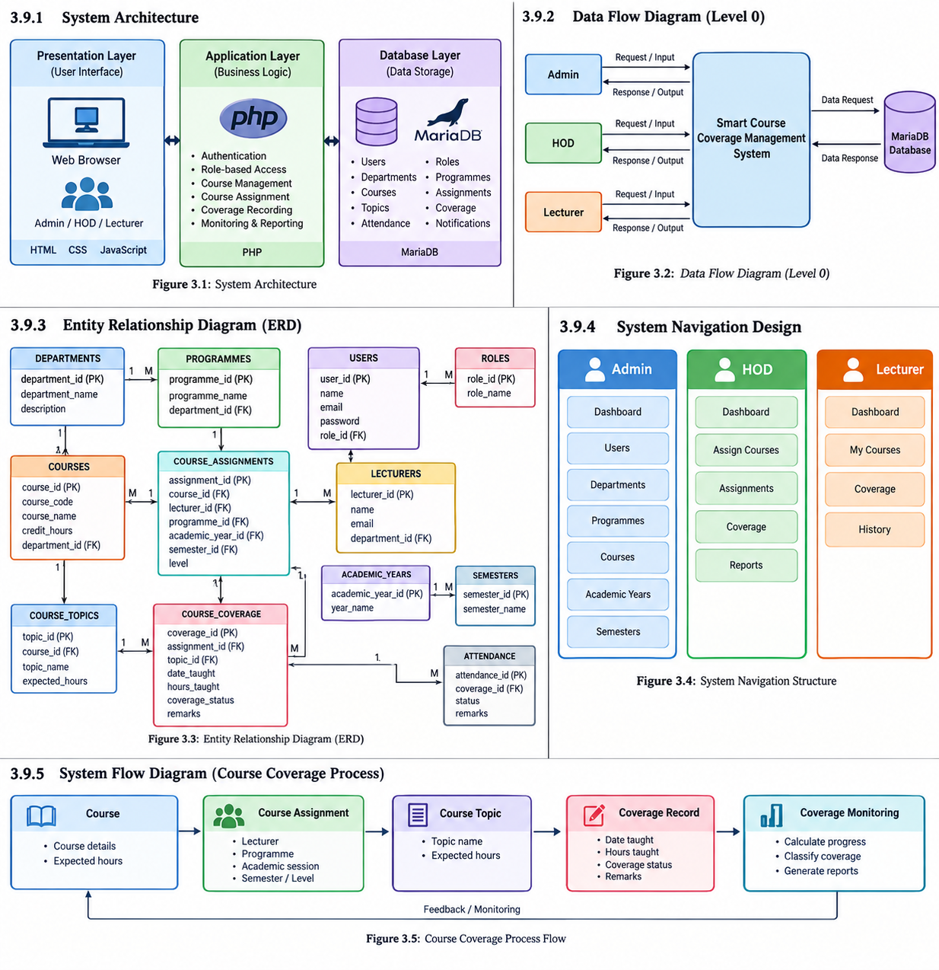

3.10 Use Case Diagram
The Use Case Diagram illustrates the functional interaction between the three categories of users and the Smart Course Coverage Management System. The three actors identified in the system are Admin, HOD, and Lecturer. Each actor is associated with specific functions according to their responsibilities.
The Admin interacts with the system to manage users, departments, programmes, courses, academic years, and semesters, as well as to access the dashboard, change the account password, and log out.
The HOD interacts with the system to access the dashboard, assign courses, manage and view assignments, monitor course coverage, access reports, change the account password, and log out.
The Lecturer interacts with the system to access the dashboard, view assigned courses through My Courses, record course coverage, view coverage history, change the account password, and log out.
All three actors share common authentication-related functions, including login, password management, and logout. However, access to the remaining functions is controlled according to the user's assigned role.
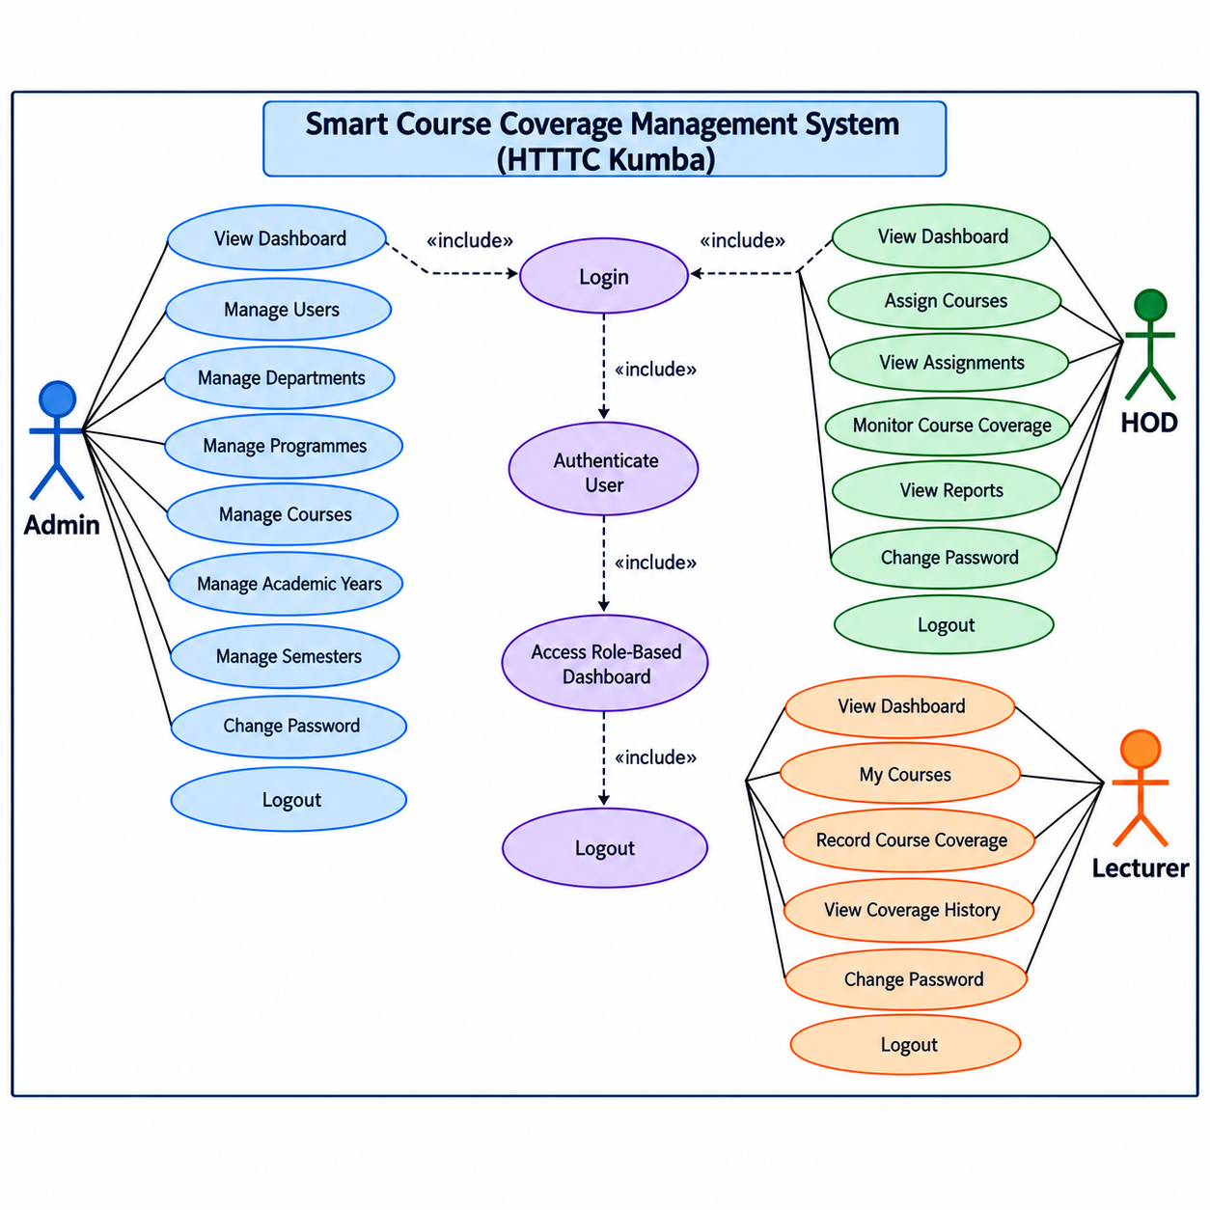Figure 3.9: Use Case Diagram of the Smart Course Coverage Management System
The use case diagram provides a visual representation of the system's functional requirements and demonstrates how the responsibilities of Admin, HOD, and Lecturer are separated within the system. It also illustrates the role-based access structure that forms an important part of the system design.

3.11 Data Flow Diagram
The Data Flow Diagram (DFD) illustrates how information moves between the users, the Smart Course Coverage Management System, and the database. It provides a graphical representation of the major data inputs, processing activities, data storage, and outputs within the proposed system.
The proposed system involves three categories of users: Admin, HOD, and Lecturer. Each user interacts with the system according to the responsibilities associated with the assigned role. The Admin provides information relating to users, departments, programmes, courses, academic years, and semesters. The HOD provides and accesses information relating to course assignments, course coverage, assignments, and reports. The Lecturer accesses assigned courses and provides course coverage information, including the topics taught, date taught, hours taught, coverage status, and remarks.
The system processes the information submitted by users and communicates with the database to store, retrieve, and update relevant records. The database serves as the central storage location for the information required by the system. The processed information is then returned to the appropriate user through the system interface.
The major data flows represented in the diagram include login credentials, authentication results, academic information, course assignment information, course coverage records, reports, and responses generated by the system. This structure ensures that information is exchanged between authorized users and the system in an organized manner.
The DFD also demonstrates the centralized nature of the proposed system. Instead of depending primarily on manually maintained logbooks, course coverage information is processed and stored electronically in a structured database. This makes it possible for authorized users to access relevant information according to their roles.
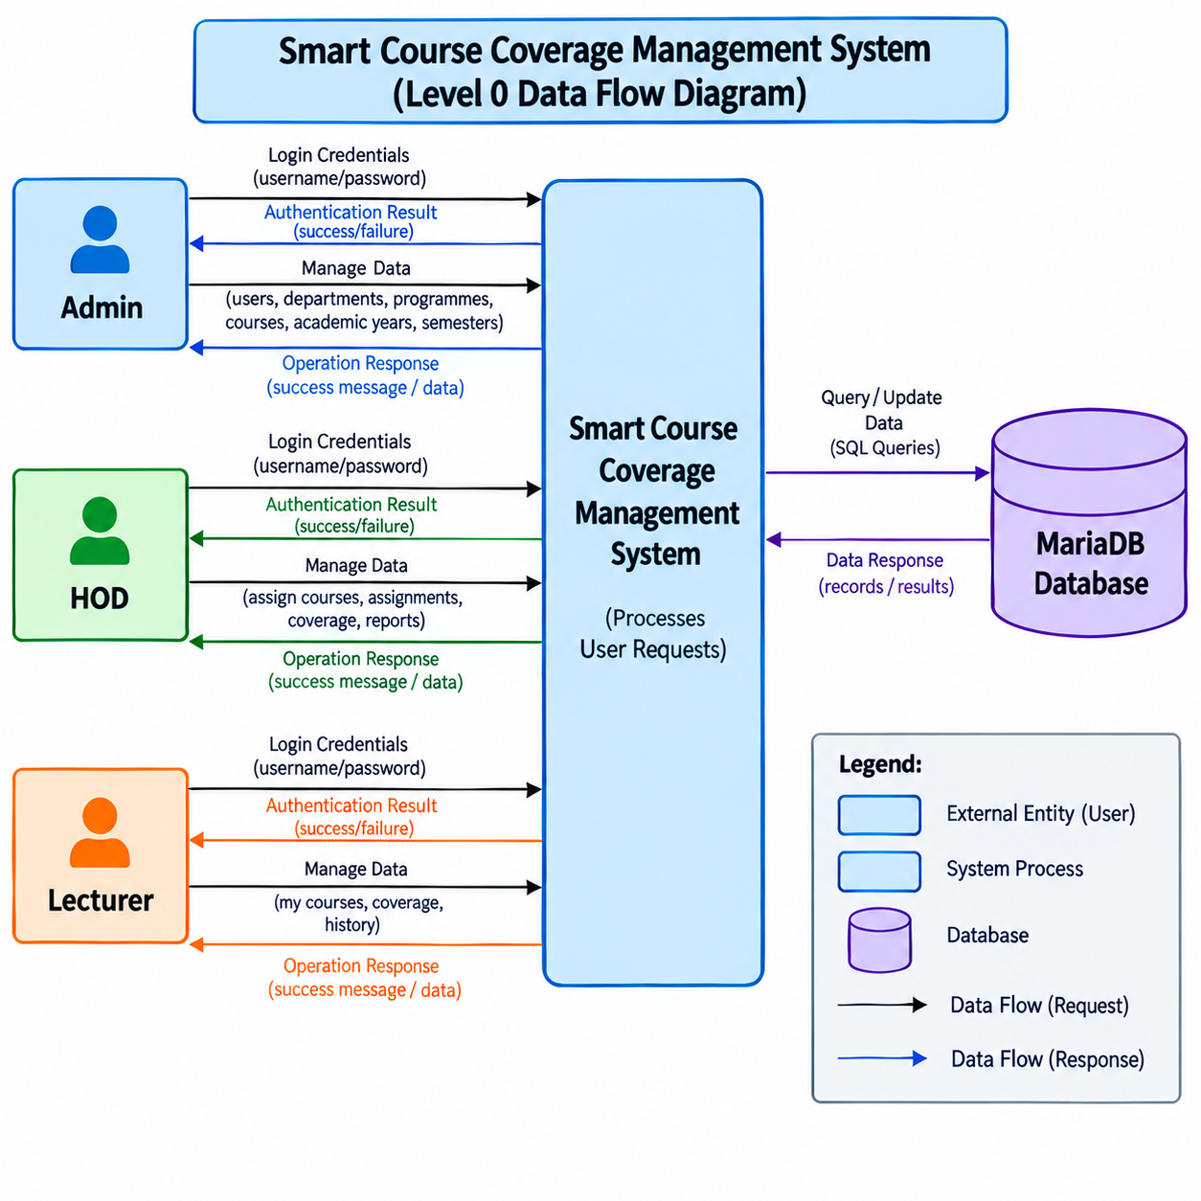Figure 3.10: Data Flow Diagram of the Smart Course Coverage Management System
The Data Flow Diagram provides an overview of the movement and processing of information within the proposed system. It therefore serves as an important design model for understanding how Admin, HOD, and Lecturer interact with the system and how their information is stored and processed.

3.12 Activity Diagram
The Activity Diagram illustrates the sequence of activities performed within the Smart Course Coverage Management System, from user authentication to the completion of the required system operation. It provides a graphical representation of the workflow followed by the different users of the system.
The activity begins when a user accesses the system login page and provides the required login credentials. The system validates the credentials and determines the role associated with the account. If the credentials are invalid, the system rejects the login attempt and requires the user to provide valid credentials. If the credentials are valid, the user is granted access to the appropriate role-based dashboard.
After successful authentication, the system directs the user to the appropriate interface according to the assigned role. The Admin accesses administrative functions such as managing users, departments, programmes, courses, academic years, and semesters. The HOD accesses functions related to course assignments, course coverage monitoring, assignments, and reports. The Lecturer accesses assigned courses, records course coverage information, and views coverage history.
For course coverage recording, the Lecturer selects an assigned course and the relevant course topic before entering the required coverage information. The information includes the date taught, hours taught, coverage status, and remarks. The system validates the information before storing the coverage record in the database.
The HOD can subsequently access the stored course coverage information to monitor the progress of assigned courses and view relevant reports. The system processes the stored information and provides the appropriate results through the user's interface.
The activity continues until the user completes the required operation and logs out of the system. The logout operation terminates the active session and prevents further access to protected system functions until the user authenticates again.
The major activities represented in the proposed workflow are therefore:
Start → Login → Validate Credentials → Identify User Role → Access Role-Based Dashboard → Perform Role-Specific Activity → Process and Store Data → Display Result → Logout → End
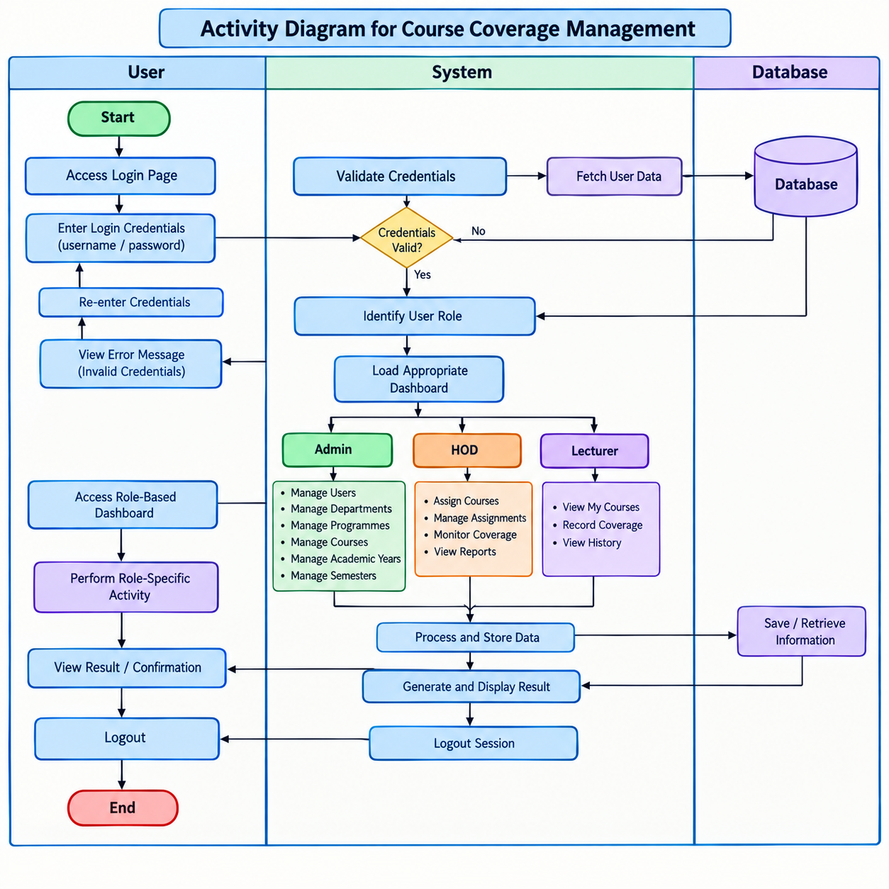Figure 3.11: Activity Diagram of the Smart Course Coverage Management System
The Activity Diagram provides a clear representation of the operational workflow of the proposed system. It shows how authentication, role identification, course management, course coverage recording, monitoring, and logout are connected within the system.

3.13 Sequence Diagram
A sequence diagram is used to illustrate the interaction between users and the Smart Course Coverage Management System in a chronological order. It shows how users initiate actions, how the system processes requests, and how information is retrieved from or stored in the database. The sequence diagram for the proposed system focuses on the major interaction involved in accessing the system, performing role-specific activities, and managing course coverage information.
The main participants represented in the sequence are the Admin, HOD, Lecturer, Smart Course Coverage Management System, and Database. The three system users interact with the system according to their assigned roles and responsibilities.
The sequence begins when an authorized user accesses the login page and provides the required login credentials. The system validates the credentials against the user information stored in the database. When the credentials are valid, the system identifies the user's role and displays the appropriate dashboard. If the credentials are invalid, the system displays an error message and allows the user to try again.
After successful authentication, the system provides role-specific functions. The Admin can access functions for managing users, departments, programmes, courses, academic years, and semesters. The HOD can manage course assignments, monitor course coverage, review coverage information, and access reports. The Lecturer can view assigned courses, access relevant course topics, record course coverage, and view coverage history.
When a lecturer records course coverage, the system receives information such as the course assignment, course topic, date taught, hours taught, coverage status, and remarks. The system validates the information and stores the coverage record in the database. The system can subsequently retrieve the stored information for the lecturer's history and for HOD monitoring and reporting.
For coverage monitoring, the system retrieves the relevant course assignment, topic, expected hours, and recorded hours from the database. It processes the information to determine the progress of the course and presents the resulting information to the authorized user. This allows course coverage information to be monitored in an organized manner.
The sequence ends when the user logs out. The system terminates the active session and returns the user to the login page. This interaction sequence demonstrates how authentication, role-based access, course management, course assignment, course coverage recording, monitoring, and information retrieval are connected within the proposed system.
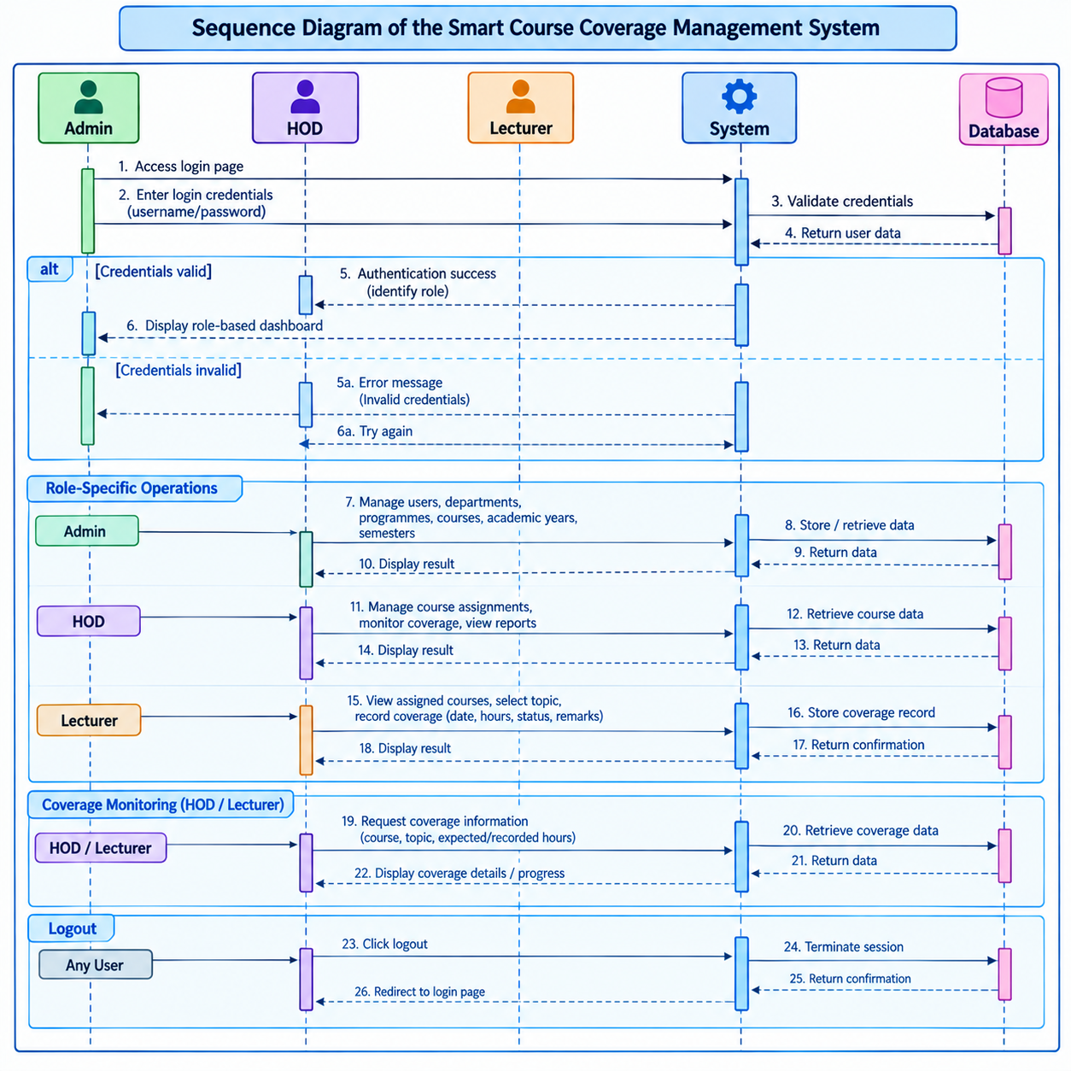
Figure 3.12: Sequence Diagram of the Smart Course Coverage Management System

3.13.1 Summary of the Sequence
The sequence diagram therefore provides a chronological representation of the major interactions within the Smart Course Coverage Management System. It demonstrates how the Admin, HOD, and Lecturer communicate with the system and how the system communicates with the database to process and manage course coverage information. The diagram also emphasizes the role-based nature of the proposed system and the flow of information from user input to database processing and system output.

3.14 Database Design
The database design defines how information required by the Smart Course Coverage Management System is organized, stored, related, and retrieved. The system uses a relational database approach in which information is divided into related tables. This structure helps reduce unnecessary duplication, maintain data consistency, and support efficient retrieval of course coverage information.
The database for the system is named course_coverage_management_system and is implemented using MariaDB. It contains tables for managing users, roles, departments, programmes, lecturers, courses, academic sessions, course assignments, course topics, course coverage, attendance, and notifications. The database uses primary keys to uniquely identify records and relationships between related tables to connect academic and course coverage information.
The main database entities are described below.

3.14.1 Roles Table
The roles table stores the roles available within the system. The system defines three user roles: Admin, HOD, and Lecturer. The table contains role_id as its primary key and role_name for identifying the role. The role information is used to determine the functions and access available to each user.

3.14.2 Users Table
The users table stores the accounts used to authenticate users of the system. Its main attributes include user_id, full_name, email, password, role_id, status, and created_at. The user_id uniquely identifies each user, while role_id associates the user with one of the defined system roles. The email field is uniquely indexed in the database.

3.14.3 Departments Table
The departments table stores information about academic departments. It contains department_id, department_name, and description. The department_id serves as the primary key, while the department name is uniquely indexed to avoid duplicate department names.

3.14.4 Programs Table
The programs table stores academic programme information. Its attributes include program_id, program_name, department_id, and duration. The table therefore provides information that can be associated with departments and used when courses are assigned to lecturers for particular programmes.

3.14.5 Lecturers Table
The lecturers table stores information about lecturers. The main attributes are lecturer_id, staff_no, full_name, email, department_id, phone, and status. The lecturer identifier uniquely identifies each lecturer, while the department identifier associates the lecturer with a department. The database also defines uniqueness constraints for lecturer email information.

3.14.6 Courses Table
The courses table stores information about courses offered within the institution. It contains course_id, course_code, course_name, credit_value, department_id, and description. The course identifier serves as the primary key, while the course code is uniquely indexed.

3.14.7 Academic Session Table
The academic_session table stores information about academic sessions. It contains information such as the session identifier, session name, starting date, ending date, and status. The session identifier is the primary key, while the session name is uniquely indexed. This table allows course assignments and coverage information to be associated with a particular academic session.

3.14.8 Course Assignment Table
The database uses the table name course_assgnment for storing course assignment information. The table contains assignment_id, course_id, lecturer_id, program_id, session_id, semester, and level. The assignment identifier serves as the primary key.
This table is important because it connects a course with a lecturer, programme, academic session, semester, and level. It therefore provides the basis for determining which lecturer is responsible for a particular course in a particular academic context.

3.14.9 Course Topics Table
The database uses the table name cousre_topics for storing individual topics belonging to courses. The table contains topic_id, course_id, topic_number, topic_title, description, and expected_hours.
The expected_hours field is particularly important for course coverage monitoring because it represents the expected teaching hours associated with a topic. The actual database name cousre_topics is retained in this report because it is the name defined in the implemented database.

3.14.10 Course Coverage Table
The course_coverage table stores records of course coverage activities. Its main attributes include coverage_id, assignment_id, topic_id, date_taught, hours_taught, coverage_status, remarks, updated_by, and updated_at.
This table connects a coverage record to a course assignment and a particular course topic. The date_taught field records when the topic was taught, while hours_taught records the actual teaching hours. The coverage_status and remarks fields provide additional information about the recorded coverage.

3.14.11 Attendance Table
The attendance table stores attendance-related information associated with course assignments and lecturers. Its fields include attendance_id, assignment_id, lecturer_id, class_date, start_time, end_time, status, and remarks. The table provides a structured location for storing attendance information within the database.

3.14.12 Notifications Table
The notifications table stores notification information associated with system users. Its fields include notification_id, user_id, title, message, notification_type, is_read, and created_at. This structure allows notification information to be associated with individual users and provides fields for recording whether a notification has been read.

3.14.13 Database Relationships
The tables are designed to work together to support the flow of course coverage information. A role can be associated with users, while departments can be associated with programmes, lecturers, and courses. Courses can have multiple topics, while course assignments connect courses with lecturers, programmes, academic sessions, semesters, and levels.
Course coverage records are associated with both course assignments and course topics. This relationship allows the system to determine what course is being taught, which lecturer is responsible for the course, which topic is being covered, and how many hours have been recorded.
The general relationship can therefore be represented as:
Department → Programme
Department → Lecturer
Department → Course
Role → User
Course → Course Topic
Course → Course Assignment
Lecturer → Course Assignment
Programme → Course Assignment
Academic Session → Course Assignment
Course Assignment → Course Coverage
Course Topic → Course Coverage

3.14.14 Primary Keys and Data Integrity
Primary keys are used to uniquely identify records within the database. The implemented database defines primary keys for the major entities, including user_id, role_id, department_id, program_id, lecturer_id, course_id, session_id, assignment_id, topic_id, and coverage_id. Auto-increment properties are also defined for these identifiers.
Unique constraints are also used for selected fields, including role names, department names, course codes, session names, and user email addresses. These constraints help reduce duplicate records and support data integrity.

3.14.15 Database Design Summary
The database design provides a structured foundation for the Smart Course Coverage Management System. It organizes user information, academic structures, course assignments, course topics, and course coverage records into related entities. This structure supports the major activities of the system, including authentication, course assignment, course coverage recording, progress monitoring, and retrieval of historical coverage information.
The Entity Relationship Diagram presented in the following section provides a graphical representation of the major entities and their relationships within the database.
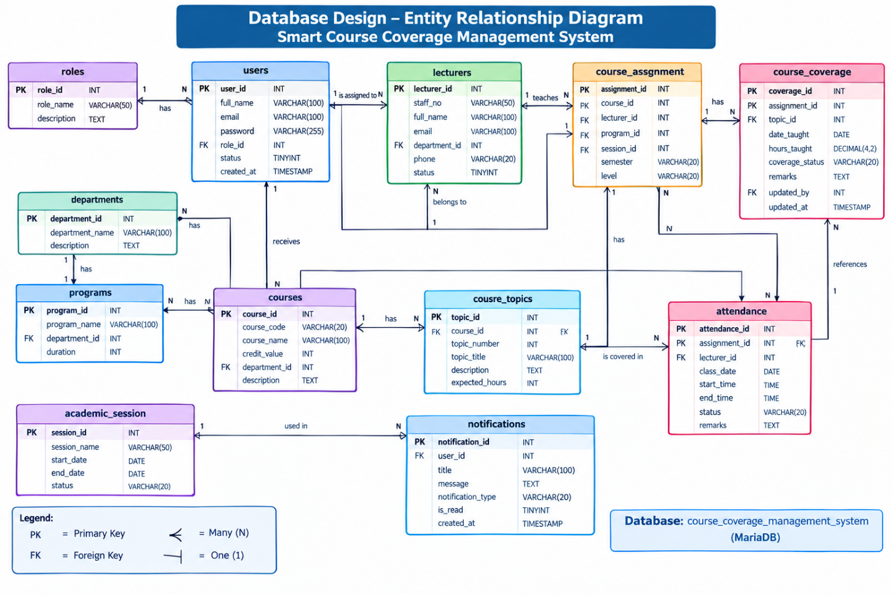
Figure 3.14: Database Design - Entity Relationship Diagram of the Smart Course Coverage Management System

3.15 Entity Relationship Diagram
The Entity Relationship Diagram (ERD) provides a graphical representation of the entities within the Smart Course Coverage Management System database and the relationships between them. It shows how the major categories of information are organized and connected to support the management of users, academic structures, course assignments, course topics, and course coverage.
The ERD is based on the relational database structure implemented for the system. The main entities represented include Roles, Users, Departments, Programs, Lecturers, Courses, Academic Sessions, Course Assignments, Course Topics, Course Coverage, Attendance, and Notifications.
Each entity contains attributes that describe the information stored in the corresponding database table. Primary keys are used to uniquely identify records, while foreign-key fields identify relationships with related entities.

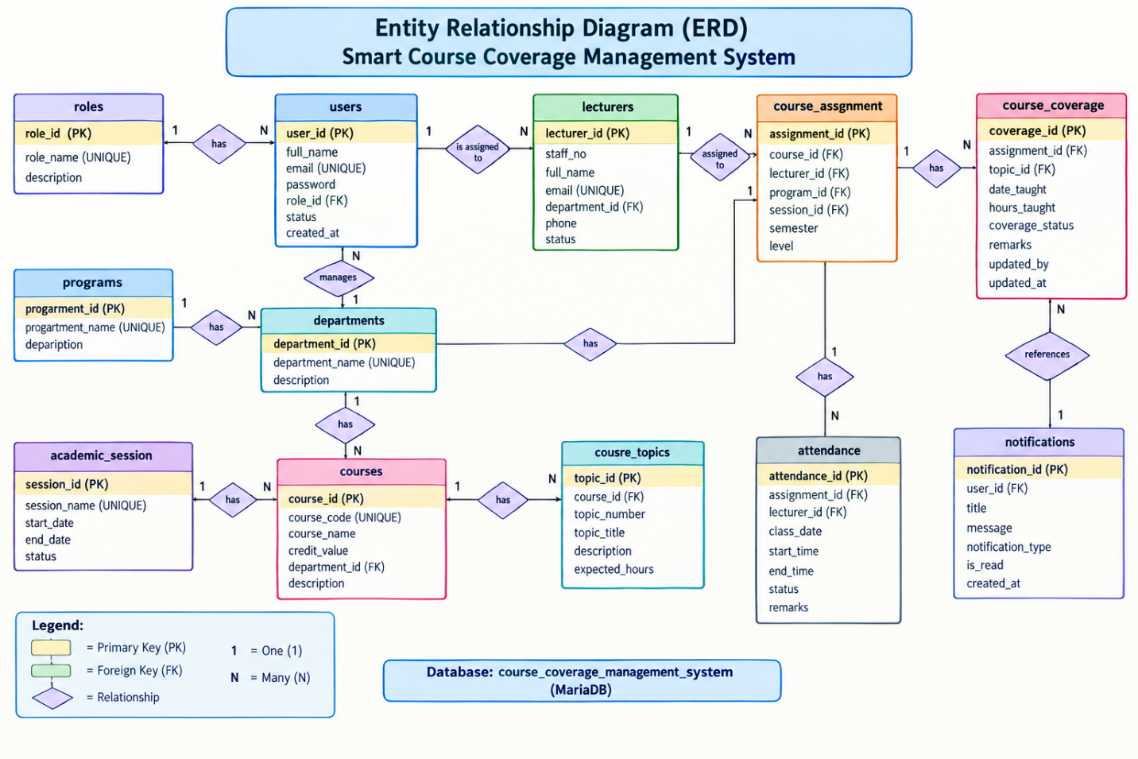
Figure 3.15: Entity Relationship Diagram of the Smart Course Coverage Management System

3.15.1 Role and User Relationship
The Roles entity defines the system roles available to users, namely Admin, HOD, and Lecturer. The Users entity contains user account information and includes role_id, which associates a user with a role.
Conceptually, one role can be associated with multiple users, while each user is associated with a particular role.

3.15.2 Department Relationships
The Departments entity provides the academic organizational structure of the system. Departments are associated with Programs, Lecturers, and Courses.
A department can have multiple programmes, lecturers, and courses. The corresponding department identifier is used to associate these records with their department.

3.15.3 Course and Course Topic Relationship
The Courses entity stores course information, while the cousre_topics entity stores the individual topics belonging to each course.
One course can contain multiple course topics. Each course topic is associated with a particular course through course_id. The topic information includes the topic number, title, description, and expected teaching hours.

3.15.4 Course Assignment Relationships
The course_assgnment entity connects courses with lecturers, programmes, and academic sessions. It also stores the semester and level associated with an assignment.
A course assignment therefore provides the academic context in which a particular lecturer is assigned to teach a course. The assignment identifier is subsequently used by course coverage records to identify the relevant teaching assignment.

3.15.5 Course Coverage Relationship
The course_coverage entity records the actual teaching coverage of course topics. Each coverage record is associated with a course assignment and a course topic.
The entity stores information such as the date taught, hours taught, coverage status, remarks, the user who updated the record, and the update date.
This relationship is important because it connects the planned course structure with the actual teaching activities recorded in the system.

3.15.6 Academic Session Relationship
The academic_session entity stores information about academic sessions, including the session name, start date, end date, and status.
Academic sessions are associated with course assignments so that assignments can be identified according to the academic period in which they are applicable.

3.15.7 Attendance Relationship
The attendance entity stores attendance-related information associated with course assignments and lecturers. It contains information such as class date, starting time, ending time, attendance status, and remarks.
This allows attendance information to be organized in relation to the corresponding course assignment and lecturer.

3.15.8 Notification Relationship
The notifications entity stores notifications associated with system users. Each notification contains information such as its title, message, notification type, read status, and creation date.
The user_id field associates notification records with the users to whom the notifications belong.

3.15.9 Overall Database Relationship
The relationships represented in the ERD provide an organized structure for managing course coverage information. The general flow begins with the institutional structure of departments and programmes, continues through courses and course assignments, and leads to course topics and course coverage records.
The relationship can be summarized as follows:
Department → Programme
Department → Lecturer
Department → Course
Role → User
Course → Course Topic
Course → Course Assignment
Lecturer → Course Assignment
Programme → Course Assignment
Academic Session → Course Assignment
Course Assignment → Course Coverage
Course Topic → Course Coverage
Course Assignment → Attendance
Lecturer → Attendance
User → Notification

3.15.10 Importance of the ERD
The ERD provides a clear representation of how the database supports the operations of the Smart Course Coverage Management System. It helps ensure that related information can be connected and retrieved efficiently. It also provides a foundation for database implementation, maintenance, and future development of the system.
The ERD therefore serves as an important design reference for understanding how users, academic information, course assignments, teaching topics, and course coverage records are organized within the system.

3.16 Project Schedule
The project schedule presents the major activities undertaken during the development of the Smart Course Coverage Management System. It provides a structured plan for organizing the project activities from the initial identification of the problem through system analysis, design, implementation, testing, documentation, and final preparation for defence.
The project follows an iterative and incremental development approach. Consequently, some activities are reviewed and refined as development progresses. The major activities include problem identification, preliminary study, literature review, requirements analysis, system design, database development, system implementation, testing and debugging, system refinement, documentation, and final preparation for defence.
Table 3.1 presents the approximate schedule of the major project activities.
Table 3.1: Project Schedule
No. | Project Activity | Start Date | End Date | Status
1 | Problem Identification and Definition | 05 January 2027 | 15 January 2027 | Completed
2 | Preliminary Study and Information Gathering | 12 January 2027 | 29 January 2027 | Completed
3 | Literature Review | 20 January 2027 | 12 February 2027 | Completed
4 | Requirements Analysis | 05 February 2027 | 19 February 2027 | Completed
5 | Analysis of Existing System | 12 February 2027 | 26 February 2027 | Completed
6 | System Design | 20 February 2027 | 12 March 2027 | Completed
7 | Database Design and Development | 01 March 2027 | 19 March 2027 | Completed
8 | System Implementation | 15 March 2027 | 23 April 2027 | In Progress
9 | System Testing and Debugging | 12 April 2027 | 30 April 2027 | In Progress
10 | System Refinement and Improvement | 24 April 2027 | 07 May 2027 | Planned
11 | Project Documentation | 01 May 2027 | 14 May 2027 | Planned
12 | Final Review and Preparation for Defence | 15 May 2027 | 28 May 2027 | Planned

3.16.1 Description of Project Activities
Problem Identification and Definition:
This stage involved identifying the problem associated with the management and monitoring of course coverage and defining the focus of the project at HTTTC Kumba.
Preliminary Study and Information Gathering:
Relevant information concerning course coverage management, users, academic activities, and the existing logbook-based approach was gathered to provide a basis for analyzing the existing system.
Literature Review:
Relevant academic and technical materials were reviewed to establish the conceptual and theoretical foundation of the study and to examine existing approaches to course and academic information management.
Requirements Analysis:
The requirements of the proposed system were identified and organized into functional and non-functional requirements. The responsibilities of the Admin, HOD, and Lecturer were also considered.
Analysis of Existing System:
The existing logbook-based course coverage approach was examined to identify its limitations and establish the need for a computerized solution.
System Design:
The system architecture, user interactions, data flow, activities, sequence of operations, database structure, and other design components were developed.
Database Design and Development:
The relational database for the system was designed and implemented. The database contains structures for users, roles, departments, programmes, lecturers, courses, academic sessions, course assignments, course topics, course coverage, attendance, and notifications.
System Implementation:
The proposed system was implemented using the selected development technologies and tools. The major user interfaces and system modules were developed according to the identified requirements.
System Testing and Debugging:
The implemented system was tested to identify functional errors, navigation problems, data-related issues, authentication problems, and other defects. Identified problems were corrected during the development process.
System Refinement and Improvement:
The system was reviewed and improved based on testing results. Interfaces, navigation, functionality, and system behavior were refined where necessary.
Project Documentation:
The project report was prepared to document the study, system analysis, design, implementation, testing, results, conclusion, and recommendations.
Final Review and Preparation for Defense:
The final stage involves reviewing the completed project, correcting documentation errors, organizing supporting materials, and preparing the project for presentation and defence.

3.16.2 Schedule Representation
The project activities can also be presented using a Gantt chart to provide a visual representation of the planned timing and duration of each activity.
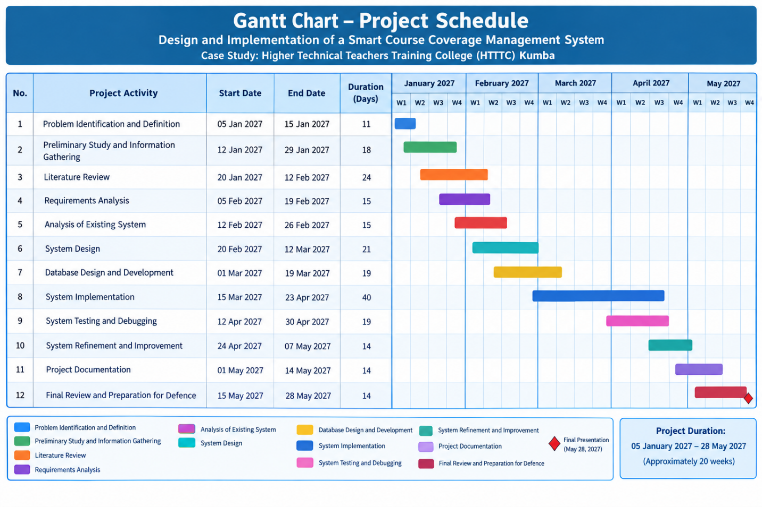The project schedule provides a systematic framework for managing the different stages of the Smart Course Coverage Management System. It also supports the iterative development methodology by allowing implementation, testing, correction, and refinement activities to occur progressively before the final project presentation in May 2027.

3.17 Cost Evaluation
Cost evaluation involves estimating the resources and expenses required for the development of the Smart Course Coverage Management System. It provides an overview of the financial resources required for activities such as system development, internet access, electricity, transportation, documentation, printing, and other project-related requirements.
Most of the software technologies used in the development of the system, including PHP, HTML, CSS, JavaScript, XAMPP, MariaDB, phpMyAdmin, and Visual Studio Code, are freely available. Consequently, the major estimated costs are associated with hardware usage, connectivity, electricity, transportation, documentation, and other development activities.
The estimated project costs are presented in Table 3.2.
Table 3.2: Estimated Project Cost
No. | Item/Resource | Estimated Cost (XAF)
1 | Computer/Laptop usage and maintenance | 250,000
2 | Internet/Data subscription | 20,000
3 | Electricity/Power supply | 30,000
4 | Transportation and information gathering | 20,000
5 | Printing and photocopying | 35,000
6 | Project report binding and documentation | 25,000
7 | Stationery and other materials | 20,000
8 | Software and development tools | 0
9 | Testing and miscellaneous development expenses | 10,000
 | Estimated Total | 435,000

3.17.1 Hardware Cost
The computer or laptop represents an important resource required for the development of the system. It is used for writing source code, designing the database, running the XAMPP development environment, testing the system, preparing documentation, and carrying out debugging activities. An estimated amount of 250,000 XAF is allocated to computer/laptop usage and maintenance.

3.17.2 Internet and Connectivity Cost
Internet connectivity is required for research, downloading development resources, accessing documentation, communicating during the project, and obtaining relevant technical information. An estimated amount of 20,000 XAF is allocated for internet and data services during the project period.

3.17.3 Electricity Cost
Electricity is required to operate the computer and other equipment used during development, testing, documentation, and project preparation. An estimated amount of 30,000 XAF is allocated for electricity and related power requirements.

3.17.4 Transportation Cost
Transportation expenses may arise during information gathering, consultation, project supervision, and other activities related to the development of the system. An estimated amount of 20,000 XAF is allocated for transportation.

3.17.5 Printing and Documentation Cost
Printing and photocopying are required for project documents, drafts, supporting materials, and other academic documentation. An estimated amount of 35,000 XAF is allocated for printing and photocopying.

3.17.6 Binding Cost
The final project report requires proper preparation and binding before submission and defence. An estimated amount of 25,000 XAF is allocated for report binding and related documentation.

3.17.7 Stationery Cost
Stationery such as paper, pens, files, and other materials may be required during the preparation and documentation stages. An estimated amount of 20,000 XAF is allocated for these materials.

3.17.8 Software and Development Tools
The principal development technologies used for the system are freely available or open-source. These include PHP, HTML, CSS, JavaScript, XAMPP, MariaDB, phpMyAdmin, and Visual Studio Code. Therefore, no direct software licensing cost is included in the estimated budget.

3.17.9 Testing and Miscellaneous Expenses
Additional expenses may arise during system testing, debugging, corrections, documentation, and other unforeseen project activities. An estimated amount of 10,000 XAF is allocated for testing and miscellaneous development expenses.

3.17.10 Total Estimated Cost
Based on the estimates presented in Table 3.2, the total estimated cost of developing the Smart Course Coverage Management System is 435,000 XAF.
The cost evaluation provides an approximate financial plan for the project. Actual expenditure may vary depending on the availability of existing resources, changes in data costs, transportation expenses, printing requirements, and other project-related factors.

3.18 Development Tools
The development of the Smart Course Coverage Management System required a combination of programming languages, database technologies, development environments, and supporting software tools. These tools were selected to support the design, implementation, testing, debugging, and maintenance of the system.
The major development tools used in the project are presented below.

3.18.1 PHP 8.0.30
PHP (Hypertext Preprocessor) is the primary server-side programming language used to develop the application. PHP is responsible for processing user requests, implementing system logic, handling authentication, managing sessions, processing forms, communicating with the database, and generating dynamic web pages.
The implemented system uses PHP 8.0.30.

3.18.2 HTML5
HTML (HyperText Markup Language) is used to structure the content and elements of the system's web pages. HTML5 provides the structure for interfaces such as the login page, dashboards, forms, tables, and other system pages.

3.18.3 CSS3
CSS (Cascading Style Sheets) is used to control the presentation and visual appearance of the system. CSS3 is used for page layout, spacing, typography, forms, navigation elements, tables, buttons, and other interface components.

3.18.4 JavaScript (ES6+)
JavaScript is used to provide client-side functionality and interaction within the web interface. ECMAScript 2015 (ES6) and later JavaScript features support interface behaviour, form interactions, validation, and other dynamic functions.

3.18.5 MariaDB 10.4.32
MariaDB is the relational database management system used to store and manage the data of the application. The database stores information relating to users, roles, departments, programmes, lecturers, courses, academic sessions, course assignments, course topics, course coverage, attendance, and notifications.
The implemented project uses MariaDB 10.4.32.

3.18.6 phpMyAdmin 5.2.1
phpMyAdmin is used as the database management interface for creating, importing, viewing, and managing the project's database. The project uses phpMyAdmin 5.2.1.

3.18.7 XAMPP 8.0.30
XAMPP provides the local development environment used to run the web application. The XAMPP 8.0.30 package used for the project provides the required Apache, MariaDB, PHP, and phpMyAdmin components.

3.18.8 Apache 2.4.58
Apache is the web server used to execute and serve the PHP application in the local development environment. The XAMPP package used for the project includes Apache 2.4.58.

3.18.9 Visual Studio Code 1.138.0
Visual Studio Code is the code editor used for writing, editing, organizing, and debugging the project's source code. The stable version 1.138.0 was released on September 16, 2026.

3.18.10 Web Browser
A modern web browser is used to access and test the system's user interfaces. It allows the developer to interact with the application and verify functions such as authentication, navigation, forms, dashboards, course management, and course coverage recording.

3.18.11 Development Tools Summary
Table 3.3: Development Tools and Their Versions
No. | Tool/Technology | Version | Purpose
1 | PHP | 8.0.30 | Server-side application development
2 | HTML | HTML5 | Structuring web pages
3 | CSS | CSS3 | Interface styling and layout
4 | JavaScript | ES6+ | Client-side interaction
5 | MariaDB | 10.4.32 | Database management
6 | phpMyAdmin | 5.2.1 | Database administration
7 | XAMPP | 8.0.30 | Local development environment
8 | Apache | 2.4.58 | Web server
9 | Visual Studio Code | 1.138.0 | Source-code editing
10 | Web Browser | Modern browser | System access and testing

3.18.12 Summary
The combination of these tools provides the technical environment required for implementing the Smart Course Coverage Management System. PHP handles the application logic, HTML5 and CSS3 provide the structure and presentation of the interfaces, JavaScript supports client-side interaction, while MariaDB manages the application's data. XAMPP, Apache, phpMyAdmin, Visual Studio Code, and a web browser provide the supporting environment for development, database management, and testing.

CHAPTER FOUR

IMPLEMENTATION, RESULTS AND TESTING

4.1 Introduction
This chapter presents the implementation, results, and testing of the Smart Course Coverage Management System developed for Higher Technical Teachers Training College (HTTTC) Kumba. The implementation is based on the requirements and system design presented in Chapter Three. The system was developed as a web-based application using PHP, HTML, CSS and JavaScript, with MariaDB used for database management.
The chapter describes how the designed system was transformed into a functional application. It presents the major system interfaces and explains the functions available to the three categories of users: Admin, HOD (Head of Department), and Lecturer. The chapter also presents the implementation of course management, course assignment, course coverage recording, coverage history, and progress monitoring.
Particular attention is given to the implementation of the course coverage process. The system provides a structured method for associating courses with lecturers, programmes, academic sessions, semesters and levels, while course topics and coverage records are maintained in the database. Coverage information includes the date taught, hours taught, coverage status and remarks. The system uses the recorded teaching hours and expected course hours to support course progress monitoring.
The chapter further presents the testing process used to verify that the implemented system performs its intended functions. Testing covers important areas such as authentication, role-based access, course management, course assignment, course coverage recording, data storage, coverage history and system navigation. The results of the tests will be used to determine whether the implemented functions satisfy the specified system requirements.
The chapter is organized into sections covering system implementation, user interfaces, major system modules, testing, test results and discussion of the results.

4.2 System Implementation
The implementation of the Smart Course Coverage Management System involved converting the requirements and designs presented in Chapter Three into a functional web-based application. The system was developed using PHP for server-side processing, HTML and CSS for the structure and presentation of the interfaces, JavaScript for client-side interactions, and MariaDB for storing and managing system data. The application was developed and tested within the XAMPP environment, using Apache as the web server and phpMyAdmin for database administration.
The implementation was organized around the three identified categories of system users: Admin, HOD (Head of Department), and Lecturer. Each user is authenticated through the login interface and is provided with access to functions corresponding to the user's role. This role-based structure helps ensure that users interact only with the functions relevant to their responsibilities.

4.2.1 System Environment
The system operates within a web-based client-server environment. The user accesses the application through a web browser, while the PHP application processes requests and communicates with the MariaDB database. Apache provides the web-server environment required to execute the PHP application.
The main implementation environment consists of PHP 8.0.30, MariaDB 10.4.32, phpMyAdmin 5.2.1, Apache, HTML5, CSS3, JavaScript and XAMPP. Visual Studio Code was used as the development environment.
The general implementation flow can be represented as follows:
User → Web Browser → Apache/PHP Application → MariaDB Database → PHP Application → Web Browser
This structure enables the system to receive user requests, process the required operations, retrieve or update information in the database, and present the resulting information through the appropriate system interface.

4.2.2 Database Implementation
The database component was implemented using MariaDB. The database created for the system is named course_coverage_management_system. It stores the information required for user management, academic information, course assignments and course coverage monitoring.
The implemented database contains tables for roles, users, departments, programmes, lecturers, courses, academic sessions, course assignments, course topics, course coverage, attendance and notifications. These tables provide the data structures required to establish relationships between users, courses, lecturers, programmes, academic sessions and course coverage records.
Primary keys are used to uniquely identify records, while foreign keys establish relationships between related records. This structure allows course coverage information to be associated with the appropriate course assignment and course topic.

4.2.3 Authentication and Role-Based Access Implementation
Authentication was implemented to control access to the system. Users provide their email address and password through the login interface. The system verifies the supplied credentials and identifies the user's role before providing access to the appropriate dashboard.
The system supports three roles:
- Admin – responsible for administrative and academic information management.
- HOD – responsible for course assignment, course coverage monitoring and reports.
- Lecturer – responsible for accessing assigned courses and recording course coverage.
Role-based access ensures that the functions available after login correspond to the user's assigned role. The system also provides a password-change function for authenticated users and supports logout to terminate the active session.

4.2.4 Admin Module Implementation
The Admin module provides functions for managing major administrative and academic information required by the system. The Admin interface includes access to the dashboard, users, departments, programmes, courses, academic years and semesters.
Through this module, the Admin can maintain the basic information required for the operation of the course coverage management process. The information managed through these functions provides the foundation upon which courses can be assigned and course coverage can subsequently be recorded and monitored.

4.2.5 HOD Module Implementation
The HOD module provides functions related to course assignment and monitoring of course coverage. The HOD interface provides access to the dashboard, course assignment functions, assignments, coverage and reports.
The course assignment functions support the association of courses with lecturers, programmes, academic sessions, semesters and levels. The coverage and reporting functions provide the HOD with access to course progress information recorded within the system.

4.2.6 Lecturer Module Implementation
The Lecturer module provides functions that allow lecturers to work with courses assigned to them. The Lecturer interface includes the dashboard, My Courses, Coverage and History.
The lecturer can access assigned courses and record relevant course coverage information. A coverage record contains information such as the topic taught, date taught, hours taught, coverage status and remarks. Recorded information is stored in the database and can subsequently be accessed through the coverage history.

4.2.7 Course Coverage Implementation
Course coverage is one of the central functions of the system. The implementation links course assignments with course topics and coverage records. When coverage information is recorded, the system stores the associated assignment, topic, date taught, hours taught, coverage status, remarks and other relevant information.
The system also supports progress monitoring by comparing the hours taught with the expected hours associated with course topics. This provides a structured basis for monitoring the progress of course delivery.
The implemented coverage classification is based on the following ranges:
Coverage Percentage | Classification
75% and above | Excellent
50%–74% | Good
25%–49% | Average
Below 25% | Poor
Courses with coverage below 50% can also be identified as low-coverage courses for monitoring purposes.

4.2.8 Security and Data Management
Security considerations were incorporated into the implementation through user authentication, role-based access control, password protection and session management. Passwords are handled using secure password hashing rather than storing passwords as plain text.
The system also uses controlled access to protected pages so that authenticated users can access functions according to their assigned roles. Data entered through the application is stored in the centralized database, allowing related academic and course coverage information to be maintained in an organized manner.

4.2.9 Summary of System Implementation
The implementation transformed the system design into a functional web-based course coverage management application. The implemented structure provides separate functions for Admin, HOD and Lecturer users while maintaining a centralized database for managing academic and course coverage information. The following sections present the major interfaces and functional modules of the implemented system.

4.3 System Interfaces
The Smart Course Coverage Management System provides a set of web-based interfaces through which authorized users interact with the system. The interfaces were designed according to the different responsibilities of the three system roles: Admin, HOD (Head of Department), and Lecturer.
The system uses a login interface as the main entry point. After successful authentication, the user is directed to the dashboard corresponding to the assigned role. Each dashboard provides access to the functions available to that particular user.

4.3.1 Login Interface
The login interface provides the authentication point for accessing the system. It requires the user to provide an email address and password. The system verifies the submitted credentials and identifies the user's role before granting access.
After successful authentication, the user is redirected to the appropriate dashboard. The system therefore uses the login process to ensure that only authorized users can access protected system functions.

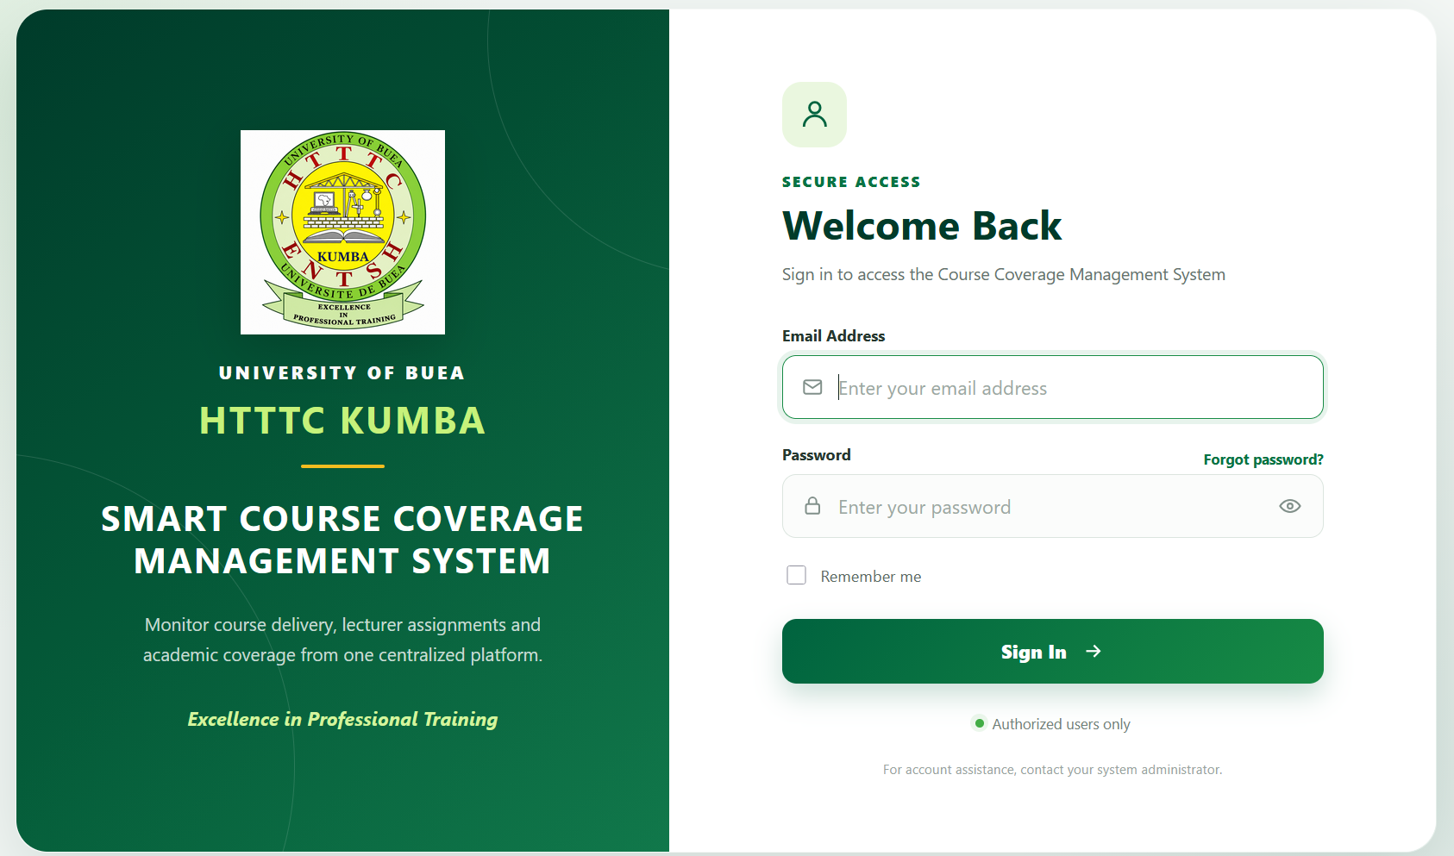

4.3.2 Dashboard Interfaces
After authentication, each user is presented with a dashboard appropriate to their role. The dashboard serves as the main navigation point and provides access to the functions available to the user.
The Admin dashboard provides access to administrative and academic management functions. The HOD dashboard provides access to course assignment, coverage monitoring and reporting functions, while the Lecturer dashboard provides access to assigned courses, coverage recording and coverage history.

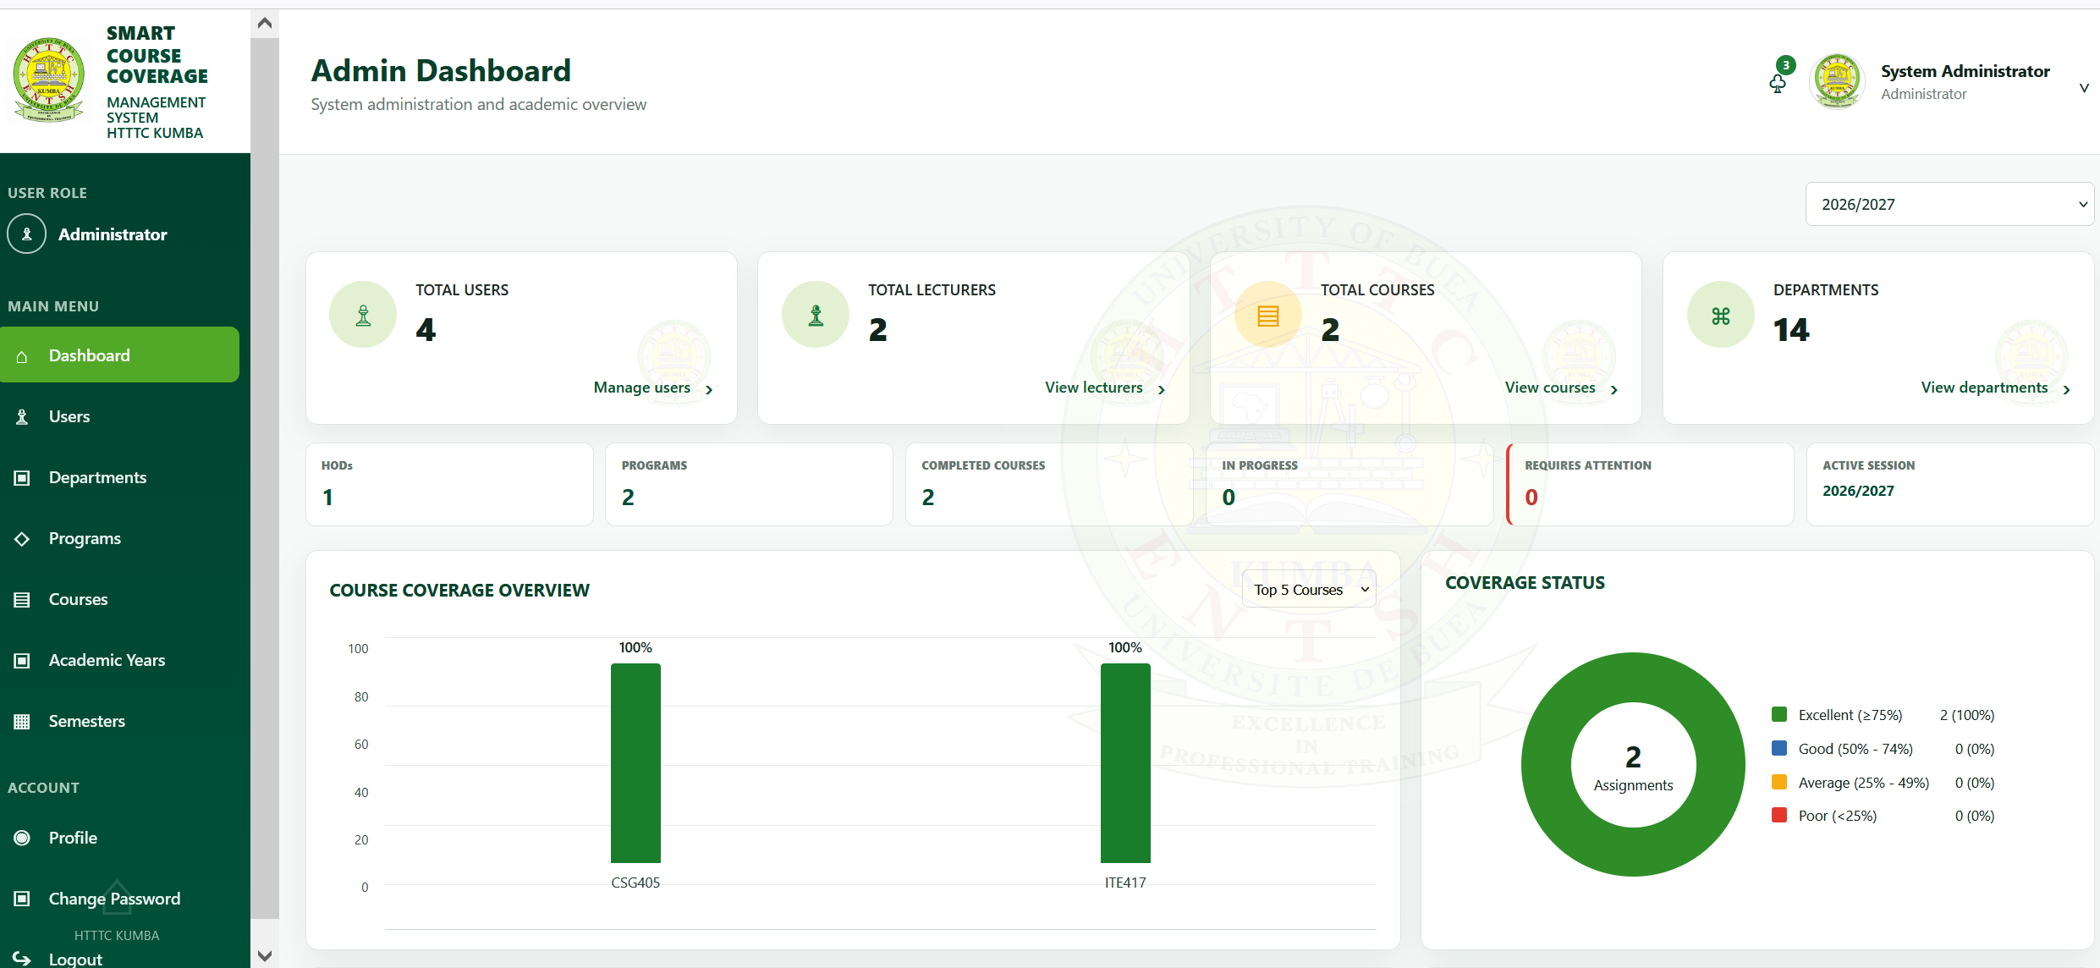

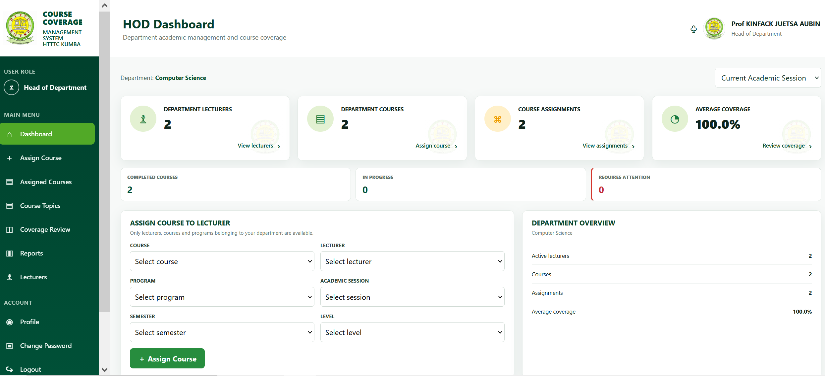

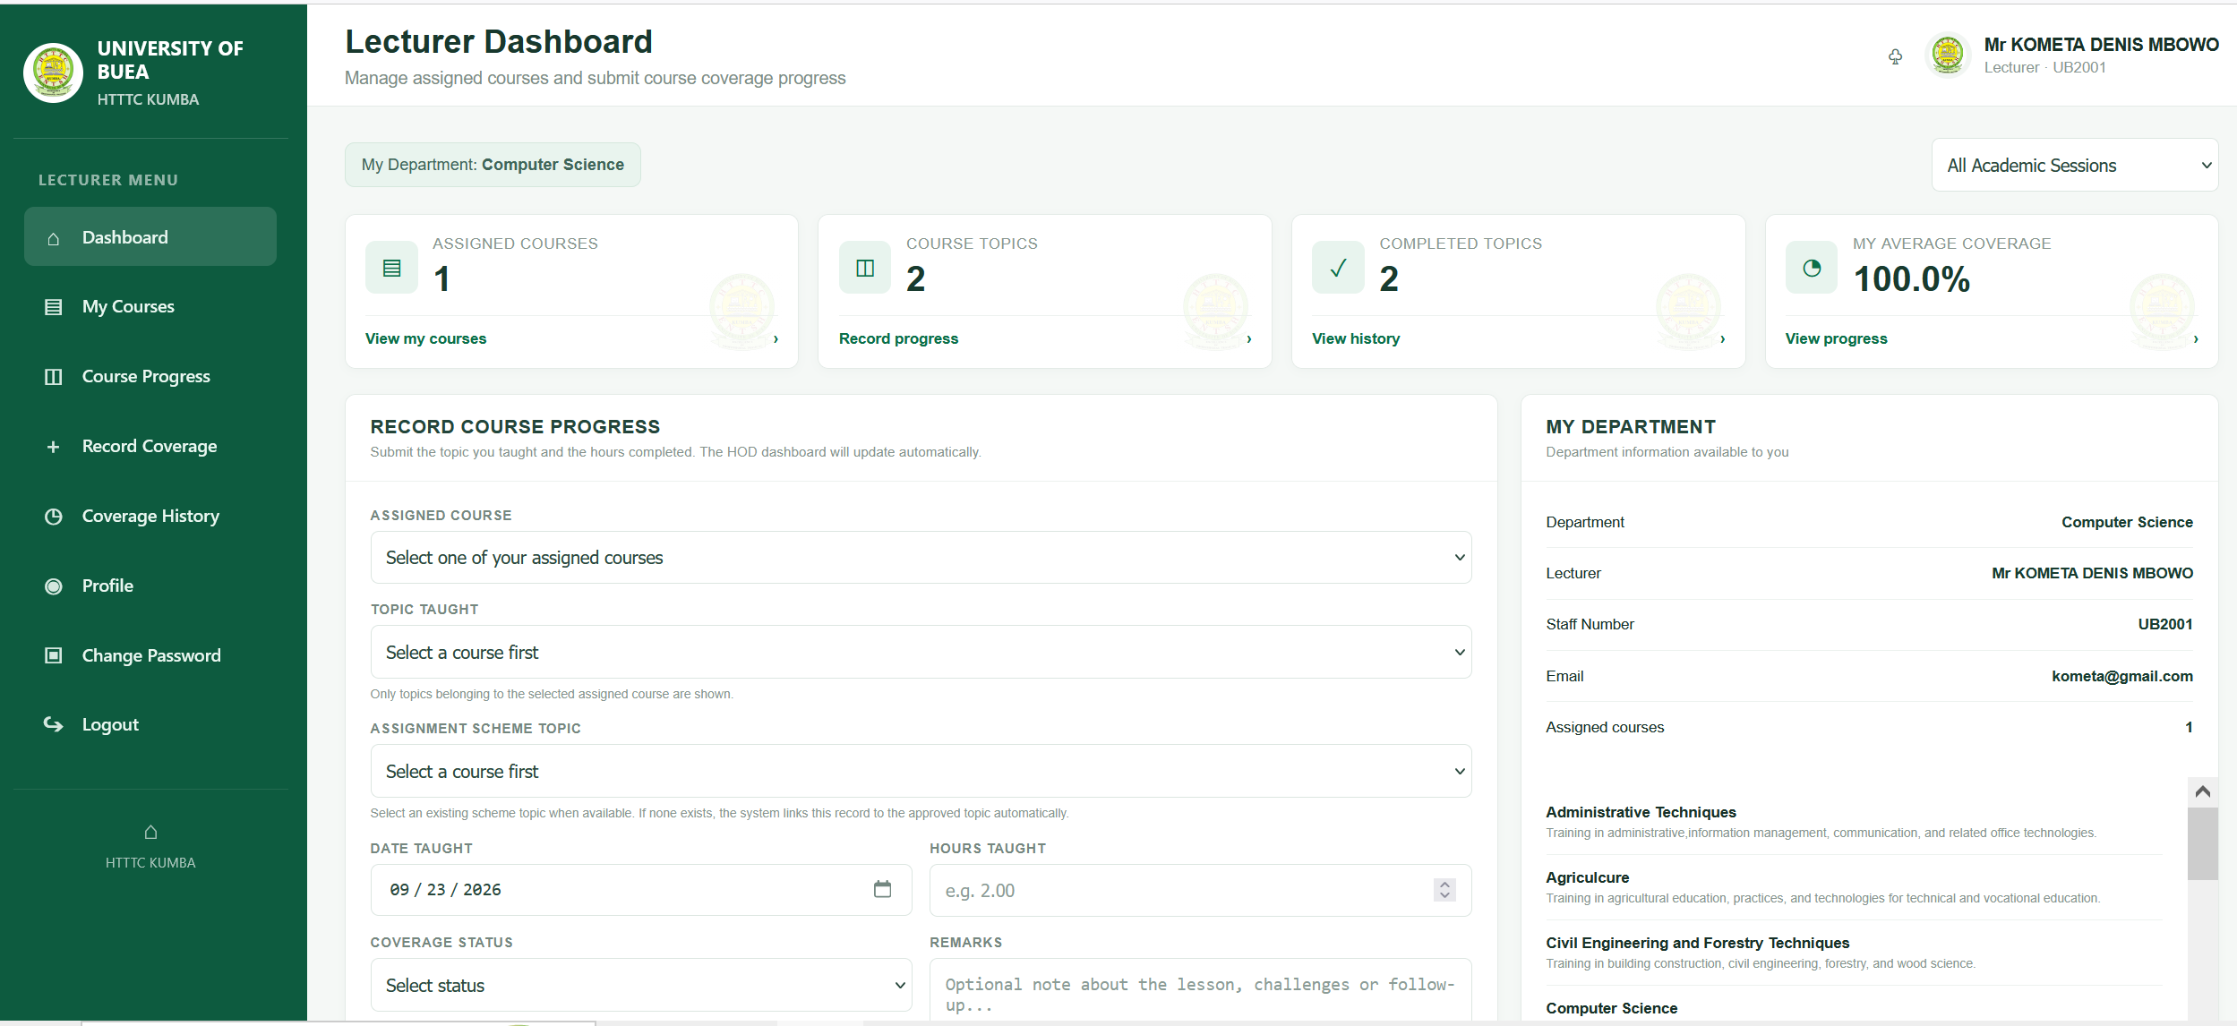

4.3.3 Navigation Interfaces
The system provides role-specific navigation menus. The Admin navigation includes Dashboard, Users, Departments, Programs, Courses, Academic Years and Semesters. The HOD navigation includes Dashboard, Assign Courses, Assignments, Coverage and Reports. The Lecturer navigation includes Dashboard, My Courses, Coverage and History.
These navigation structures allow users to access the functions relevant to their responsibilities without unnecessarily exposing functions belonging to other roles.
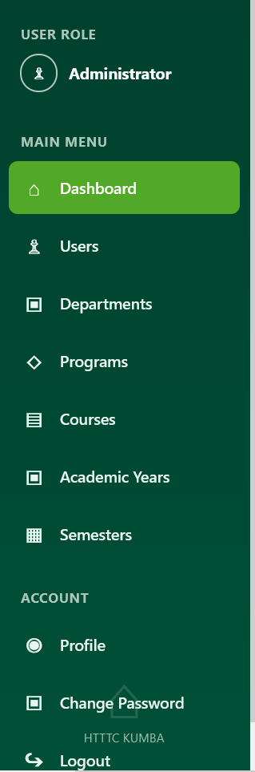
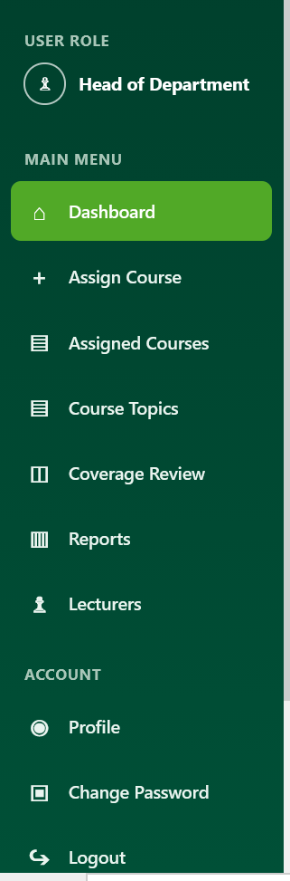
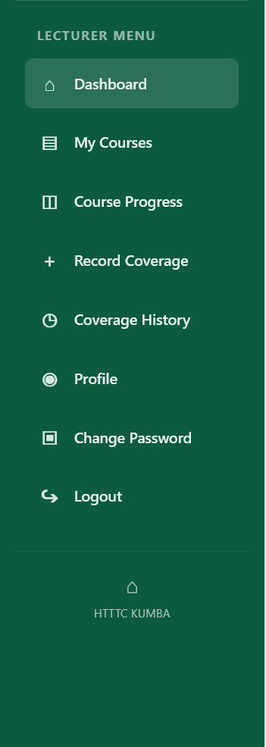

4.3.4 Password Management Interface
The system provides a password-change interface for authenticated users. The user is required to provide the current password, a new password and confirmation of the new password. The system validates the submitted information before updating the user's password.
This interface supports account security by allowing users to change their passwords when necessary.
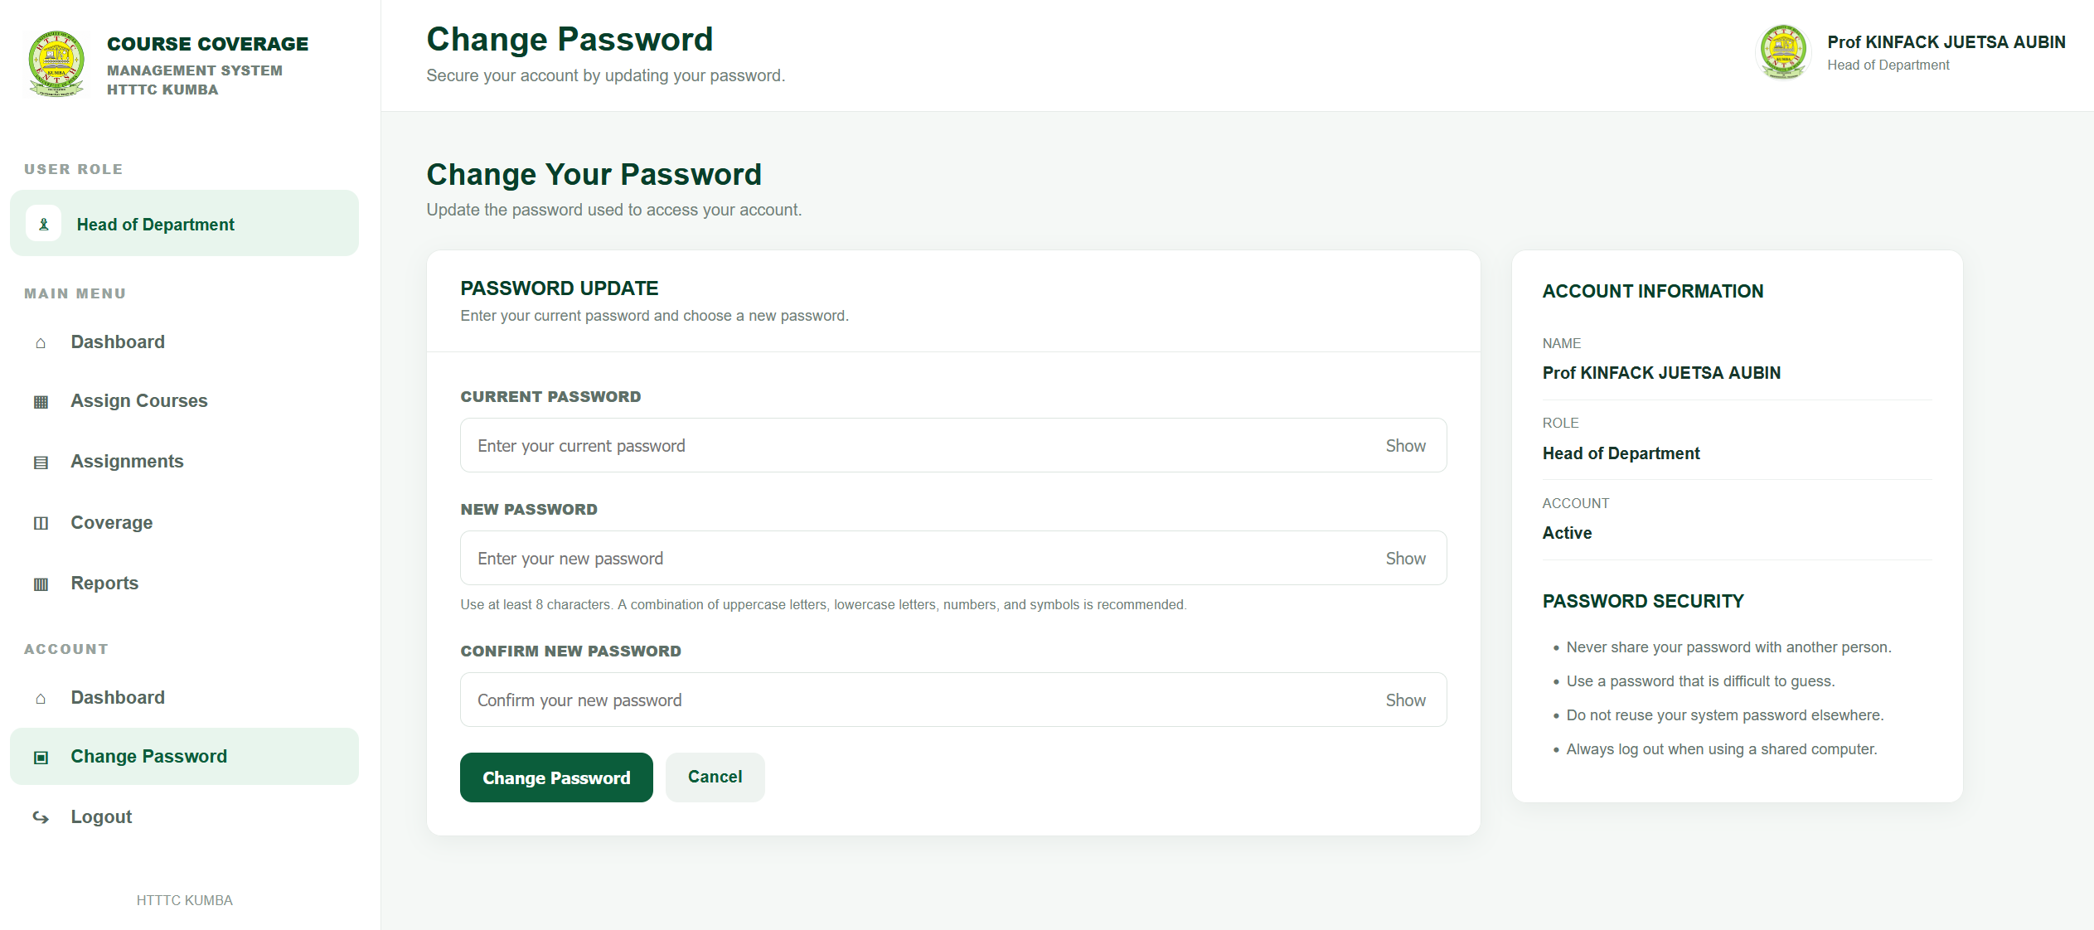

4.3.5 Interface Design Considerations
The system interfaces were designed to provide a clear and structured way of interacting with the application. The interface organization is based on the responsibilities of each user role, while navigation is provided through role-specific menus.
The interfaces support the major activities of the system, including academic information management, course assignment, course coverage recording, coverage history and progress monitoring. The separation of functions according to user roles also contributes to controlled access and easier navigation.
The next sections present the specific interfaces and functions available to the Admin, HOD and Lecturer users.

4.4 Admin Interface
The Admin interface provides the administrative functions required for managing the information and configuration of the Smart Course Coverage Management System. After successful authentication, an Admin user is directed to the Admin dashboard, from which the available administrative modules can be accessed.
The Admin interface is organized around the management of users and the academic information required for course coverage management. The available navigation options include Dashboard, Users, Departments, Programs, Courses, Academic Years and Semesters. The interface also provides access to password management and logout functions.

4.4.1 Admin Dashboard
The Admin dashboard serves as the main interface for accessing administrative functions. It provides the Admin with an overview of the system and links to the different management modules.
The dashboard provides access to the information required to maintain the system's academic structure and user accounts. The information displayed on the dashboard is derived from records stored in the system database.

4.4.2 User Management
The User Management function provides the Admin with access to user information. This module supports the management of accounts required for accessing the system.
Users are associated with roles that determine the functions they can access. The system supports the three defined roles: Admin, HOD and Lecturer. This role-based structure allows the system to distinguish between administrative, departmental and lecturer activities.

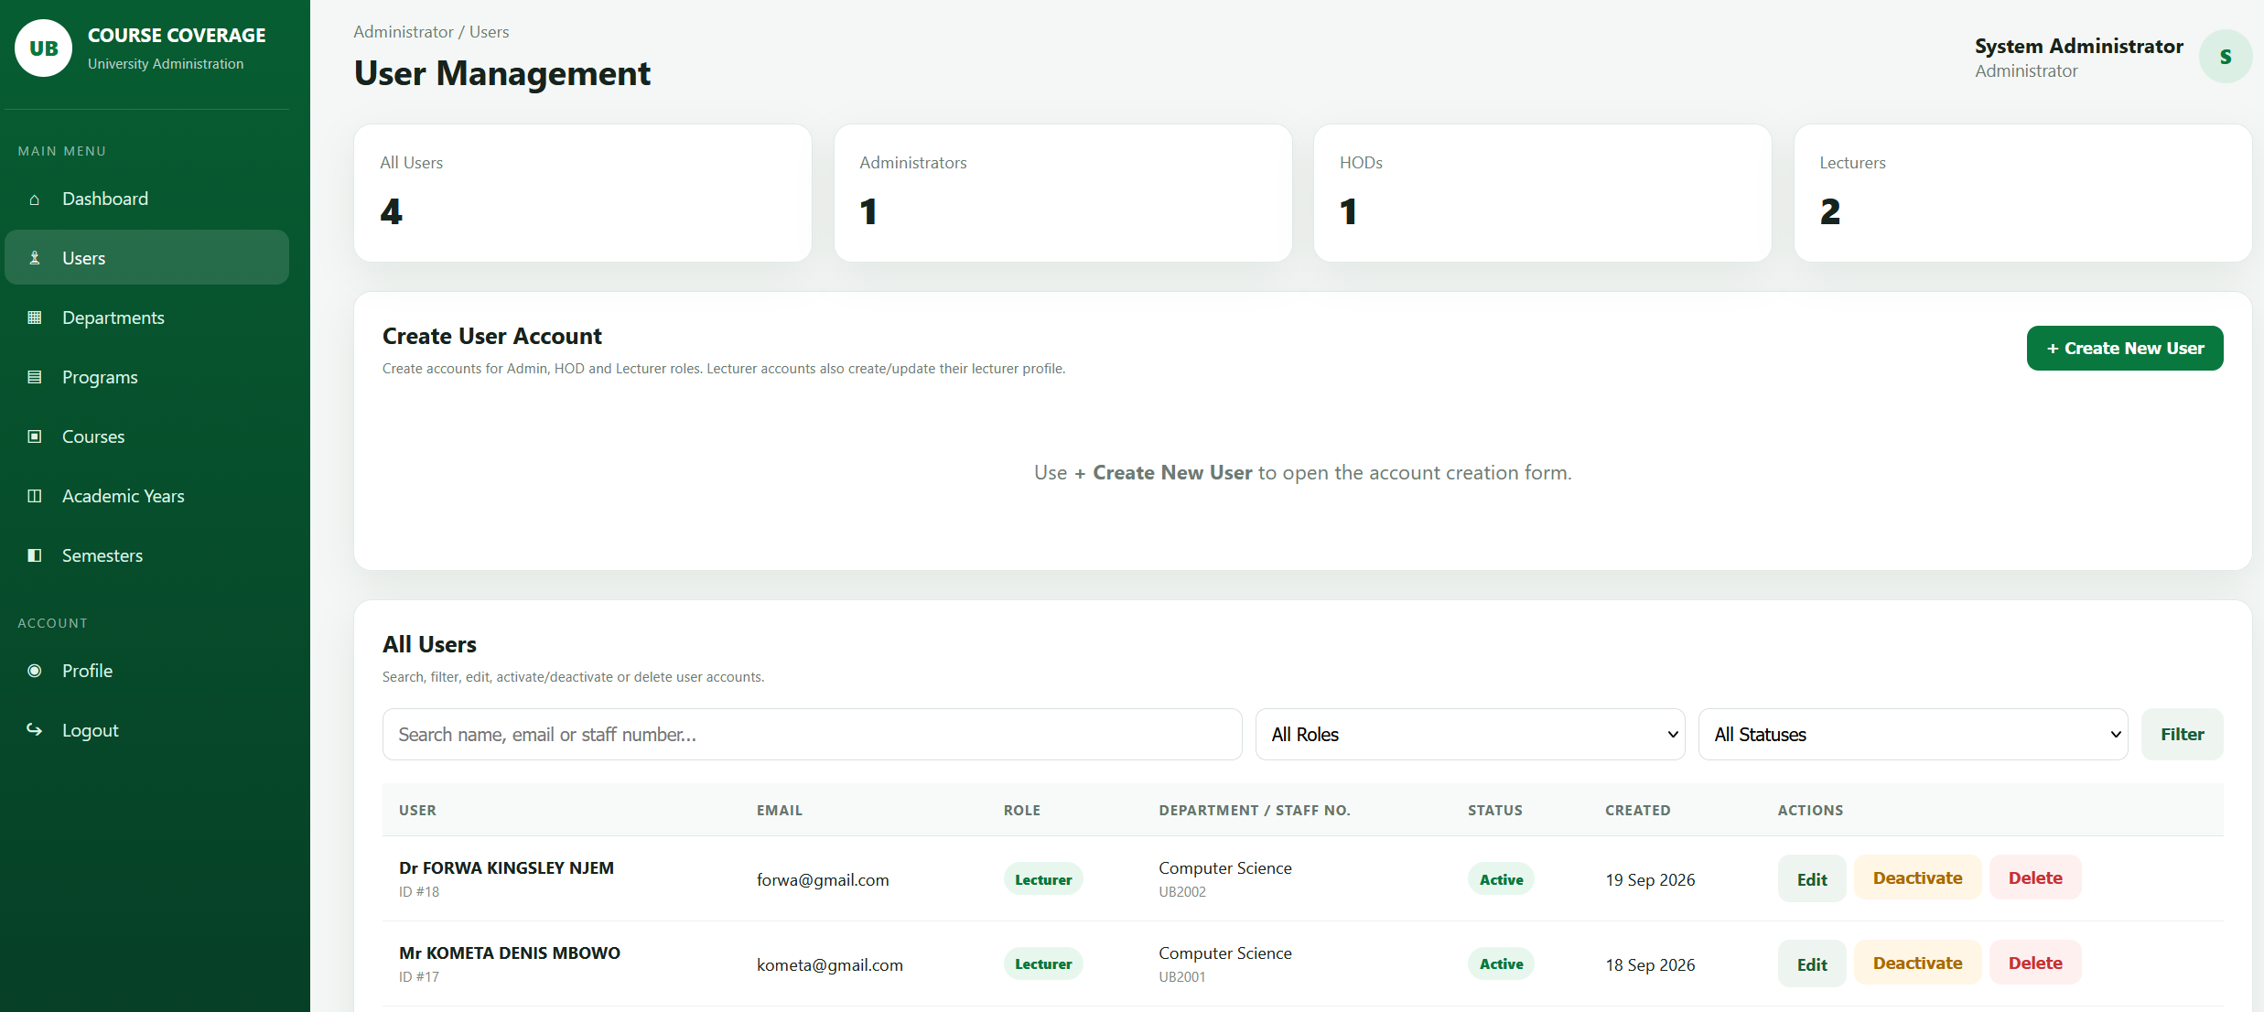4.4.3 Department Management
The Department Management function provides the Admin with access to departmental information. Departments form part of the academic structure used to organize programmes, lecturers and courses within the system.
The department records stored in the database can therefore be used to establish the academic relationships required by other modules of the system.

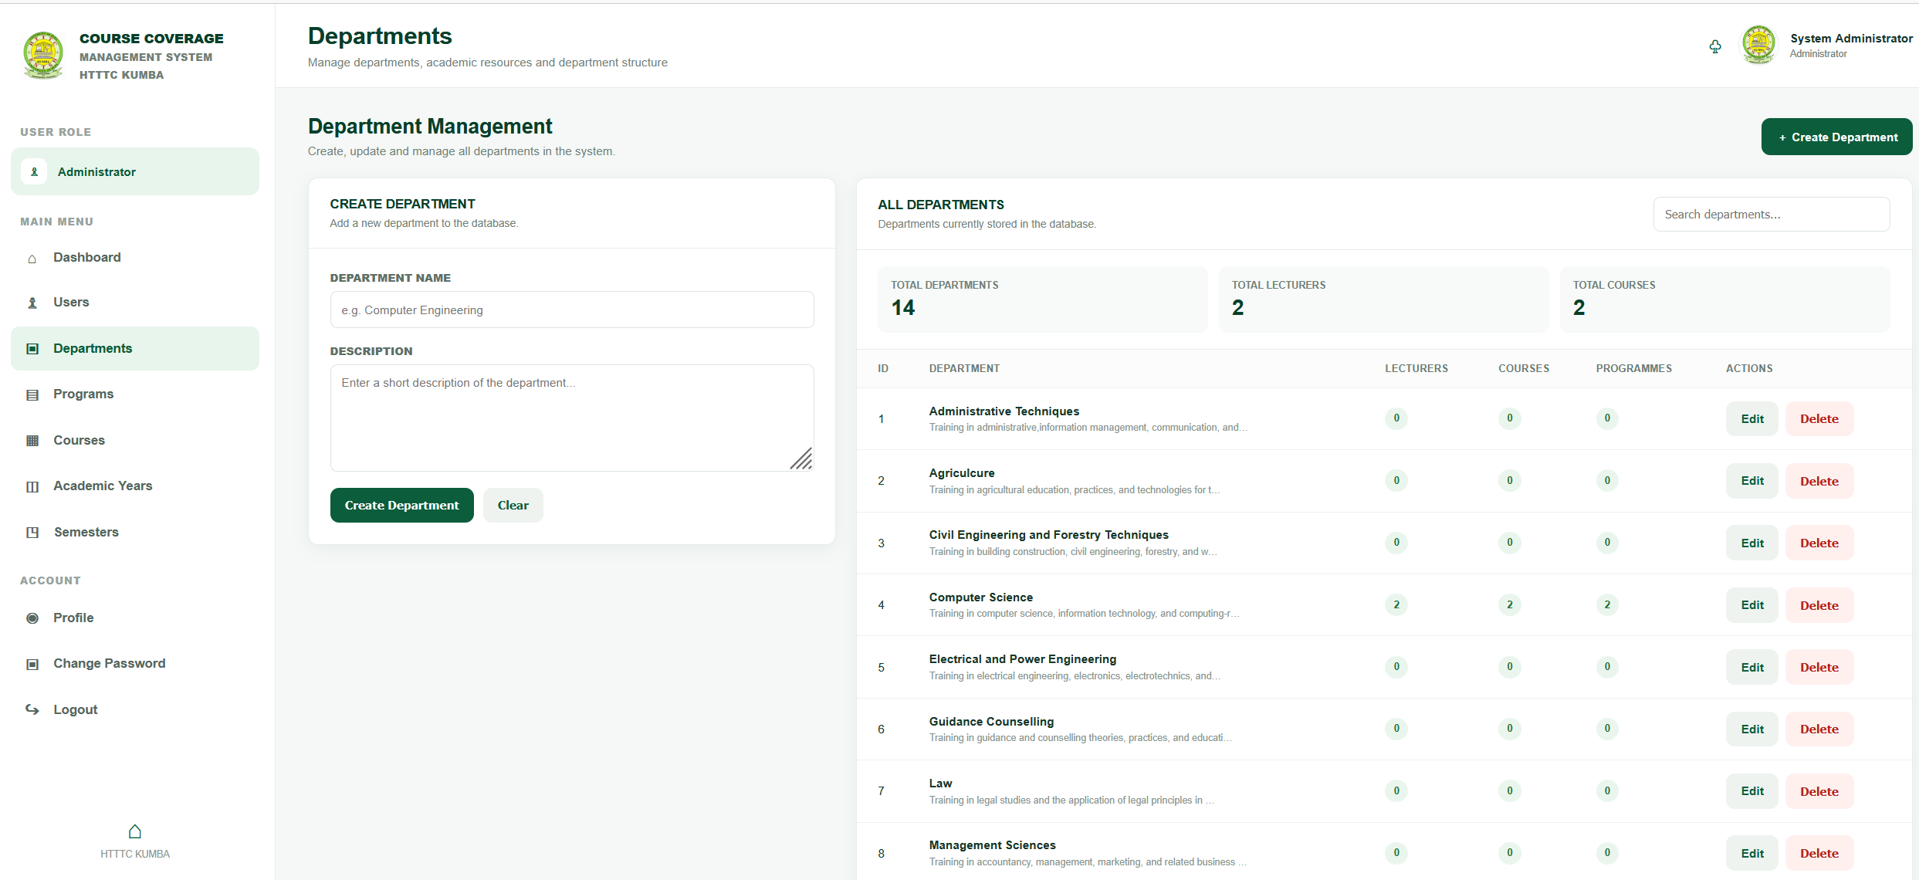4.4.4 Programme Management
The Programme Management function allows the Admin to maintain information about academic programmes. Each programme is associated with a department in the database.
Programme information is important to the course assignment process because courses can be associated with programmes when assignments are created.

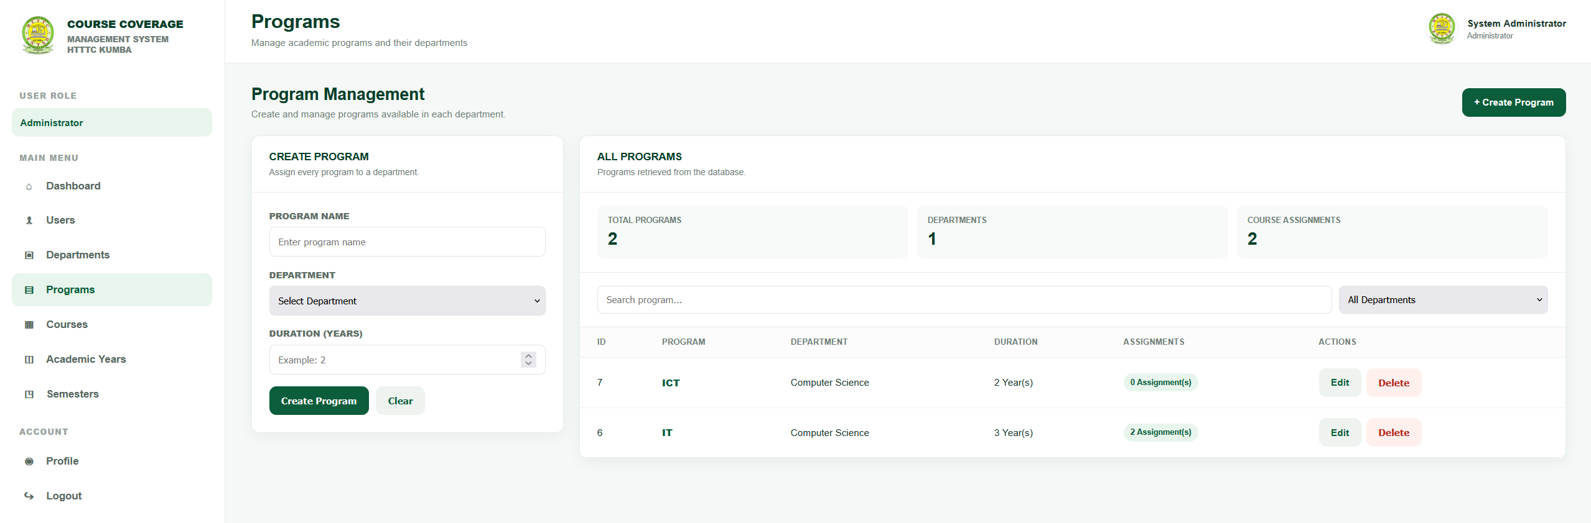4.4.5 Course Management
The Course Management function provides the Admin with access to course information. Course records contain information such as course code, course name, credit value, department and description.
The course information maintained through this module provides the foundation for course assignment and subsequent course coverage management.

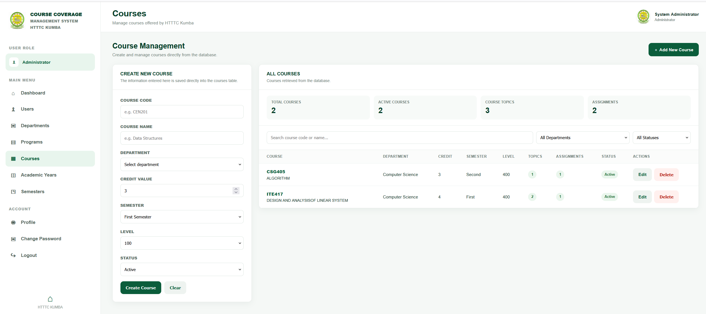4.4.6 Academic Year and Semester Management
The Admin interface also provides functions for maintaining academic session and semester information. Academic sessions are stored in the database with information including the session name, start date, end date and status.
This information provides the academic context within which courses are assigned and course coverage is monitored.

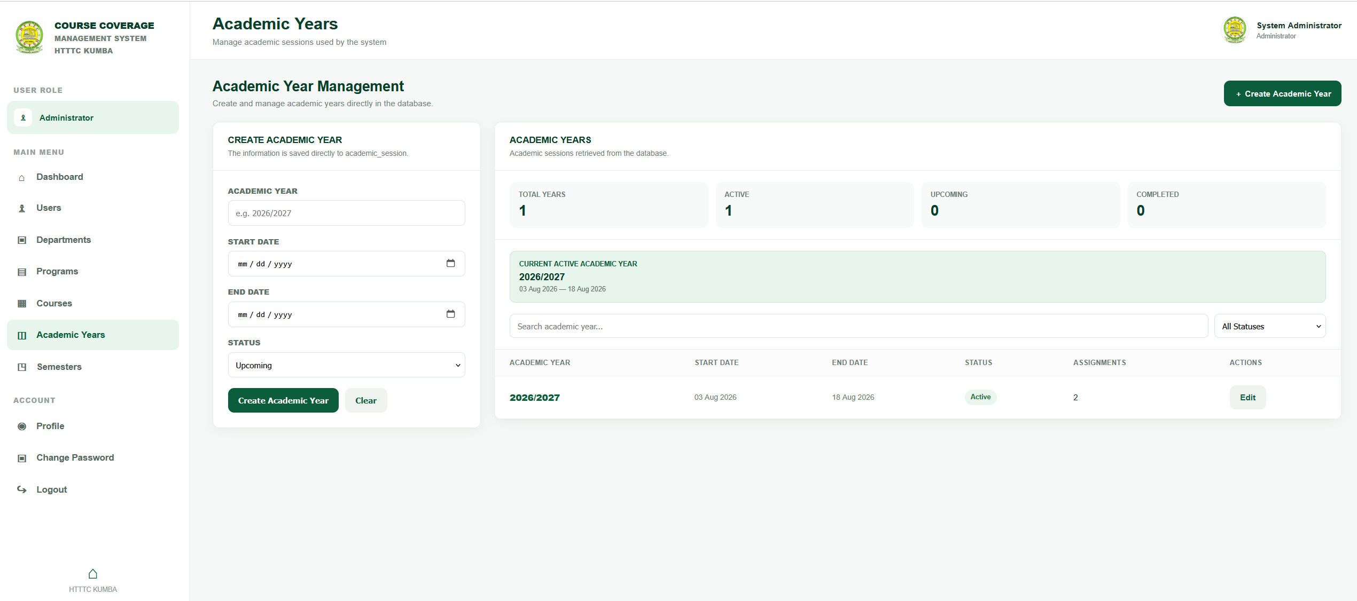4.4.7 Password Management and Logout
The Admin interface provides access to password management, allowing an authenticated Admin user to change the account password. The system validates the current password and the new password before making the update.
The logout function terminates the active user session and returns the user to the appropriate authentication entry point. This helps prevent continued access to protected system pages after the user has finished using the application.

4.4.8 Summary of Admin Interface
The Admin interface provides the administrative foundation of the Smart Course Coverage Management System. Through the available modules, the Admin maintains users and the academic information required for course assignment and coverage monitoring. The information managed by the Admin subsequently supports the activities performed by HOD and Lecturer users.

4.5 HOD Interface
The HOD (Head of Department) interface provides the functions required for managing course assignments and monitoring course coverage within the Smart Course Coverage Management System. After successful authentication, the HOD is directed to the HOD dashboard, which provides access to the functions associated with the HOD role.
The HOD navigation structure includes Dashboard, Assign Courses, Assignments, Coverage, and Reports. These functions enable the HOD to manage course assignments, review course delivery information, monitor coverage progress and access organized coverage information.

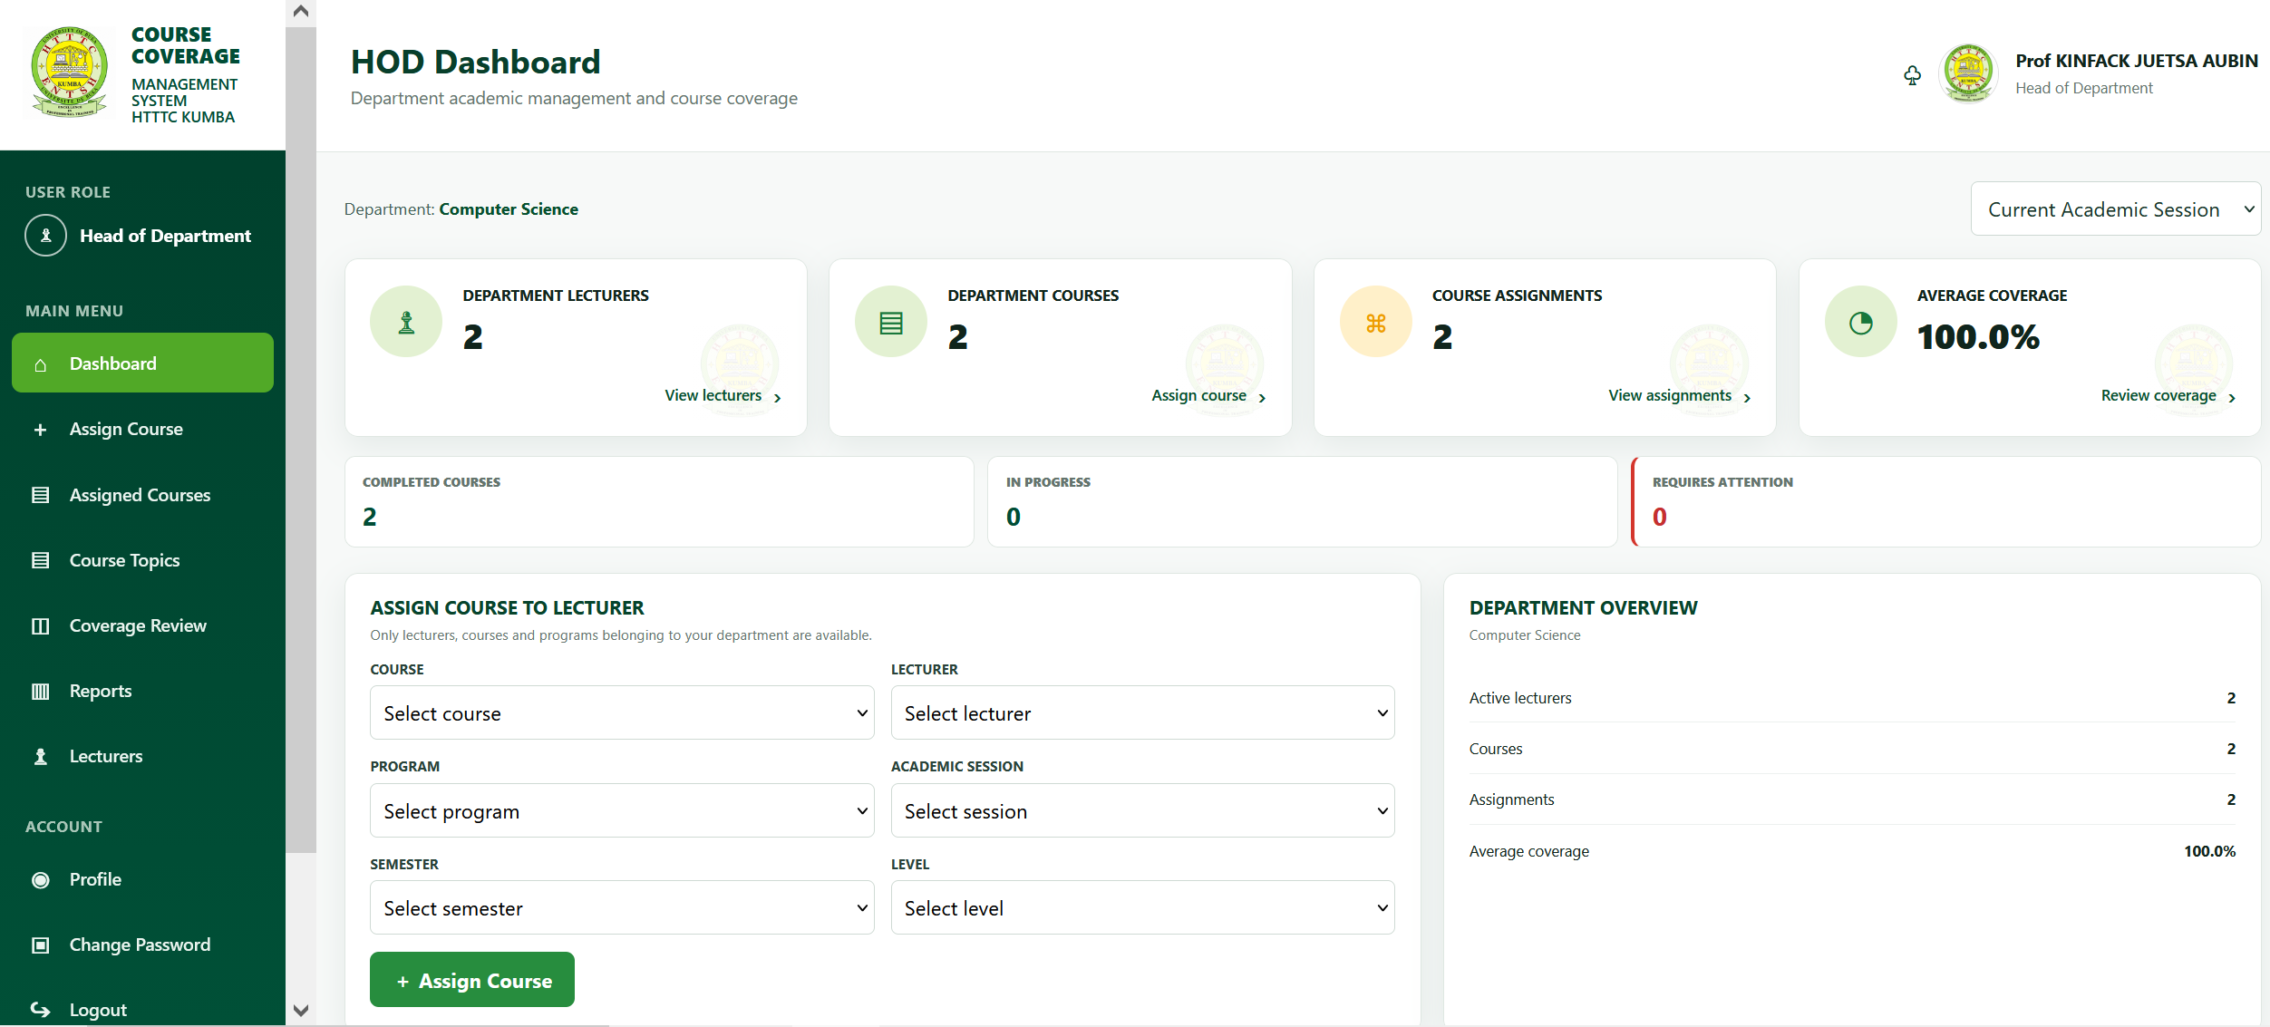4.5.1 HOD Dashboard
The HOD dashboard serves as the main entry point to the departmental course management and monitoring functions. It provides navigation to the course assignment, assignment management, coverage and reporting modules.
The dashboard enables the HOD to access information required for monitoring the progress of courses assigned to lecturers.

4.5.2 Course Assignment
The Assign Courses function provides the HOD with the ability to associate courses with lecturers and the relevant academic context. A course assignment is associated with information such as the course, lecturer, programme, academic session, semester and level.
This function establishes the relationship required for subsequent course coverage recording and monitoring.

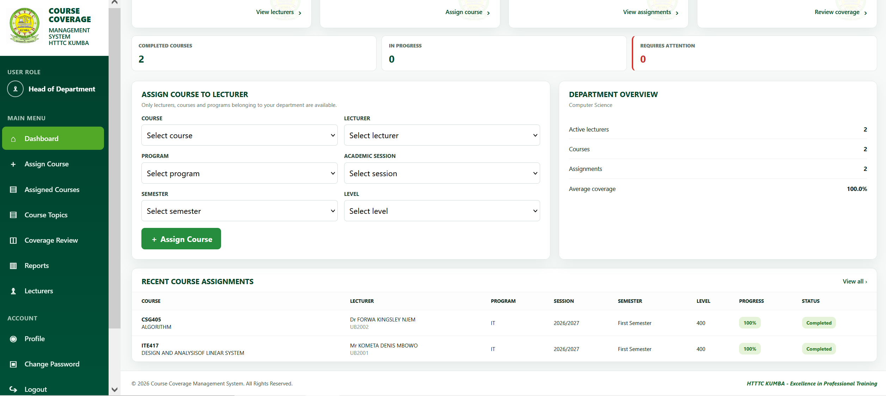4.5.3 Assignment Management
The Assignments function provides the HOD with access to existing course assignments. This allows assigned courses to be reviewed within the system and provides a structured view of the courses associated with lecturers and their academic context.
The assignment information serves as a link between the course and the subsequent coverage records.

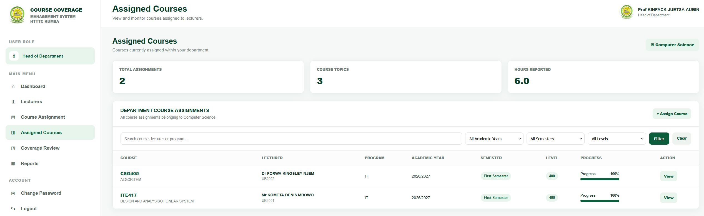4.5.4 Course Coverage Monitoring
The Coverage function provides the HOD with access to course coverage information recorded in the system. Coverage records contain information such as the course assignment, topic, date taught, hours taught, coverage status and remarks.
The HOD can use this information to monitor the progress of course delivery based on the records available in the system.

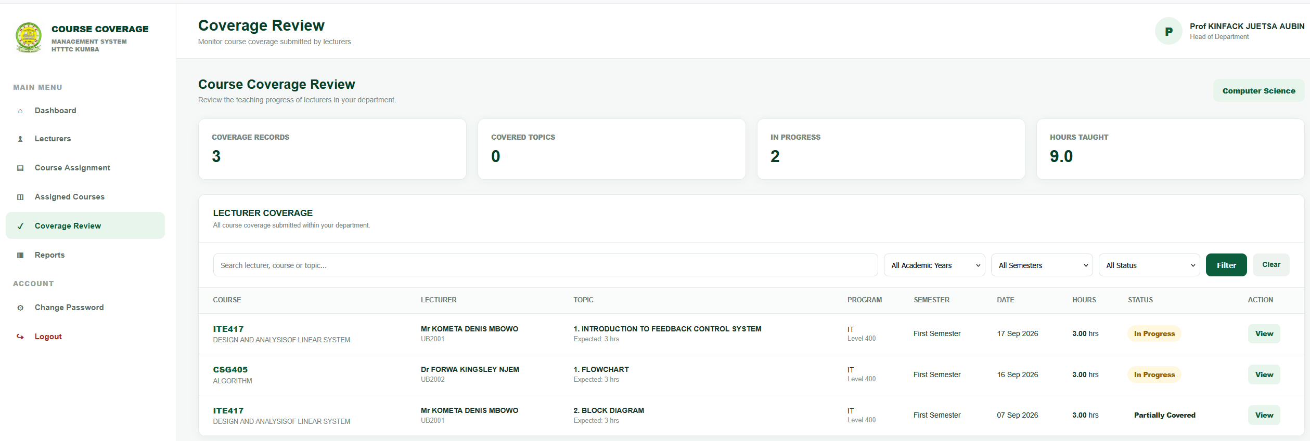4.5.5 Reports
The Reports function provides organized course coverage and progress information for monitoring purposes. The reporting component supports the HOD in reviewing the coverage information maintained in the system.
The coverage information can be interpreted using the system's defined coverage classifications, which are based on the relationship between actual teaching hours and expected teaching hours.

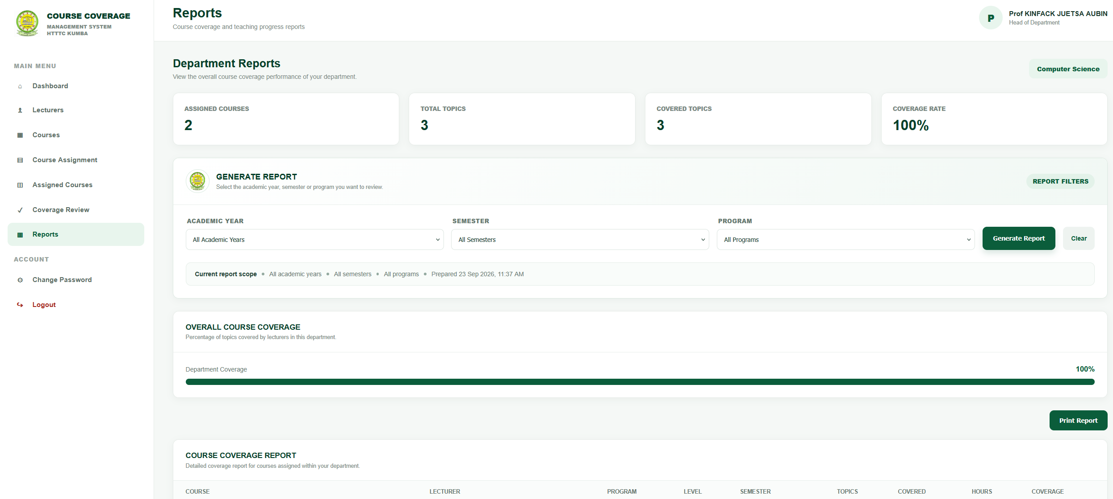4.5.6 Password Management and Logout
The HOD interface provides access to password management, allowing the authenticated HOD to change the account password. The system validates the required password information before updating the account.
The logout function terminates the active session and prevents continued access to protected HOD pages after the user has logged out.

4.5.7 Summary of HOD Interface
The HOD interface provides the departmental course management and monitoring functions of the system. Through course assignment, assignment management, coverage monitoring and reporting, the HOD can access structured information concerning course delivery and progress. These functions connect the academic information maintained by the Admin with the course coverage records entered by Lecturers.

4.6 Lecturer Interface
The Lecturer interface provides the functions required by lecturers to access their assigned courses and record course coverage information in the Smart Course Coverage Management System. After successful authentication, the Lecturer is directed to the Lecturer dashboard, which provides access to the functions associated with the Lecturer role.
The Lecturer navigation structure includes Dashboard, My Courses, Coverage, and History. These functions support the lecturer's activities in accessing assigned courses, recording teaching coverage and reviewing previously recorded coverage information.

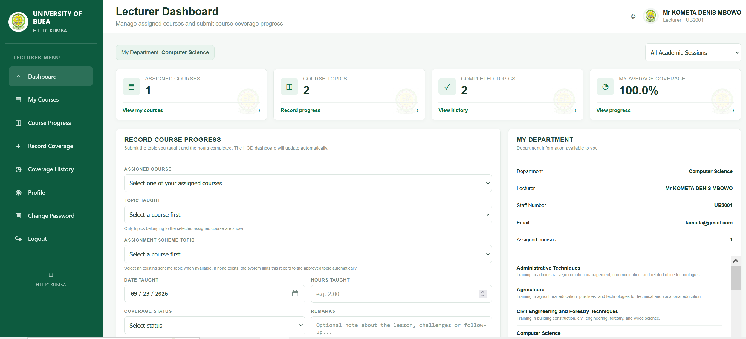4.6.1 Lecturer Dashboard
The Lecturer dashboard serves as the main entry point to the functions available to the Lecturer. It provides navigation to the lecturer's assigned courses, course coverage and coverage history.
The dashboard allows the Lecturer to access the functions required for recording and reviewing course delivery information.

4.6.2 My Courses
The My Courses function provides the Lecturer with access to courses assigned to them. The assigned course information is linked to the relevant course assignment and academic context stored in the database.
This function enables the Lecturer to identify the courses for which coverage information is to be recorded.

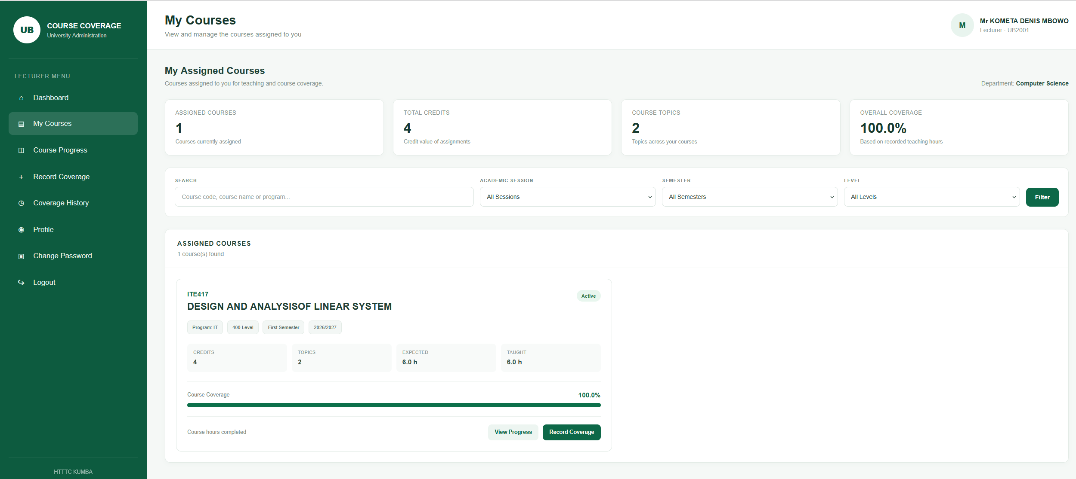4.6.3 Course Coverage
The Coverage function allows the Lecturer to record course coverage information for an assigned course. The coverage record is associated with the relevant course assignment and course topic.
The information recorded includes the topic taught, date taught, hours taught, coverage status and remarks. Once submitted, the information is stored in the centralized database for subsequent monitoring and retrieval.

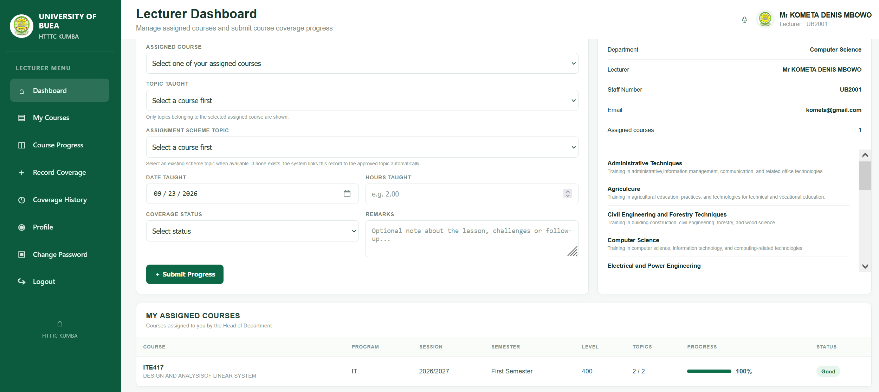4.6.4 Coverage History
The History function provides the Lecturer with access to previously recorded course coverage information. This allows the Lecturer to review coverage records that have already been entered into the system.
The availability of historical records provides a structured way of reviewing previously recorded teaching activities.

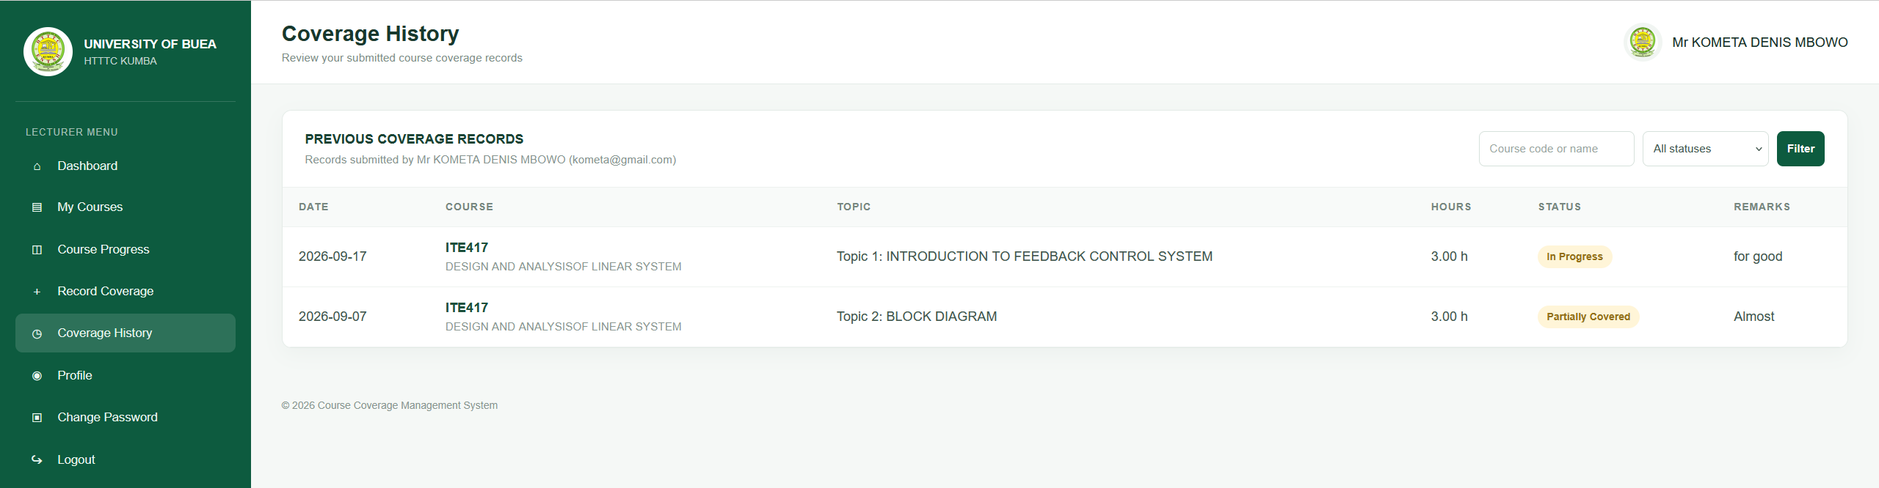4.6.5 Password Management and Logout
The Lecturer interface provides access to password management, allowing an authenticated Lecturer to change the account password. The system validates the required password information before updating the account.
The logout function terminates the active session and prevents continued access to protected Lecturer pages after the user has logged out.

4.6.6 Summary of Lecturer Interface
The Lecturer interface provides the functions required for accessing assigned courses, recording course coverage and reviewing coverage history. Through these functions, course delivery information can be entered into the centralized database and subsequently made available for course coverage monitoring and reporting.

4.7 Course Management
Course management is an important component of the Smart Course Coverage Management System because course information provides the foundation for course assignment and subsequent course coverage monitoring. The course management function is available to the Admin and is used to maintain the course information required by the system.
The course information is stored in the centralized MariaDB database. Each course is associated with the relevant department and contains information required to identify and describe the course.

4.7.1 Course Information
The course records maintained by the system include the following information:
- Course code
- Course name
- Credit value
- Department
- Course description
Each course is uniquely identified by its course ID in the database. The department association helps organize courses according to the academic structure maintained within the system.

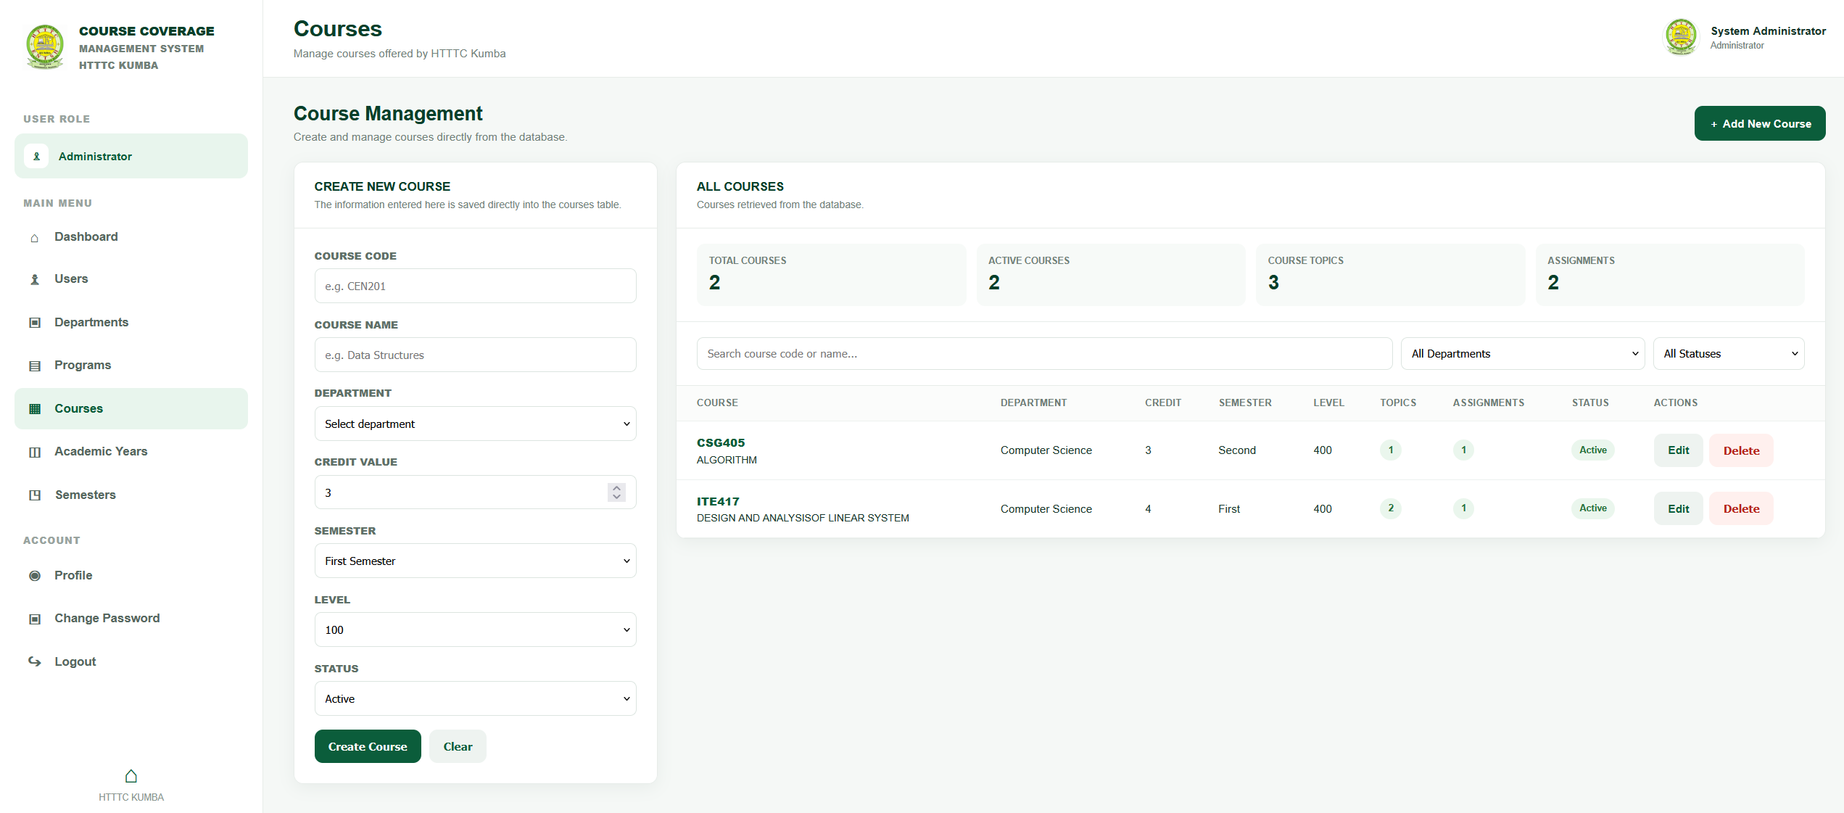4.7.2 Course Creation and Maintenance
The Admin manages course information through the Course Management module. Course records can be maintained so that accurate course information is available for subsequent course assignment.
Maintaining course information in a centralized database reduces the need to repeatedly enter the same course information when the course is used in other system operations.

4.7.3 Relationship with Course Assignment
Course management provides the course information required by the HOD when assigning courses to lecturers. A course assignment connects a course with a lecturer, programme, academic session, semester and level.
This relationship allows the system to identify not only the course being taught but also the academic context and lecturer associated with its delivery.

4.7.4 Relationship with Course Topics
Course topics are associated with their respective courses in the database. The topics provide the basis for recording specific course coverage activities.
When a Lecturer records coverage, the coverage record can therefore be associated with the appropriate course assignment and topic. This provides a structured relationship between the course, its topics and the teaching activities recorded in the system.

4.7.5 Course Data Management
The centralized storage of course information allows other modules of the system to retrieve the required course data. This supports course assignment, course topic management and course coverage recording.
The course management function therefore forms part of the data foundation of the system and contributes to maintaining consistent academic information throughout the course coverage management process.

4.7.6 Summary
The Course Management module provides a structured method for maintaining course information within the Smart Course Coverage Management System. The maintained course records support course assignment and provide the basis for linking course topics and coverage records to the appropriate courses.

4.8 Course Assignment
The Course Assignment module is responsible for associating courses with lecturers within the appropriate academic context. This function is performed by the HOD and provides the link between the courses maintained by the Admin and the lecturers responsible for delivering them.
The course assignment information is stored in the centralized database and provides the basis for subsequent course coverage recording and monitoring.

4.8.1 Course Assignment Information
A course assignment contains information that identifies the course, lecturer and academic context in which the course is to be delivered. The implemented database structure associates a course assignment with:
- Course
- Lecturer
- Programme
- Academic session
- Semester
- Level
This structure allows the system to distinguish between different teaching assignments and provides the information required for monitoring course delivery.

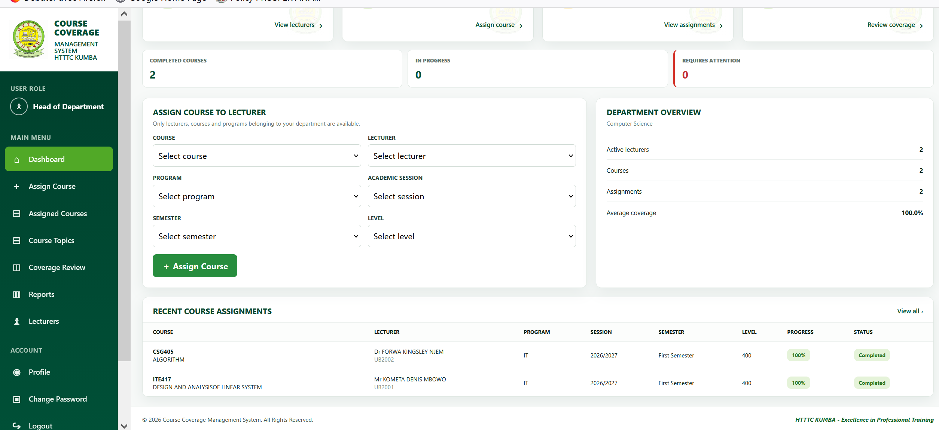4.8.2 Assignment Process
The HOD accesses the Assign Courses function and selects the relevant information required to create a course assignment. The selected course is associated with the appropriate lecturer, programme, academic session, semester and level.
After the assignment information is recorded, it becomes available within the system for subsequent access by the Lecturer and for monitoring by the HOD.

4.8.3 Relationship with Lecturer
The course assignment establishes a relationship between a lecturer and a course. This relationship allows the system to identify the courses that belong to a particular lecturer.
The Lecturer can subsequently access assigned courses through the My Courses interface. This ensures that course coverage records can be associated with the appropriate lecturer and course assignment.

4.8.4 Relationship with Course Coverage
Course assignments provide the foundation for recording course coverage. A coverage record is linked to an assignment and a course topic. Therefore, the system can identify the course and lecturer associated with each coverage record.
This relationship also supports the monitoring of course progress because coverage information can be grouped and analyzed according to the relevant course assignment.

4.8.5 Assignment Management
The HOD can access existing assignments through the Assignments module. This provides a structured view of course assignments stored in the system and supports the monitoring of the courses assigned for delivery.
The assignment records also provide the academic context required when interpreting course coverage information.

4.8.6 Summary
The Course Assignment module establishes the connection between courses, lecturers and the relevant academic context. By maintaining these relationships in the centralized database, the system provides a structured foundation for lecturer access, course coverage recording and subsequent monitoring of course delivery.

4.9 Course Coverage Recording
The Course Coverage Recording module is one of the central components of the Smart Course Coverage Management System. It provides a structured method for recording the teaching activities associated with assigned courses. The function is primarily used by Lecturers, while the recorded information can subsequently be accessed for monitoring and reporting purposes.
The coverage information is stored in the centralized MariaDB database and is associated with the relevant course assignment and course topic. This provides a structured relationship between the course being taught, the lecturer responsible for the course, the topic covered and the teaching activity recorded.

4.9.1 Coverage Information
The system records important information relating to each course coverage activity. The information includes:
- Course assignment
- Course topic
- Date taught
- Hours taught
- Coverage status
- Remarks
- User responsible for updating the record
These fields provide the information required to maintain an organized record of course delivery activities.

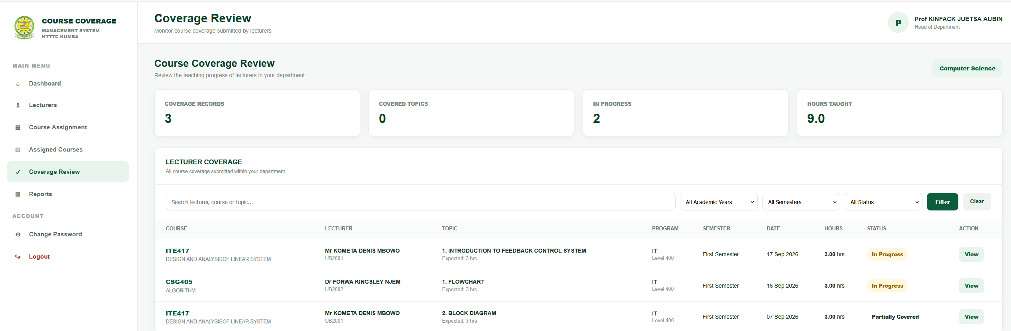4.9.2 Recording Course Coverage
The Lecturer accesses the Coverage function from the Lecturer interface and records the relevant teaching information for an assigned course. The Lecturer selects the appropriate course topic and provides the date on which the topic was taught, the number of hours taught, the coverage status and any relevant remarks.
After the information is submitted, the system processes the information and stores the coverage record in the database. The stored record can subsequently be retrieved for monitoring and historical review.

4.9.3 Association with Course Topics
Course coverage records are associated with individual course topics. This allows the system to maintain information about the specific portions of a course that have been taught.
The course topic structure includes information such as the topic number, topic title, description and expected hours. Associating coverage records with these topics provides a basis for comparing expected teaching hours with actual hours recorded.

4.9.4 Recording Teaching Hours
The system records the number of hours taught for each coverage activity. The recorded hours contribute to the monitoring of course progress.
The relationship between the expected hours of course topics and the hours actually taught provides the basis for calculating course coverage progress within the system.

4.9.5 Coverage Status and Remarks
The Lecturer can specify the coverage status and provide remarks when recording a course coverage activity. These fields provide additional information about the recorded teaching activity and can assist in understanding the circumstances surrounding a particular coverage record.

4.9.6 Data Storage and Retrieval
After a coverage record has been submitted, it is stored in the centralized database. The record can subsequently be retrieved through the system's coverage and history functions.
Centralized storage allows the recorded information to be available for authorized monitoring and reporting activities while maintaining the relationship between the coverage record, course assignment and course topic.

4.9.7 Summary
The Course Coverage Recording module provides a structured electronic method for documenting course delivery activities. By recording the course topic, date taught, hours taught, coverage status and remarks, the system creates organized coverage records that can be used for progress monitoring, historical review and reporting.

4.10 Coverage History
The Coverage History module provides access to previously recorded course coverage information within the Smart Course Coverage Management System. It enables authorized users, particularly Lecturers, to review coverage records that have already been entered into the system.
The module is supported by the centralized database, where course coverage records are stored together with their associated course assignments and course topics. This provides a structured record of teaching activities and allows previously recorded information to be retrieved when required.

4.10.1 Purpose of Coverage History
The main purpose of the Coverage History module is to maintain and provide access to previously recorded course coverage activities. Instead of relying on separate manual records, coverage information entered into the system remains available in the database for subsequent review.
The history provides a record of the teaching activities associated with assigned courses and topics.

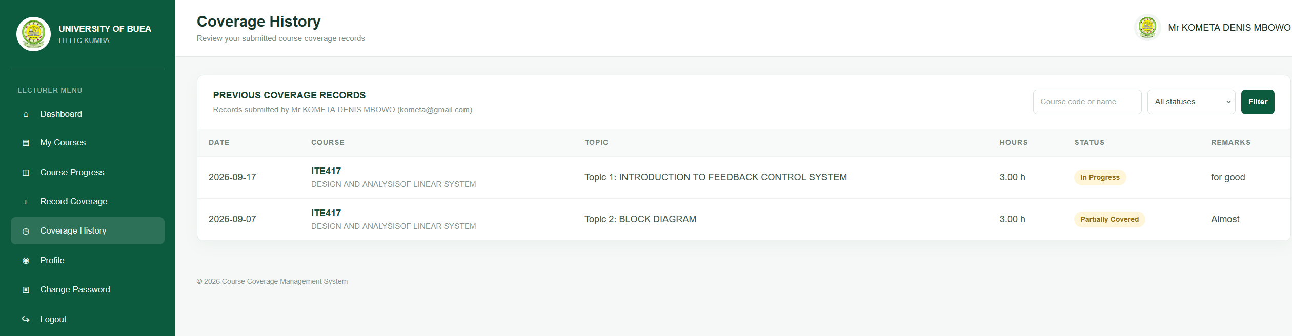4.10.2 Information Available in Coverage History
Coverage history is based on the information stored in the course coverage records. The records may contain information such as:
- Course assignment
- Course topic
- Date taught
- Hours taught
- Coverage status
- Remarks
- Date the record was updated
This information allows previously recorded teaching activities to be reviewed in an organized manner.

4.10.3 Lecturer Access to Coverage History
The Lecturer can access the History function from the Lecturer interface. This provides access to previously recorded coverage information associated with the lecturer's course activities.
The history function allows the Lecturer to review information that has already been recorded without having to create a new coverage record.

4.10.4 Role in Course Monitoring
Coverage history contributes to the monitoring of course delivery by providing a record of previously entered coverage activities. The information can be used alongside current coverage information to understand the progress of course delivery over time.
The stored records also provide supporting information for coverage monitoring and reporting functions available to authorized users.

4.10.5 Centralized Storage
Coverage history is maintained through the centralized database rather than as separate records for individual teaching activities. Each coverage record is linked to its relevant course assignment and topic, allowing the system to maintain the relationship between the teaching activity and the course being delivered.
This organization improves the accessibility and consistency of course coverage records within the system.

4.10.6 Summary
The Coverage History module provides a structured record of previously entered course coverage information. By maintaining historical coverage records in the centralized database, the system supports review of teaching activities and provides information that can contribute to course progress monitoring and reporting.

4.11 Reports/Progress Monitoring
The Reports and Progress Monitoring component provides organized information for monitoring course coverage within the Smart Course Coverage Management System. The component is particularly relevant to the HOD, who requires course coverage information to monitor the progress of courses assigned to lecturers.
The progress information is generated from course coverage records stored in the centralized database. The system uses the relationship between the hours taught and the expected hours associated with course topics to support the assessment of course coverage progress.

4.11.1 Coverage Progress Calculation
Course coverage progress is determined by comparing the total hours taught with the expected teaching hours. The general calculation can be represented as:
Coverage Percentage = (Total Hours Taught / Total Expected Hours) × 100
This calculation provides an indication of the proportion of the expected course content that has been covered based on the teaching hours recorded in the system.

4.11.2 Coverage Classification
The system classifies course coverage according to the calculated coverage percentage. The implemented classification is:
Coverage Percentage | Classification
75% and above | Excellent
50%–74% | Good
25%–49% | Average
Below 25% | Poor
The classification provides a simple way of interpreting the progress information stored in the system.

4.11.3 Low Coverage Monitoring
The system also identifies courses with coverage below 50% as low-coverage courses. This provides an additional monitoring indicator that can assist the HOD in identifying courses whose recorded progress is relatively low compared with their expected teaching hours.
The identification of low coverage is based on the coverage information available in the database and does not replace the detailed course coverage records.

4.11.4 Reports Interface
The Reports function provides the HOD with access to organized course coverage information. The information presented through the reporting component is based on the course assignments and coverage records stored in the system.
The reports support the review of course progress and provide information that can be used to monitor the delivery of assigned courses.

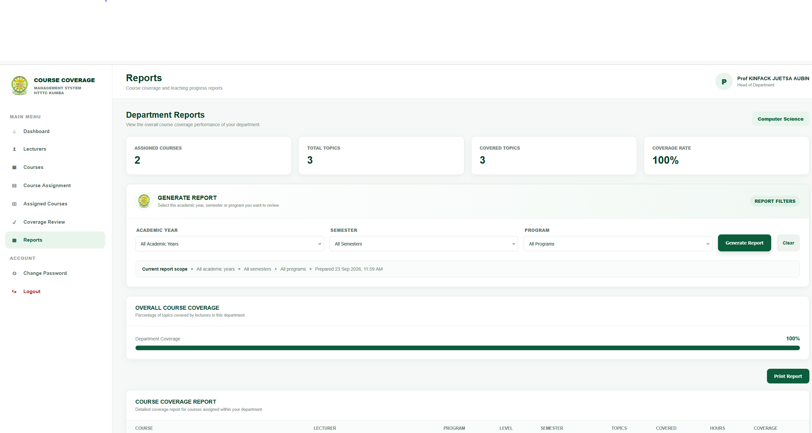4.11.5 Role of Progress Monitoring
Progress monitoring provides a structured means of reviewing course delivery information. By using recorded teaching hours and expected hours, the system provides an indication of the progress of assigned courses.
The information can also be reviewed alongside coverage history to provide a broader view of recorded teaching activities.

4.11.6 Summary
The Reports and Progress Monitoring component supports the monitoring of course delivery through organized coverage information and calculated progress indicators. It uses stored course coverage data to determine coverage percentages, classify course progress and identify courses with coverage below the defined monitoring threshold. The component therefore provides the HOD with structured information for reviewing course coverage within the system.

4.12 System Testing
System testing was carried out to verify that the implemented Smart Course Coverage Management System performs according to the requirements defined in Chapter Three. The testing process focused on checking the major functions of the application, the interaction between system modules, data processing and storage, authentication, role-based access and the recording and retrieval of course coverage information.
Testing was performed during the iterative development process. Identified errors were corrected and the affected functions were tested again to ensure that the corrections did not introduce new problems into the system.

4.12.1 Testing Objectives
The main objectives of system testing were to:
- Verify that users can successfully authenticate using valid credentials.
- Verify that invalid login information is rejected.
- Verify that users are directed to the appropriate dashboard according to their roles.
- Verify that users can access only the functions associated with their roles.
- Verify that academic information can be managed correctly.
- Verify that courses can be assigned to lecturers.
- Verify that course coverage information can be recorded.
- Verify that coverage records are stored correctly in the database.
- Verify that previously recorded coverage information can be retrieved.
- Verify that coverage progress is calculated and classified according to the defined criteria.
- Verify that users can change their passwords.
- Verify that users can log out and terminate their active sessions.

4.12.2 Testing Approach
The testing approach focused on the major functional components of the system. Each function was checked using appropriate input data, and the resulting system behavior was compared with the expected behavior.
The major areas tested included authentication, role-based access, user management, academic information management, course assignment, course coverage recording, coverage history, progress monitoring, password management and logout.

4.12.3 Authentication Testing
Authentication testing was conducted to verify that the system correctly handles user login. Valid credentials were used to confirm successful authentication, while invalid credentials were used to verify that unauthorized access is rejected.
The test also verified that authenticated users are redirected to the dashboard corresponding to their assigned role.

4.12.4 Role-Based Access Testing
Role-based access testing was used to verify that Admin, HOD and Lecturer users receive the appropriate system functions.
The Admin interface provides administrative and academic management functions, the HOD interface provides course assignment and monitoring functions, while the Lecturer interface provides assigned-course, coverage and history functions.
This testing ensures that system functions are presented according to the user's assigned role.

4.12.5 Course Management Testing
Course management functions were tested to verify that course information can be entered, maintained and retrieved correctly. The testing considered important course information such as course code, course name, credit value, department and description.

4.12.6 Course Assignment Testing
Course assignment testing was performed to verify that courses can be associated with lecturers, programmes, academic sessions, semesters and levels.
The test also verified that the resulting assignment information is available for subsequent course coverage activities.

4.12.7 Course Coverage Testing
Course coverage testing focused on the recording of teaching activities. The system was tested to verify that coverage information such as the course topic, date taught, hours taught, coverage status and remarks can be entered and stored correctly.
The relationship between coverage records, course assignments and course topics was also considered during testing.

4.12.8 Coverage History Testing
The Coverage History function was tested to verify that previously recorded coverage information can be retrieved and displayed to the authorized user.
This testing ensures that stored teaching records remain available for subsequent review.

4.12.9 Progress Monitoring Testing
Progress monitoring was tested to verify that the system processes recorded teaching hours against expected hours and produces the corresponding coverage percentage.
The coverage classification was also checked against the defined ranges:
- 75% and above — Excellent
- 50%–74% — Good
- 25%–49% — Average
- Below 25% — Poor

4.12.10 Password and Session Testing
Password management was tested to verify that authenticated users can change their passwords using the required current-password and new-password information.
Session and logout functionality were also tested to verify that users can terminate their sessions and that protected pages are not intended to remain accessible after logout.

4.12.11 Database Testing
Database testing was performed to verify that information submitted through the application is correctly stored and that stored records can be retrieved when required.
Particular attention was given to the relationships between users, courses, course assignments, course topics and course coverage records because these relationships are important to the operation of the system.

4.12.12 Summary
System testing provided a structured means of verifying the major functions of the implemented application. The testing covered authentication, role-based access, academic information management, course assignment, course coverage, coverage history, progress monitoring, password management, session control and database operations. The detailed test cases and their observed results are presented in the following section.

4.13 Test Results
The Smart Course Coverage Management System was subjected to functional testing to determine whether the implemented modules operate according to the specified requirements. The testing focused on the major functions of the system, including user authentication, role-based access, course management, course assignment, course coverage recording, coverage history, progress monitoring, password management, and database operations.
The tests were successfully carried out, and the system performed the expected operations for the functions evaluated.

4.13.1 Authentication Testing
The login function was tested using valid and invalid user credentials. The system successfully authenticated authorized users and prevented access when incorrect credentials were provided.
The system also correctly identified the role of the authenticated user and directed the user to the appropriate dashboard. The three supported roles, namely Admin, HOD, and Lecturer, were correctly recognized.

4.13.2 Role-Based Access Testing
Role-based access was successfully tested. Users were provided with functions corresponding to their assigned roles.
The Admin was able to access administrative functions, the HOD was able to access course assignment, coverage monitoring, and reporting functions, while the Lecturer was able to access assigned courses, course coverage, and coverage history.
The test confirmed that users could not access functions outside their authorized roles.

4.13.3 Course Management Testing
The course management functions were successfully tested. Course information, including course code, course name, credit value, department, and description, was correctly processed and stored in the database.
The information could also be retrieved successfully when required.

4.13.4 Course Assignment Testing
The course assignment function was successfully tested. Courses were correctly associated with lecturers, programmes, academic sessions, semesters, and levels.
The assignment information was stored correctly and was subsequently available for course coverage management.

4.13.5 Course Coverage Recording Testing
The course coverage recording function was successfully tested. Coverage records were correctly associated with the appropriate course assignment and course topic.
The system successfully processed the following information:
- Course assignment;
- Course topic;
- Date taught;
- Hours taught;
- Coverage status; and
- Remarks.
The recorded information was successfully stored in the database for subsequent monitoring and retrieval.

4.13.6 Coverage History Testing
The coverage history function was successfully tested. Previously recorded course coverage information could be retrieved and displayed correctly.
This confirmed that the system maintains coverage records that can be reviewed over time.

4.13.7 Progress Monitoring Testing
The progress monitoring function was successfully tested. The system correctly calculated course coverage based on the relationship between hours taught and expected hours.
The coverage percentage is calculated using:
Coverage Percentage = (Total Hours Taught / Total Expected Hours) × 100
The system correctly classified the calculated coverage percentage according to the defined categories:
Coverage Percentage | Classification
75% and above | Excellent
50% – 74% | Good
25% – 49% | Average
Below 25% | Poor
The system also correctly identified courses with coverage below 50% as low-coverage courses for monitoring purposes.

4.13.8 Password and Session Testing
Password management was successfully tested. Authenticated users were able to change their passwords after providing the required information.
The system correctly validated the current password, enforced the minimum password requirement, confirmed the new password, and securely stored the updated password.
Logout functionality was also successfully tested. After logout, the user session was terminated and protected pages could no longer be accessed through the previous authenticated session.

4.13.9 Database Testing
Database operations were successfully tested. Information entered through the application was correctly stored in and retrieved from the course_coverage_management_system database.
The relationships among users, roles, departments, programmes, lecturers, courses, academic sessions, course assignments, course topics, and course coverage records operated correctly during testing.

4.13.10 Test Results Summary
The overall test results are summarized below.
Test Area | Expected Result | Observed Result | Status
User Authentication | Authorized users should log in successfully | Users were authenticated correctly and invalid credentials were rejected | Passed
Role-Based Access | Users should access functions according to their roles | Role-specific functions were correctly provided | Passed
Course Management | Course information should be correctly managed | Course information was successfully managed and retrieved | Passed
Course Assignment | Courses should be correctly assigned | Course assignments were successfully recorded | Passed
Course Coverage | Coverage records should be correctly recorded | Coverage information was successfully recorded and stored | Passed
Coverage History | Previous coverage records should be retrievable | Previous records were successfully retrieved | Passed
Progress Monitoring | Coverage percentage should be correctly calculated | Coverage percentage and classifications were correctly calculated | Passed
Password Management | Users should be able to change passwords securely | Password changes were successfully processed and validated | Passed
Logout/Session | User sessions should be terminated after logout | Sessions were successfully terminated after logout | Passed
Database Operations | Data should be correctly stored and retrieved | Database storage and retrieval operations functioned correctly | Passed
Overall, the testing confirmed that the major implemented functions of the Smart Course Coverage Management System operated as expected. The successful results indicate that the system satisfies the main functional requirements identified during the requirements analysis and system design stages. The system was therefore considered ready for further refinement and final evaluation.

4.14 Discussion of Results
The implementation and testing of the Smart Course Coverage Management System demonstrate that the developed system addresses the major problems identified in the existing course coverage management approach at HTTTC Kumba. The system provides a centralized computerized platform for managing course-related information and monitoring course coverage.
The successful authentication tests demonstrate that the system provides controlled access to authorized users. The role-based access mechanism also ensures that Admin, HOD, and Lecturer users are provided with functions appropriate to their responsibilities. This supports the requirement for organized and controlled access to academic information.
The successful course management and course assignment tests demonstrate that course information can be organized and associated with the appropriate lecturer, programme, academic session, semester, and level. This provides a structured relationship between course allocation and subsequent course coverage activities.
The successful course coverage recording test confirms that teaching activities can be electronically recorded using relevant information such as the course topic, date taught, hours taught, coverage status, and remarks. This provides a more organized approach to maintaining course coverage records compared with relying entirely on manually maintained records.
The coverage history test also confirmed that previously recorded coverage information can be retrieved. This provides a useful record of course delivery and supports the monitoring of teaching activities over time.
The progress monitoring test demonstrated that the system can calculate course coverage using the total hours taught in relation to the expected hours. The calculated percentage is then classified into the defined coverage categories of Excellent, Good, Average, or Poor. Courses with coverage below 50% can also be identified for monitoring purposes. This provides HOD users with structured information for reviewing course progress.
The successful database tests demonstrate that the system can store and retrieve the information required for course coverage management. The relationships among the different academic entities provide a structured foundation for managing users, courses, lecturers, programmes, academic sessions, assignments, topics, and coverage records.
The password and session tests further demonstrate that the system includes basic security mechanisms for protecting user accounts and restricting access to protected functions after logout.
Overall, the test results indicate that the major implemented functions of the system operated according to their intended requirements. The system therefore provides a computerized approach to course coverage management that supports centralized information management, role-based access, course assignment, electronic coverage recording, historical tracking, and progress monitoring.
The results also provide evidence that the proposed system can serve as an improved approach to managing course coverage information at HTTTC Kumba. However, continued maintenance, regular data backup, user training, and further refinement would be necessary to support effective long-term use of the system.

CHAPTER FIVE

CONCLUSION AND RECOMMENDATIONS

5.1 Introduction
This chapter presents the conclusion and recommendations of the study on the Design and Implementation of a Smart Course Coverage Management System: Case Study HTTTC Kumba. The study focused on addressing the challenges associated with the existing course coverage management approach, particularly the ineffective implementation of logbooks for recording and monitoring course coverage.
The developed system provides a computerized platform for managing course coverage information through a centralized database. It supports the activities of the three identified categories of users: Admin, HOD, and Lecturer. The system provides facilities for managing academic information, assigning courses, recording course coverage, maintaining coverage history, and monitoring course progress.
The implementation and testing of the system demonstrated that the major implemented functions operated according to their intended requirements. The system successfully handled authentication, role-based access, course management, course assignment, course coverage recording, coverage history, progress monitoring, password management, and database operations.
This chapter therefore summarizes the findings of the study, presents the conclusion drawn from the work, provides recommendations for the effective use and maintenance of the system, and identifies possible areas for future improvement.

5.2 Conclusion
This study focused on the design and implementation of a Smart Course Coverage Management System: Case Study HTTTC Kumba, with the aim of providing a more organized and computerized approach to managing and monitoring course coverage.
The study identified limitations associated with the existing course coverage management approach, particularly the ineffective implementation of logbooks for recording and monitoring course delivery. These limitations included difficulties in maintaining centralized records, retrieving historical coverage information, monitoring course progress, and obtaining organized information for effective course coverage management.
To address these challenges, a computerized system was designed and implemented using PHP, HTML, CSS, JavaScript, and MariaDB. The system provides a centralized database for managing relevant academic information and supports three categories of users: Admin, HOD, and Lecturer. Each user is provided with functions corresponding to their responsibilities within the system.
The implemented system provides facilities for managing users, departments, programmes, courses, academic sessions, course assignments, course topics, and course coverage records. It also provides mechanisms for recording teaching hours, maintaining coverage history, calculating course coverage progress, and classifying coverage according to the defined coverage categories.
System testing was conducted on the major implemented functions. The results showed that authentication, role-based access, course management, course assignment, course coverage recording, coverage history, progress monitoring, password management, session management, and database operations functioned as expected.
The study therefore concludes that the developed system provides a structured computerized approach to course coverage management at HTTTC Kumba. By centralizing course coverage information and providing appropriate functions for Admin, HOD, and Lecturer users, the system can support more organized record management and facilitate the monitoring of course delivery and progress.
The project also demonstrates the importance of applying information systems and database technologies to academic management activities. With appropriate maintenance, user training, data management, and future improvements, the system can provide a useful foundation for improving the management of course coverage information within the institution.

5.3 Recommendations
Based on the findings and results obtained from the study, the following recommendations are made to support the effective use, maintenance, and further development of the Smart Course Coverage Management System at HTTTC Kumba.
- Adoption of the computerized system:
The institution should consider adopting the developed system as a computerized approach for managing and monitoring course coverage information. This can help reduce dependence on manually maintained logbooks and provide more organized access to course coverage records.
- Proper user training:
Admin, HOD, and Lecturer users should be adequately trained on how to use the system. Training should cover login procedures, role-specific functions, course assignment, course coverage recording, monitoring, and other relevant operations.
- Regular data backup:
Regular backups of the system database should be performed to reduce the risk of losing important academic information in the event of hardware failure, accidental deletion, or other technical problems.
- Protection of user accounts:
Users should keep their login credentials confidential and avoid sharing passwords with unauthorized persons. Passwords should also be changed when necessary to maintain account security.
- Regular system maintenance:
The system should be regularly maintained to identify and correct errors, improve performance, update security mechanisms, and ensure that the system continues to meet institutional requirements.
- Accurate data entry:
Users should ensure that course assignments, course topics, teaching dates, hours taught, coverage status, and other information entered into the system are accurate. Accurate data is necessary for reliable course coverage monitoring and reporting.
- Adequate technical infrastructure:
The institution should provide the necessary computing, networking, power, and server infrastructure required for reliable operation of the system.
- Continuous user feedback:
Feedback should be collected from Admin, HOD, and Lecturer users during actual use of the system. Such feedback can help identify areas that require improvement and ensure that future modifications address genuine user needs.
- Controlled access to academic information:
Access to system functions and academic information should continue to be controlled according to user roles. This will help prevent unauthorized modification or access to information.
- Regular review of course coverage information:
HOD users should regularly review recorded course coverage information and progress indicators. This can help identify courses with low coverage and support timely monitoring of course delivery.
These recommendations are intended to support the effective operation of the developed system and provide a basis for its maintenance and continuous improvement within the institutional context.

5.4 Suggestions for Future Improvements
Although the developed Smart Course Coverage Management System provides the main functions required for course coverage management, further improvements can be considered to enhance its functionality, usability, security, and scalability. The following areas are suggested for future development:
- Mobile Application Development:
A mobile application could be developed to allow authorized users, particularly Lecturers and HODs, to access relevant course coverage functions conveniently using smartphones and tablets.
- Enhanced Notification System:
The notification functionality could be further developed to provide automatic notifications to relevant users when important course coverage events occur, particularly when a course has low coverage.
- Advanced Reporting and Analytics:
Future versions could provide more detailed reports and graphical analytics to help users examine course coverage trends, compare progress across courses, and identify areas requiring attention.
- Online Deployment:
The system could be deployed on a secure institutional server or cloud-based environment to allow authorized users to access it remotely rather than being limited to a local development environment.
- Improved Data Security:
Additional security mechanisms could be introduced, including stronger password policies, enhanced session protection, audit trails, and more comprehensive monitoring of user activities.
- Automated Backup and Recovery:
An automated database backup and recovery mechanism could be implemented to improve data protection and facilitate recovery in case of system failure or data loss.
- Integration with Other Institutional Systems:
Future development could allow the course coverage system to exchange relevant information with other authorized institutional systems, provided that such integration is required and appropriate.
- Expanded Monitoring Features:
Additional monitoring tools could be introduced to provide more detailed information about course delivery, teaching hours, outstanding topics, and overall progress.
- Improved User Interface:
The user interface could be continuously refined based on feedback from Admin, HOD, and Lecturer users to improve ease of navigation, accessibility, and overall user experience.
- Scalability and Institutional Expansion:
Future versions could be designed to support additional departments, programmes, users, and academic records as the institution's requirements grow.
These improvements would provide opportunities for extending the capabilities of the system beyond its current scope while maintaining its primary purpose of supporting effective course coverage management.

REFERENCES
Connolly, T., & Begg, C. (2015). Database systems: A practical approach to design, implementation, and management (6th ed.). Pearson.
Coronel, C., & Morris, S. (2019). Database systems: Design, implementation, & management (13th ed.). Cengage Learning.
Dennis, A., Wixom, B. H., & Roth, R. M. (2018). Systems analysis and design (7th ed.). John Wiley & Sons.
Duckett, J. (2014). HTML and CSS: Design and build websites. Wiley.
Elmasri, R., & Navathe, S. B. (2016). Fundamentals of database systems (7th ed.). Pearson.
European Commission. (2020). Digital education action plan 2021–2027: Resetting education and training for the digital age. Publications Office of the European Union.
Kendall, K. E., & Kendall, J. E. (2019). Systems analysis and design (10th ed.). Pearson.
Laudon, K. C., & Laudon, J. P. (2022). Management information systems: Managing the digital firm (17th ed.). Pearson.
Nielsen, J. (1994). Usability engineering. Morgan Kaufmann.
Nixon, R. (2021). Learning PHP, MySQL & JavaScript: With jQuery, CSS & HTML5 (6th ed.). O’Reilly Media.
Object Management Group. (2017). OMG unified modeling language (OMG UML), version 2.5.1. Object Management Group.
Oracle. (n.d.). MySQL 8.0 reference manual. Oracle Corporation.
OWASP Foundation. (2021). OWASP Top 10: The ten most critical web application security risks. OWASP Foundation.
Pressman, R. S., & Maxim, B. R. (2020). Software engineering: A practitioner’s approach (9th ed.). McGraw-Hill Education.
Shneiderman, B., Plaisant, C., Cohen, M., Jacobs, S., Elmqvist, N., & Diakopoulos, N. (2016). Designing the user interface: Strategies for effective human-computer interaction (6th ed.). Pearson.
Sommerville, I. (2016). Software engineering (10th ed.). Pearson.
Stair, R., & Reynolds, G. (2018). Principles of information systems (13th ed.). Cengage Learning.
UNESCO. (2023). Global education monitoring report 2023: Technology in education: A tool on whose terms? UNESCO.
Welling, L., & Thomson, L. (2017). PHP and MySQL web development (5th ed.). Addison-Wesley Professional.
Whitten, J. L., & Bentley, L. D. (2007). Systems analysis and design methods (7th ed.). McGraw-Hill/Irwin.

APPENDICES

APPENDIX A: SYSTEM SCREENSHOTS
This appendix presents selected screenshots of the implemented Smart Course Coverage Management System interfaces.

A.1 Login Interface
[INSERT LOGIN PAGE SCREENSHOT HERE]

A.2 Admin Dashboard
[INSERT ADMIN DASHBOARD SCREENSHOT HERE]

A.3 HOD Dashboard
[INSERT HOD DASHBOARD SCREENSHOT HERE]

A.4 Lecturer Dashboard
[INSERT LECTURER DASHBOARD SCREENSHOT HERE]

A.5 User Management
[INSERT USER MANAGEMENT SCREENSHOT HERE]

A.6 Department Management
[INSERT DEPARTMENT MANAGEMENT SCREENSHOT HERE]

A.7 Programme Management
[INSERT PROGRAMME MANAGEMENT SCREENSHOT HERE]

A.8 Course Management
[INSERT COURSE MANAGEMENT SCREENSHOT HERE]

A.9 Course Assignment
[INSERT COURSE ASSIGNMENT SCREENSHOT HERE]

A.10 Course Coverage Recording
[INSERT COURSE COVERAGE SCREENSHOT HERE]

A.11 Coverage History
[INSERT COVERAGE HISTORY SCREENSHOT HERE]

A.12 Reports/Progress Monitoring
[INSERT REPORTS SCREENSHOT HERE]

A.13 Change Password
[INSERT CHANGE PASSWORD SCREENSHOT HERE]

APPENDIX B: DATABASE STRUCTURE
This appendix presents the database structure used by the Smart Course Coverage Management System.
Database Name: course_coverage_management_system
The database contains the following major tables:
- roles
- users
- departments
- programs
- lecturers
- courses
- academic_session
- course_assgnment
- cousre_topics
- course_coverage
- attendance
- notifications
[INSERT DATABASE STRUCTURE/SQL SCREENSHOT HERE]

APPENDIX C: SYSTEM DIAGRAMS
This appendix contains the diagrams used to describe the design and operation of the system.

C.1 Use Case Diagram
[INSERT USE CASE DIAGRAM HERE]

C.2 Data Flow Diagram
[INSERT DATA FLOW DIAGRAM HERE]

C.3 Activity Diagram
[INSERT ACTIVITY DIAGRAM HERE]

C.4 Sequence Diagram
[INSERT SEQUENCE DIAGRAM HERE]

C.5 Entity Relationship Diagram
[INSERT ER DIAGRAM HERE]

C.6 Database Design Diagram
[INSERT DATABASE DESIGN DIAGRAM HERE]

C.7 Gantt Chart

APPENDIX D: SYSTEM TESTING MATERIAL
This appendix provides supporting information used during system testing.
Test Area | Result
User Authentication | Passed
Role-Based Access | Passed
Course Management | Passed
Course Assignment | Passed
Course Coverage Recording | Passed
Coverage History | Passed
Progress Monitoring | Passed
Password Management | Passed
Logout/Session Management | Passed
Database Operations | Passed

APPENDIX E: SAMPLE SYSTEM DATA
This appendix may contain selected sample records used to demonstrate the operation of the system, including course information, course assignments, course topics, and course coverage records.
[INSERT VERIFIED SAMPLE DATA HERE]

APPENDIX F: SOURCE CODE EXTRACTS
This appendix may contain selected source-code extracts from the implemented system to demonstrate important functions such as authentication, database connectivity, password management, course coverage processing, and role-based access control.
F.1 db_connect.php
<?php

$host = "localhost";
$user = "root";
$password = "";
$database = "login_system";

$conn = mysqli_connect($host, $user, $password, $database);

if(!$conn){
die("Connection Failed");
}

?>

F.2 index.php

<?php
session_start();
require_once __DIR__ . '/../config/database.php';

if ($_SERVER['REQUEST_METHOD'] !== 'POST') {
header('Location: ../index.php');
exit;
}

$email = trim($_POST['email'] ?? '');
$password = $_POST['password'] ?? '';

if ($email === '' || $password === '') {
$_SESSION['login_error'] = 'Please enter your email address and password.';
header('Location: ../index.php');
exit;
}

try {
// The same login works for Admin, HOD and Lecturer.
$stmt = $pdo->prepare(
'SELECT u.user_id, u.full_name, u.email, u.password, u.role_id, u.status,
r.role_name
FROM users u
INNER JOIN roles r ON r.role_id = u.role_id
WHERE u.email = :email
LIMIT 1'
);
$stmt->execute(['email' => $email]);
$user = $stmt->fetch();

if (!$user) {
$_SESSION['login_error'] = 'Invalid email or password.';
header('Location: ../index.php');
exit;
}

if (strtolower($user['status']) !== 'active') {
$_SESSION['login_error'] = 'Your account is not active. Please contact the administrator.';
header('Location: ../index.php');
exit;
}

if (!password_verify($password, $user['password'])) {
$_SESSION['login_error'] = 'Invalid email or password.';
header('Location: ../index.php');
exit;
}

// Prevent session fixation after successful authentication.
session_regenerate_id(true);

$_SESSION['user_id'] = (int) $user['user_id'];
$_SESSION['full_name'] = $user['full_name'];
$_SESSION['email'] = $user['email'];
$_SESSION['role_id'] = (int) $user['role_id'];
$_SESSION['role'] = strtolower(trim($user['role_name']));
$_SESSION['logged_in'] = true;

// Different dashboards from one login page.
switch ($_SESSION['role']) {
case 'admin':
header('Location: ../admin/dashboard.php');
break;

case 'hod':
case 'head of department':
header('Location: ../hod/dashboard.php');
break;

case 'lecturer':
header('Location: ../lecturer/dashboard.php');
break;

default:
session_unset();
session_destroy();
session_start();
$_SESSION['login_error'] = 'Your account has an unsupported role. Please contact the administrator.';
header('Location: ../index.php');
break;
}
exit;

} catch (PDOException $e) {
$_SESSION['login_error'] = 'Unable to process your login right now. Please try again.';
header('Location: ../index.php');
exit;
}

F.3 courses.php
<?php
session_start();

if (empty($_SESSION['logged_in'])) {
header('Location: ../index.php');
exit;
}

$role = strtolower(trim((string)($_SESSION['role'] ?? '')));
if (!in_array($role, ['admin', 'administrator'], true)) {
header('Location: dashboard.php');
exit;
}

require_once __DIR__ . '/../config/database.php';

function e($value): string {
return htmlspecialchars((string)$value, ENT_QUOTES, 'UTF-8');
}

if (empty($_SESSION['course_csrf'])) {
$_SESSION['course_csrf'] = bin2hex(random_bytes(32));
}
$csrf = $_SESSION['course_csrf'];

$error = '';
$success = '';

/*
* Courses page is connected to the existing courses table:
* course_id, course_code, course_name, credit_value,
* department_id, semester, level, status.
*/

try {
if ($_SERVER['REQUEST_METHOD'] === 'POST') {
if (!hash_equals($csrf, (string)($_POST['csrf_token'] ?? ''))) {
throw new RuntimeException('Invalid security token. Please refresh the page.');
}

$action = $_POST['action'] ?? '';

if ($action === 'save_course') {
$courseId = (int)($_POST['course_id'] ?? 0);
$courseCode = trim((string)($_POST['course_code'] ?? ''));
$courseName = trim((string)($_POST['course_name'] ?? ''));
$creditValue = (int)($_POST['credit_value'] ?? 0);
$departmentId = (int)($_POST['department_id'] ?? 0);
$semester = trim((string)($_POST['semester'] ?? ''));
$level = trim((string)($_POST['level'] ?? ''));
$status = trim((string)($_POST['status'] ?? 'Active'));

if ($courseCode === '' || $courseName === '') {
throw new RuntimeException('Course code and course name are required.');
}

if ($departmentId <= 0) {
throw new RuntimeException('Please select a department.');
}

if ($creditValue <= 0) {
throw new RuntimeException('Credit value must be greater than zero.');
}

if ($semester === '') {
throw new RuntimeException('Please select a semester.');
}

if ($level === '') {
throw new RuntimeException('Please select a level.');
}

if (!in_array($status, ['Active', 'Inactive'], true)) {
$status = 'Active';
}

// Verify department exists.
$stmt = $pdo->prepare("SELECT department_id FROM departments WHERE department_id = ?");
$stmt->execute([$departmentId]);
if (!$stmt->fetchColumn()) {
throw new RuntimeException('Selected department does not exist.');
}

if ($courseId > 0) {
$stmt = $pdo->prepare(
"UPDATE courses
SET course_code = ?, course_name = ?, credit_value = ?,
department_id = ?, semester = ?, level = ?, status = ?
WHERE course_id = ?"
);
$stmt->execute([
$courseCode, $courseName, $creditValue,
$departmentId, $semester, $level, $status, $courseId
]);
$success = 'Course updated successfully.';
} else {
$stmt = $pdo->prepare(
"INSERT INTO courses
(course_code, course_name, credit_value, department_id, semester, level, status)
VALUES (?, ?, ?, ?, ?, ?, ?)"
);
$stmt->execute([
$courseCode, $courseName, $creditValue,
$departmentId, $semester, $level, $status
]);
$success = 'Course created successfully and saved to the database.';
}
}

if ($action === 'delete_course') {
$courseId = (int)($_POST['course_id'] ?? 0);

if ($courseId <= 0) {
throw new RuntimeException('Invalid course selected.');
}

/*
* Protect related records. A course should not be deleted if it
* already has topics or assignments.
*/
$stmt = $pdo->prepare("SELECT COUNT(*) FROM cousre_topics WHERE course_id = ?");
$stmt->execute([$courseId]);
if ((int)$stmt->fetchColumn() > 0) {
throw new RuntimeException('This course cannot be deleted because it already has course topics.');
}

$stmt = $pdo->prepare("SELECT COUNT(*) FROM course_assgnment WHERE course_id = ?");
$stmt->execute([$courseId]);
if ((int)$stmt->fetchColumn() > 0) {
throw new RuntimeException('This course cannot be deleted because it has lecturer assignments.');
}

$stmt = $pdo->prepare("DELETE FROM courses WHERE course_id = ?");
$stmt->execute([$courseId]);

if ($stmt->rowCount() === 0) {
throw new RuntimeException('Course was not found.');
}

$success = 'Course deleted successfully.';
}
}

// Departments for the course form.
$departmentsStmt = $pdo->query(
"SELECT department_id, department_name
FROM departments
ORDER BY department_name ASC"
);
$departments = $departmentsStmt->fetchAll(PDO::FETCH_ASSOC);

// Courses + department + useful counts.
$coursesStmt = $pdo->query(
"SELECT
c.course_id,
c.course_code,
c.course_name,
c.credit_value,
c.department_id,
c.semester,
c.level,
c.status,
d.department_name,
(SELECT COUNT(*) FROM cousre_topics t WHERE t.course_id = c.course_id) AS topic_count,
(SELECT COUNT(*) FROM course_assgnment a WHERE a.course_id = c.course_id) AS assignment_count
FROM courses c
LEFT JOIN departments d ON d.department_id = c.department_id
ORDER BY c.course_name ASC"
);
$courses = $coursesStmt->fetchAll(PDO::FETCH_ASSOC);

} catch (RuntimeException $ex) {
$error = $ex->getMessage();
$departments = $departments ?? [];
$courses = $courses ?? [];
} catch (PDOException $ex) {
if ((int)($ex->errorInfo[1] ?? 0) === 1062) {
$error = 'A course with that course code already exists. Please use a unique course code.';
} else {
$error = 'A database error occurred. Please check your database structure and connection.';
}
$departments = $departments ?? [];
$courses = $courses ?? [];
}

$editId = (int)($_GET['edit'] ?? 0);
$editCourse = null;

foreach ($courses as $course) {
if ((int)$course['course_id'] === $editId) {
$editCourse = $course;
break;
}
}

$adminName = $_SESSION['full_name'] ?? 'Administrator';
$totalCourses = count($courses);
$activeCourses = 0;
$totalTopics = 0;
$totalAssignments = 0;

foreach ($courses as $course) {
if (strcasecmp((string)$course['status'], 'Active') === 0) {
$activeCourses++;
}
$totalTopics += (int)$course['topic_count'];
$totalAssignments += (int)$course['assignment_count'];
}
?>
<!DOCTYPE html>
<html lang="en">
<head>
<meta charset="UTF-8">
<meta name="viewport" content="width=device-width, initial-scale=1.0">
<title>Courses | Administrator</title>
<style>
:root{
--green:#0b5d3b;--green-dark:#073f2a;--green-light:#e8f5ed;
--text:#18372b;--muted:#708078;--border:#e7ece9;--bg:#f5f8f6;
--white:#fff;--danger:#b42318;--danger-bg:#fff0ee;
--shadow:0 4px 16px rgba(17,52,38,.06)
}
*{box-sizing:border-box}
body{margin:0;background:var(--bg);font-family:Arial,Helvetica,sans-serif;color:var(--text)}
.layout{display:flex;min-height:100vh}
.sidebar{width:260px;background:#fff;border-right:1px solid var(--border);padding:20px 14px;position:fixed;top:0;bottom:0;left:0;z-index:20}
.brand{display:flex;gap:11px;align-items:center;padding:4px 8px 22px}
.brand img{width:45px;height:45px;object-fit:contain}
.brand-title{font-size:12px;font-weight:800;color:var(--green-dark);line-height:1.35}
.brand-title span{font-size:9px;color:#718078;letter-spacing:.4px}
.menu-title{font-size:9px;font-weight:800;color:#98a39e;letter-spacing:1px;margin:18px 9px 8px}
.role{background:var(--green-light);color:var(--green);border-radius:9px;padding:10px;font-size:11px;font-weight:700}
.role-badge{display:inline-grid;place-items:center;width:24px;height:24px;border-radius:7px;background:#fff;margin-right:7px}
.side-link{display:flex;align-items:center;gap:10px;text-decoration:none;color:#56675f;font-size:12px;font-weight:600;padding:11px 10px;border-radius:8px;margin:2px 0}
.side-link:hover,.side-link.active{background:var(--green-light);color:var(--green)}
.icon{width:20px;text-align:center;font-size:14px}
.side-bottom{position:absolute;bottom:18px;left:20px;right:20px;color:#89958f;font-size:9px;text-align:center}
.building{font-size:24px;color:var(--green);margin-bottom:4px}
.main{margin-left:260px;width:calc(100% - 260px);min-height:100vh}
.topbar{height:78px;background:#fff;border-bottom:1px solid var(--border);display:flex;align-items:center;justify-content:space-between;padding:0 30px}
.heading h1{margin:0;font-size:22px;color:var(--green-dark)}
.heading p{margin:5px 0 0;color:var(--muted);font-size:11px}
.top-left{display:flex;align-items:center}
.profile{display:flex;align-items:center;gap:10px}.avatar{width:38px;height:38px;object-fit:contain;border-radius:50%;border:1px solid var(--border)}
.profile-text{display:flex;flex-direction:column;gap:3px}.profile-text strong{font-size:11px}.profile-text span{font-size:9px;color:var(--muted)}
.content{padding:25px 30px 30px}
.toolbar{display:flex;justify-content:space-between;align-items:center;gap:15px;margin-bottom:18px}
.page-title h2{margin:0;font-size:19px;color:var(--green-dark)}.page-title p{margin:5px 0 0;font-size:11px;color:var(--muted)}
.btn{border:0;border-radius:8px;padding:10px 14px;font-size:11px;font-weight:700;cursor:pointer;text-decoration:none;display:inline-block}
.btn-primary{background:var(--green);color:#fff}.btn-primary:hover{background:var(--green-dark)}
.btn-secondary{background:#eef3f0;color:var(--green)}.btn-danger{background:var(--danger-bg);color:var(--danger)}
.alert{padding:12px 15px;border-radius:8px;font-size:11px;margin-bottom:18px}
.alert.success{background:#eaf7ed;color:#26713b;border:1px solid #ccebd4}.alert.error{background:#fff0ee;color:#a12b22;border:1px solid #f2cbc6}
.grid{display:grid;grid-template-columns:360px 1fr;gap:18px;align-items:start}
.panel{background:#fff;border:1px solid var(--border);border-radius:10px;box-shadow:var(--shadow);overflow:hidden}
.panel-head{padding:17px 20px;border-bottom:1px solid var(--border)}
.panel-head h3{margin:0;font-size:12px;color:var(--green-dark)}.panel-head p{margin:4px 0 0;font-size:10px;color:var(--muted)}
.form{padding:20px}.field{margin-bottom:14px}.field label{display:block;font-size:10px;font-weight:800;color:#5f7068;margin-bottom:6px}
.field input,.field select{width:100%;border:1px solid #dce5e0;border-radius:7px;padding:10px;font-size:11px;outline:none;background:#fff}
.field input:focus,.field select:focus{border-color:var(--green)}
.form-actions{display:flex;gap:8px;margin-top:6px}
.stats{display:grid;grid-template-columns:repeat(4,1fr);gap:10px;padding:15px 20px;border-bottom:1px solid var(--border)}
.stat{background:#f7faf8;border-radius:8px;padding:12px}.stat span{display:block;color:var(--muted);font-size:9px;font-weight:700}.stat strong{display:block;color:var(--green-dark);font-size:20px;margin-top:4px}
.filters{padding:15px 20px;border-bottom:1px solid var(--border);display:flex;gap:8px;flex-wrap:wrap}
.search,.filter{border:1px solid #dce5e0;border-radius:7px;padding:9px 10px;font-size:11px;background:#fff}
.search{flex:1;min-width:180px}.filter{min-width:150px}
.table-wrap{overflow:auto}table{width:100%;border-collapse:collapse;min-width:1000px}
th,td{padding:12px 10px;border-bottom:1px solid #edf1ef;text-align:left}th{background:#fbfcfb;color:#6c7b75;font-size:9px;letter-spacing:.4px}
td{font-size:11px}td:first-child,th:first-child{padding-left:20px}
.code{font-weight:800;color:var(--green)}.badge{display:inline-block;border-radius:20px;padding:5px 8px;font-size:9px;font-weight:700;background:#eaf6ed;color:#27713b}
.badge.inactive{background:#f1f3f2;color:#66736d}.actions{display:flex;gap:6px;align-items:center}.empty{text-align:center;padding:35px;color:var(--muted);font-size:11px}
.mobile-menu{display:none}
@media(max-width:1150px){.grid{grid-template-columns:1fr}.sidebar{width:220px}.main{margin-left:220px;width:calc(100% - 220px)}}
@media(max-width:760px){
.sidebar{transform:translateX(-100%);transition:.2s;width:260px}.sidebar.open{transform:translateX(0)}
.main{margin-left:0;width:100%}.topbar{padding:0 15px}.content{padding:18px 15px}
.mobile-menu{display:block;border:0;background:transparent;font-size:22px;color:var(--green);margin-right:10px}
.profile-text{display:none}.stats{grid-template-columns:repeat(2,1fr)}
}
</style>
</head>
<body>
<div class="layout">

<aside class="sidebar" id="sidebar">
<div class="brand">
<img src="../assets/images/ub-logo.png" alt="University of Buea">
<div class="brand-title">COURSE COVERAGE
<span>MANAGEMENT SYSTEM<br>HTTTC KUMBA</span>
</div>
</div>

<div class="menu-title">USER ROLE</div>
<div class="role"><span class="role-badge">♙</span> Administrator</div>

<div class="menu-title">MAIN MENU</div>
<a class="side-link" href="dashboard.php"><span class="icon">⌂</span>Dashboard</a>
<a class="side-link" href="users.php"><span class="icon">♟</span>Users</a>
<a class="side-link" href="departments.php"><span class="icon">▣</span>Departments</a>
<a class="side-link" href="programs.php"><span class="icon">▤</span>Programs</a>
<a class="side-link active" href="courses.php"><span class="icon">▦</span>Courses</a>
<a class="side-link" href="academic_years.php"><span class="icon">◫</span>Academic Years</a>
<a class="side-link" href="semesters.php"><span class="icon">◳</span>Semesters</a>

<div class="menu-title">ACCOUNT</div>
<a class="side-link" href="profile.php"><span class="icon">◉</span>Profile</a>
<a class="side-link" href="change_password.php"><span class="icon">▣</span>Change Password</a>
<a class="side-link" href="../auth/logout.php"><span class="icon">↪</span>Logout</a>

<div class="side-bottom"><div class="building">⌂</div><div>HTTTC KUMBA</div></div>
</aside>

<main class="main">
<header class="topbar">
<div class="top-left">
<button class="mobile-menu" onclick="document.getElementById('sidebar').classList.toggle('open')">☰</button>
<div class="heading">
<h1>Courses</h1>
<p>Manage courses offered by HTTTC Kumba</p>
</div>
</div>
<div class="profile">
<img class="avatar" src="../assets/images/ub-logo.png" alt="Administrator">
<div class="profile-text">
<strong><?=e($adminName)?></strong>
<span>Administrator</span>
</div>
</div>
</header>

<section class="content">
<div class="toolbar">
<div class="page-title">
<h2>Course Management</h2>
<p>Create and manage courses directly from the database.</p>
</div>
<a href="#course-form" class="btn btn-primary">＋ <?= $editCourse ? 'Edit Course' : 'Add New Course' ?></a>
</div>

<?php if ($success): ?><div class="alert success"><?=e($success)?></div><?php endif; ?>
<?php if ($error): ?><div class="alert error"><?=e($error)?></div><?php endif; ?>

<div class="grid">
<section class="panel" id="course-form">
<div class="panel-head">
<h3><?= $editCourse ? 'EDIT COURSE' : 'CREATE NEW COURSE' ?></h3>
<p><?= $editCourse ? 'Update the selected course.' : 'The information entered here is saved directly into the courses table.' ?></p>
</div>

<form class="form" method="post">
<input type="hidden" name="csrf_token" value="<?=e($csrf)?>">
<input type="hidden" name="action" value="save_course">
<input type="hidden" name="course_id" value="<?=e($editCourse['course_id'] ?? 0)?>">

<div class="field">
<label>COURSE CODE</label>
<input type="text" name="course_code" maxlength="50" placeholder="e.g. CEN201"
value="<?=e($editCourse['course_code'] ?? '')?>" required>
</div>

<div class="field">
<label>COURSE NAME</label>
<input type="text" name="course_name" maxlength="150" placeholder="e.g. Data Structures"
value="<?=e($editCourse['course_name'] ?? '')?>" required>
</div>

<div class="field">
<label>DEPARTMENT</label>
<select name="department_id" required>
<option value="">Select department</option>
<?php foreach ($departments as $department): ?>
<option value="<?=e($department['department_id'])?>"
<?= ((int)($editCourse['department_id'] ?? 0) === (int)$department['department_id']) ? 'selected' : '' ?>>
<?=e($department['department_name'])?>
</option>
<?php endforeach; ?>
</select>
</div>

<div class="field">
<label>CREDIT VALUE</label>
<input type="number" name="credit_value" min="1" max="20"
value="<?=e($editCourse['credit_value'] ?? 3)?>" required>
</div>

<div class="field">
<label>SEMESTER</label>
<select name="semester" required>
<?php
$semesters = ['First','Second'];
foreach ($semesters as $s):
?>
<option value="<?=e($s)?>" <?= (($editCourse['semester'] ?? '') === $s) ? 'selected' : '' ?>>
<?=e($s)?> Semester
</option>
<?php endforeach; ?>
</select>
</div>

<div class="field">
<label>LEVEL</label>
<select name="level" required>
<?php foreach (['100','200','300','400','500','601','602'] as $level): ?>
<option value="<?=e($level)?>" <?= (($editCourse['level'] ?? '') === $level) ? 'selected' : '' ?>>
<?=e($level)?>
</option>
<?php endforeach; ?>
</select>
</div>

<div class="field">
<label>STATUS</label>
<select name="status">
<option value="Active" <?= (($editCourse['status'] ?? 'Active') === 'Active') ? 'selected' : '' ?>>Active</option>
<option value="Inactive" <?= (($editCourse['status'] ?? '') === 'Inactive') ? 'selected' : '' ?>>Inactive</option>
</select>
</div>

<div class="form-actions">
<button class="btn btn-primary" type="submit">
<?= $editCourse ? 'Save Changes' : 'Create Course' ?>
</button>
<?php if ($editCourse): ?>
<a class="btn btn-secondary" href="courses.php">Cancel</a>
<?php else: ?>
<button class="btn btn-secondary" type="reset">Clear</button>
<?php endif; ?>
</div>
</form>
</section>

<section class="panel">
<div class="panel-head">
<h3>ALL COURSES</h3>
<p>Courses retrieved from the database.</p>
</div>

<div class="stats">
<div class="stat"><span>TOTAL COURSES</span><strong><?=e($totalCourses)?></strong></div>
<div class="stat"><span>ACTIVE COURSES</span><strong><?=e($activeCourses)?></strong></div>
<div class="stat"><span>COURSE TOPICS</span><strong><?=e($totalTopics)?></strong></div>
<div class="stat"><span>ASSIGNMENTS</span><strong><?=e($totalAssignments)?></strong></div>
</div>

<div class="filters">
<input class="search" id="courseSearch" type="search" placeholder="Search course code or name...">
<select class="filter" id="departmentFilter">
<option value="">All Departments</option>
<?php foreach ($departments as $department): ?>
<option value="<?=e(strtolower($department['department_name']))?>"><?=e($department['department_name'])?></option>
<?php endforeach; ?>
</select>
<select class="filter" id="statusFilter">
<option value="">All Statuses</option>
<option value="active">Active</option>
<option value="inactive">Inactive</option>
</select>
</div>

<div class="table-wrap">
<table id="coursesTable">
<thead>
<tr>
<th>COURSE</th>
<th>DEPARTMENT</th>
<th>CREDIT</th>
<th>SEMESTER</th>
<th>LEVEL</th>
<th>TOPICS</th>
<th>ASSIGNMENTS</th>
<th>STATUS</th>
<th>ACTIONS</th>
</tr>
</thead>
<tbody>
<?php if ($courses): ?>
<?php foreach ($courses as $course): ?>
<tr data-department="<?=e(strtolower($course['department_name'] ?? ''))?>"
data-status="<?=e(strtolower($course['status']))?>">
<td>
<div class="code"><?=e($course['course_code'])?></div>
<div style="font-size:10px;margin-top:3px"><?=e($course['course_name'])?></div>
</td>
<td><?=e($course['department_name'] ?? '—')?></td>
<td><?=e($course['credit_value'])?></td>
<td><?=e($course['semester'])?></td>
<td><?=e($course['level'])?></td>
<td><span class="badge"><?=e($course['topic_count'])?></span></td>
<td><span class="badge"><?=e($course['assignment_count'])?></span></td>
<td>
<span class="badge <?=strtolower($course['status']) === 'inactive' ? 'inactive' : ''?>">
<?=e($course['status'])?>
</span>
</td>
<td>
<div class="actions">
<a class="btn btn-secondary" href="courses.php?edit=<?=e($course['course_id'])?>#course-form">Edit</a>
<form method="post" onsubmit="return confirm('Delete this course? Courses with topics or lecturer assignments cannot be deleted.');">
<input type="hidden" name="csrf_token" value="<?=e($csrf)?>">
<input type="hidden" name="action" value="delete_course">
<input type="hidden" name="course_id" value="<?=e($course['course_id'])?>">
<button class="btn btn-danger" type="submit">Delete</button>
</form>
</div>
</td>
</tr>
<?php endforeach; ?>
<?php else: ?>
<tr><td colspan="9" class="empty">No courses found. Create your first course using the form.</td></tr>
<?php endif; ?>
</tbody>
</table>
</div>
</section>
</div>
</section>
</main>
</div>

<script>
const search = document.getElementById('courseSearch');
const dept = document.getElementById('departmentFilter');
const status = document.getElementById('statusFilter');
const rows = document.querySelectorAll('#coursesTable tbody tr');

function filterCourses() {
const q = (search.value || '').toLowerCase().trim();
const d = (dept.value || '').toLowerCase();
const s = (status.value || '').toLowerCase();

rows.forEach(row => {
const text = row.textContent.toLowerCase();
const rowDept = row.dataset.department || '';
const rowStatus = row.dataset.status || '';

const matchSearch = !q || text.includes(q);
const matchDept = !d || rowDept === d;
const matchStatus = !s || rowStatus === s;

row.style.display = matchSearch && matchDept && matchStatus ? '' : 'none';
});
}

search?.addEventListener('input', filterCourses);
dept?.addEventListener('change', filterCourses);
status?.addEventListener('change', filterCourses);
</script>
</body>
</html>

F.4 setup.php
<?php
// One-time setup for the first Admin account.
require_once __DIR__ . '/config/database.php';

$email = 'admin@ubuea.cm';
$password = 'Admin@12345';
$fullName = 'System Administrator';

try {
// Ensure the three roles exist.
$roles = ['Admin', 'HOD', 'Lecturer'];
$roleStmt = $pdo->prepare('INSERT INTO roles (role_name) VALUES (?) ON DUPLICATE KEY UPDATE role_name = VALUES(role_name)');
foreach ($roles as $role) {
$roleStmt->execute([$role]);
}

$roleStmt = $pdo->prepare("SELECT role_id FROM roles WHERE LOWER(role_name) = 'admin' LIMIT 1");
$roleStmt->execute();
$role = $roleStmt->fetch();
if (!$role) {
throw new Exception('The Admin role could not be found.');
}

$hash = password_hash($password, PASSWORD_DEFAULT);

$check = $pdo->prepare('SELECT user_id FROM users WHERE email = ? LIMIT 1');
$check->execute([$email]);
$existing = $check->fetch();

if ($existing) {
// Reset the known test Admin account so the credentials below definitely work.
$stmt = $pdo->prepare('UPDATE users SET full_name = ?, password = ?, role_id = ?, status = ? WHERE user_id = ?');
$stmt->execute([$fullName, $hash, $role['role_id'], 'Active', $existing['user_id']]);
$message = 'Existing Admin account updated successfully.';
} else {
$stmt = $pdo->prepare('INSERT INTO users (full_name, email, password, role_id, status, created_at) VALUES (?, ?, ?, ?, ?, NOW())');
$stmt->execute([$fullName, $email, $hash, $role['role_id'], 'Active']);
$message = 'Admin account created successfully.';
}
} catch (Throwable $e) {
http_response_code(500);
echo '<h2>Setup failed</h2><p>' . htmlspecialchars($e->getMessage(), ENT_QUOTES, 'UTF-8') . '</p>';
exit;
}
?>
<!doctype html>
<html lang="en">
<head><meta charset="utf-8"><title>System Setup</title>
<style>body{font-family:Arial,sans-serif;background:#f4f7f5;padding:40px}.box{max-width:650px;margin:auto;background:#fff;padding:30px;border-radius:14px;box-shadow:0 5px 25px #0001}code{background:#f1f1f1;padding:3px 6px;border-radius:5px}.ok{color:#176b35}</style>
</head><body><div class="box">
<h2 class="ok">✓ <?= htmlspecialchars($message) ?></h2>
<p>You can now log in using:</p>
<p><strong>Email:</strong> <code><?= htmlspecialchars($email) ?></code></p>
<p><strong>Password:</strong> <code><?= htmlspecialchars($password) ?></code></p>
<p><a href="index.php">Go to Login</a></p>
<p><strong>Security:</strong> Delete <code>setup.php</code> after successful setup.</p>
</div></body></html>

